Guided Reading for Unit 8A
Chapters 32.3, 39.3-6 and 40.3-5

32.3 Feedback control maintains the internal environment in many animals
1. Throughout the text, a common theme has been regulation of homeostasis by feedback loops. We discuss feedback loops again as we look at hormone levels. What is meant by a set point?

2. Describe an example of a negative feedback loop. Clearly identify the set point, the stimulus, and the response.

3. We sometimes say that in negative feedback “more gets you less,” and in positive feedback “more gets you more.” Describe an example of a positive feedback loop.

4. What is thermoregulation?

5. Describe the difference between endothermy and ectothermy, and give an animal that exhibits each.
Property | Description | Example
Endothermy
Exothermy
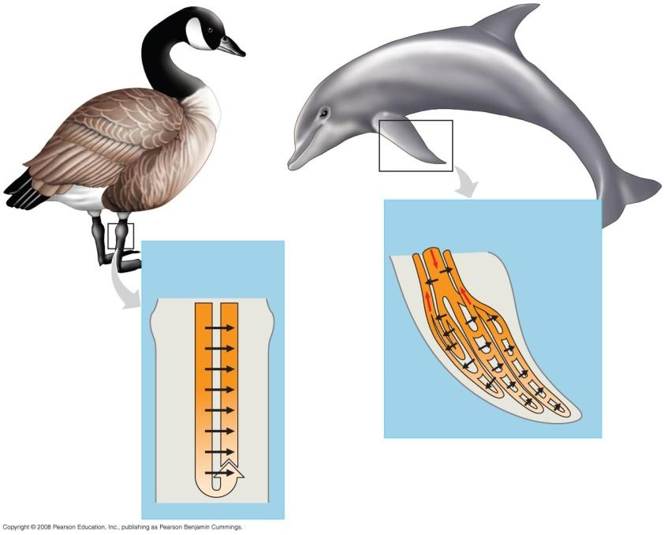

6. Heat loss in extremities is reduced by countercurrent exchange. Use this figure (32.15) to explain how countercurrent exchange works.

7. Use the terms set point, stimulus, and response when describing how a home thermostat works.

Chapter 39-Motor Mechanisms and Animal Behavior

39.3 Discrete sensory inputs can stimulate both simple and complex behaviors
- How is behavior defined?

6. What is a fixed action pattern (FAP)? Give an example.

7. What is a sign stimulus?

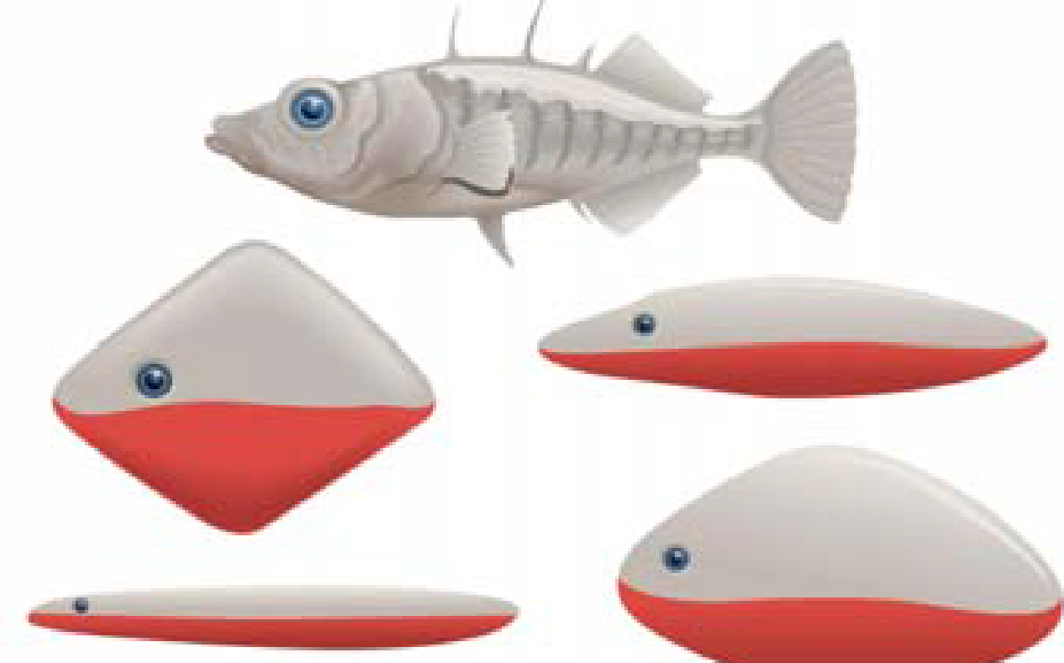

8. Nicholas Tinbergen’s work with the stickleback fish is a classic study. Explain what he found. Use the terms fixed action pattern and sign stimulus in your response.

10. Explain what is meant by circadian rhythms. Identify two behaviors, either plant or animal, that demonstrate a circadian rhythm. (You may need to refer to previous chapters for examples.)

11. Discuss two navigational strategies used by birds to migrate.

12. Animals communicate with various signals that lead to a response. (The signal-response is an important concept to remember.) Discuss two specific examples using different organisms.

39.4 Learning establishes specific links between experience and behavior
16. What is the difference between innate and learned behavior? Give an example of each.

18. Describe the process of imprinting and explain what is meant by sensitive or critical period.

39.5 Selection for individual survival and reproductive success can explain diverse behaviors
29. What is proposed by the optimal foraging theory? Explain it in terms of cost and benefit, and cite two examples from your text.

31. Explain each of these mating systems:
promiscuity
monogamy

polygamy

39.6 Genetic analysis and the concept of inclusive fitness provide a basis for studying the evolution of behavior
37. Explain the evolutionary advantage to a population of having members who exhibit altruistic behavior.

38. Altruism may reduce the fitness of an individual—for example, by making that individual more obvious to a predator. Explain this behavior using the concept of inclusive fitness.

39. Explain the logic behind geneticist J.B.S. Haldane’s comment that he would lay down his life for two brothers or eight cousins.

Chapter 40-Population Ecology and the Distribution of Organisms

40.3 Interactions between organisms and the environment limit the distribution of species
1) What two pieces of data are needed to mathematically determine density?

2) What is the difference between density and dispersion?
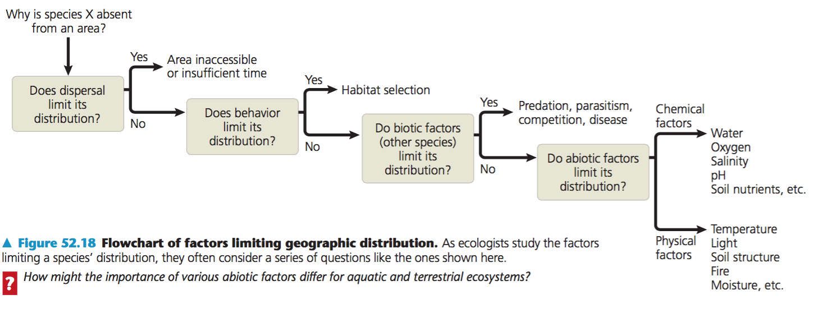

40.4 Biotic and Abiotic factors affect population density, dispersion, and demographics
3) Try the following problem.
A population ecologist wished to determine the size of a population of white-footed deer mice, Peromyscus leucopus, in a 1-hectare field. Her first trapping yielded 80 mice, all of which were marked with a dab of purple hair dye on the back of the neck. Two weeks later, the trapping was repeated. This time 75 mice were trapped, out of which 48 of the mice were marked. Using the formula below, what is the population of mice in the field? Show all Work!!!
# marked originally
Total population
# recaptured
# of recaptured marked
=
Proportion: ratio of what was caught to total population is the same as the ratio of the recaptured that were marked, with the recaptured total

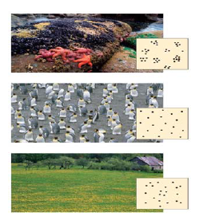
4) Label the dispersion pattern shown by each population in the figure below. Second, and most important, what do the dispersion patterns tell us about the population and its interactions?

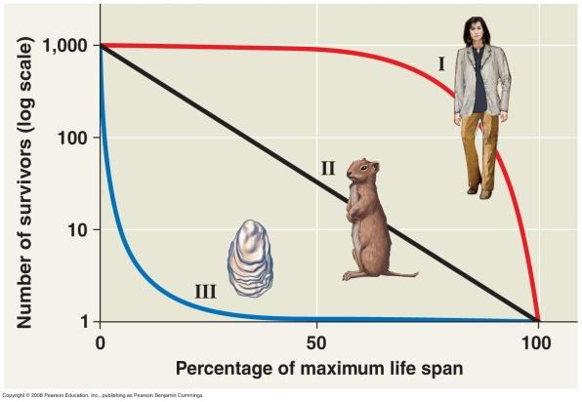
7) Compare the survival strategies of species and give an example of each type.
Type I

Type II

Type III

40.5 The exponential model describes population growth in an idealized, unlimited environment
14) What are two examples of conditions that might lead to exponential population growth in natural populations?

15) What is carrying capacity?

17) In the logistic population growth model, the per capita rate of increase approaches zero as the __________________________ is reached.

19) Explain why the exponential growth curve produces a “J-shaped” curve instead of a straight line.
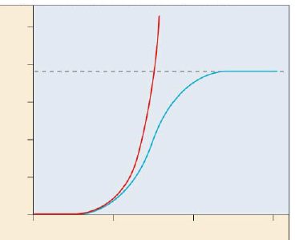
21) Label the graph illustrating the two models of population growth.

22) What happens to a population when the number of individuals approaches carrying capacity?

40.6 Population dynamics are influenced strongly by life history traits and population density
24) Compare K-selected to r-selected species. Give examples of each.
K-selected:

r-Selected:

25) Compare and contrast these two terms and list some examples:
density-independent regulation

density-dependent regulation

