RAVEN CHAPTER 8 GUIDED NOTES: PHOTOSYNTHESIS
Raven 9th edition
- What is the role of photosynthesis in the ecosystem? ______________________________________________________________________________________________
- The textbook divides the reactions of photosynthesis into 3 stages. List and briefly describe their functions:
Light-dependent reactions
___________________________________________________
Light-independent reactions (Calvin cycle)
___________________________________________________
- Write the summary equation for photosynthesis:

- Label the structures of the chloroplast
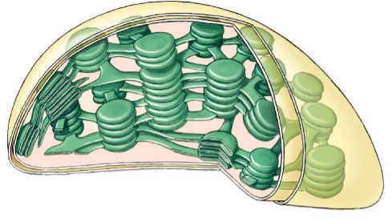

Indicate the role of each structure within the leaf:
  - mesophyll cells ________________________________
  - thylakoid _____________________________________
  - thylakoid membranes ____________________________
  - grana _______________________________________
  - stroma ______________________________________
  - photosystem ___________________________________
  - stomates ______________________________________
- What is the source of oxygen released from photosynthesis?

- Light is a form of _______________energy and is divided into packets of energy called ______________________
- What other pigments exist in green leaves and what is their function? ______________________________________________________________________________________________
- The porphyrin ring of chlorophyll contains the element ____________________ and the role of the ring is to ________________________________________
- What does chlorophyll do when excited by photons? ___________________________________________________________________________
- What is a photosystem? ______________________________________________________________________________________________

- Label the diagram and explain the difference between Photosystem I and Photosystem II.

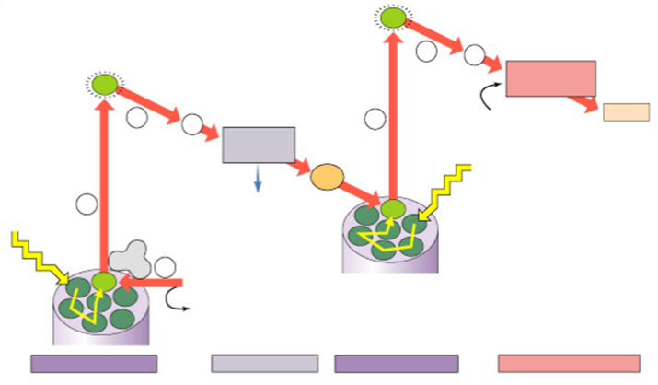

- With 2 different colored pencils, follow the energy paths of both cyclic and noncyclic electron flow. (the diagram is not from your text, but it better illustrates the concept
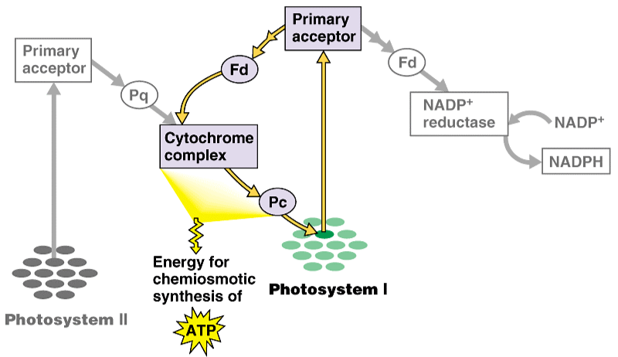 Explain how cyclic photophosphorylation differs from noncyclic photophosphorylation. _____________________________________________________________________________________________________________________________________________
- What is the function of the electron transport chain of Photosystem II? ______________________________________________________________________________________________
- How is ATP synthesis coupled with the reactions of Photosystem II? _______________________________________________ _______________________________________________ _______________________________________________
- Within the thylakoid membrane and stroma, indicate what happens to each of the following:
  - water ________________________________________
  - high energy electrons ____________________________
  - H+ __________________________________________
  - oxygen _______________________________________
  - NADP+ _______________________________________
  - ADP _________________________________________
- Where in the chloroplast is the H+ concentration highest?

- Explain what happens during carbon fixation. ______________________________________________________________________________________________
- The products of the Calvin cycle are

- For each of the materials the plant uses during the photosynthesis list which stage they are used in, their source, their role, and what their fate is.
  - water _________________________________________
  - CO2 __________________________________________
  - NADP+ __________________________________________
  - ADP ___________________________________________
  - H+ ___________________________________________
- Why is Rubisco sometimes called the most important enzyme in the world? ______________________________________________________________________________________________
- Why is the Calvin cycle also called “carbon fixation”? ______________________________________________________________________________________________

- What environmental and internal challenges have forced both C4 and CAM plants to evolve alternatives to the photosynthesis system used by other plants? _______________________________________________
_______________________________________________
- Why do high oxygen levels inhibit photosynthesis? _______________________________________________ _______________________________________________
- What happens during photorespiration and why is it considered bad for plants? _______________________________________________

- What evolutionary adaptations to the Calvin cycle are seen in C4 plants like sugar cane? ____________________________________________________________________________________________________________________________________________________________________________________________
- Draw a diagram to show the anatomical adaptations seen in C4 plants to accommodate their variation on the Calvin cycle.

32. What evolutionary adaptation to the Calvin cycle is seen in CAM plants like cacti? _________________________________________________________________________________________________________________________________________________________

