RAVEN CHAPTER 6 GUIDED NOTES: ENERGY AND METABOLISM
Raven 9th edition
- Define the following terms:
- kinetic energy _____________________________________________________
- potential energy _____________________________________________________
- oxidation _____________________________________________________
- reduction
_____________________________________________________
- Explain the First Law of Thermodynamics and its relationship to biological systems. ______________________________________________________________________________________________________________________
- Explain the Second Law of Thermodynamics and its relationship to biological systems ______________________________________________________________________________________________________________________
- What is meant by a change in free energy? ______________________________________________________________________________________________________________________
- Compare reactions that are...
a. Exergonic ___________________________________________________________ _________________________________________________________
b. Endergonic ______________________________________________________________________________________________________________________

6. Sketch the profile of an exergonic reaction and sketch the profile of an endergonic reaction.

- Define activation energy. ______________________________________________________________________________________________________________________
- How do enzymes affect the energy profile? ______________________________________________________________________________________________________________________
- Use the following diagram to explain the catalytic enzyme cycle
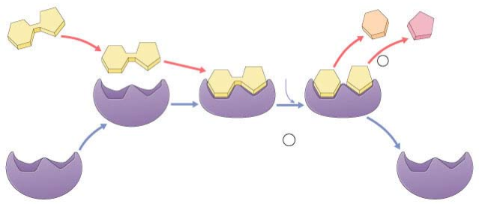

- Explain the induced fit model of enzyme action. ______________________________________________________________________________________________________________________
- Why are enzymes said to be specific? ______________________________________________________________________________________________________________________
- What are the advantages of multi-enzyme complexes?
a.____________________________________________________________________________________________________________________
b.____________________________________________________________________________________________________________________
c.___________________________________________________________________________________________________________________
- How has the discovery of catalytic RNA changed our understanding of enzymes? ______________________________________________________________________________________________________________________
- Explain how temperature and pH influence the rate of enzyme reactions.
a. temperature ______________________________________________________________________________________________________________________
b. pH ______________________________________________________________________________________________________________________
- How do competitive and noncompetitive inhibitors differ in their enzyme interactions? ______________________________________________________________________________________________________________________
16. What happens during allosteric inhibition? ________________________________________________________________________________________________________________________________
17. Explain the role of cofactors. ________________________________________________________________________________________________________________________________
18. What is a coenzyme? ________________________________________________________ ________________________________________________________________
- How does ATP “store energy”? ______________________________________________________________________________________________________________________
- How does ATP “couple reactions”? ______________________________________________________________________________________________________________________
- Define the following metabolic terms
a. anabolism _______________________________________________________________
b. catabolism ______________________________________________________________
- Explain how biochemical pathways could have evolved. ______________________________________________________________________________________________________________________
- Describe feedback inhibition. ______________________________________________________________________________________________________________________

