RAVEN CHAPTER 58 GUIDED NOTES: DYNAMICS OF ECOSYSTEMS
Raven 9th edition
- How does the definition of ecosystems expand on the concept of the community? ______________________________________________________________________________________________
- Contrast the movement of energy and nutrients within ecosystems. ______________________________________________________________________________________________
- Why is it essential that elements move through biogeochemical cycles in the ecosystem? ______________________________________________________________________________________________
- For each of the nutrient cycles identify these key components

 | Carbon cycle | Nitrogen cycle | Phosphorus cycle | Water cycle
What is the abiotic reservoir?
How nutrient enters the food chain.
How nutrient returns to the reservoir.

- What are the major processes that move carbon through the ecosystem? ______________________________________________________________________________________________
- What is the impact of combustion on the carbon cycle? ______________________________________________________________________________________________
- Identify the role of each of the following in the nitrogen cycle:
a. Nitrogen fixation ___________________________________________________
___________________________________________________
b. Ammonification ______________________________________________________________________________________________________
c. Nitrification ______________________________________________________________________________________________________
d. Denitrification ______________________________________________________________________________________________________
9. Define the following energy budget terms:
a. Primary productivity ___________________________________________________
___________________________________________________
b. Gross primary productivity _________________________________________________ ___________________________________________________
c. Net primary productivity ___________________________________________________ ___________________________________________________
- Briefly describe each of the key trophic levels within a food chain
- a. _______________________________________________
b. _______________________________________________
c. _______________________________________________
d. _______________________________________________
e. _______________________________________________
- What does a food web show that isn’t indicated by a food chain? _________________________________________________________________________________________________________________________
- Which ecosystems have the highest productivity per unit area? ______________________________________________________________________________________________
- What factors do you think contribute to such high productivity? ______________________________________________________________________________________________

- Why do you think the open ocean has is so low in productivity? ______________________________________________________________________________________________

- What is secondary productivity? ______________________________________________________________________________________________
- What happens to the size of each level in the idealized pyramid as energy is transferred through the trophic levels? _______________________________________________

- Explain what happens to the energy and biomass as it is passed through the trophic levels? ______________________________________________________________________________________________
- What limits the length of a food chain? ______________________________________________________________________________________________
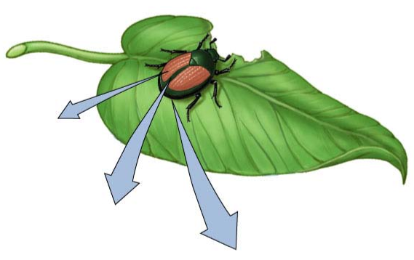
- Label and explain this diagram.

