RAVEN CHAPTER 57 GUIDED NOTES: COMMUNITY ECOLOGY
Raven 9th edition
- Define a community. Explain how a community is different from a population. ______________________________________________________________________________________________
- Define niche. (Note: Many students confuse niche with habitat. Be sure to distinguish between them) _______________________________________________

- What is the competitive exclusion principle? How does it relate to the difference between fundamental niche and realized niche? _______________________________________________
_______________________________________________

- Describe Gausse’s experiment with Paramecia and explain how it helped clarify his competitive exclusion principle. _______________________________________________
_______________________________________________
_______________________________________________
_______________________________________________

- Define and give an example of resource partitioning. ____________________________________________________________________________________________________________________________________________________________________________________________

- Describe several defense mechanisms to predation that have evolved in plants. _____________________________________________________________________________________________________________________________________________
- Give an example of how herbivores have evolved responses to plant defenses. _____________________________________________________________________________________________________________________________________________
- Describe several defense mechanisms to predation that have evolved in animals. _____________________________________________________________________________________________________________________________________________
- Define and give an example of the following animal defenses:
a. Cryptic coloration ______________________________________________________________________________________________
b. Aposematic coloration ______________________________________________________________________________________________
c. Batesian mimicry ______________________________________________________________________________________________
d. Mullerian mimicry ______________________________________________________________________________________________
10. Define symbiosis. ______________________________________________________________________________________________________

11. Fill in the chart of interspecific interactions.

Interaction | Characterize the Relationship | Example
Competition
Predation & Parasitism
Mutualism
Commensalism
- Explain how predators influence the balance of species in a community. ____________________________________________________________________________________________ _______________________________________________
- Explain what ecological concept this diagram illustrates. _______________________________________________
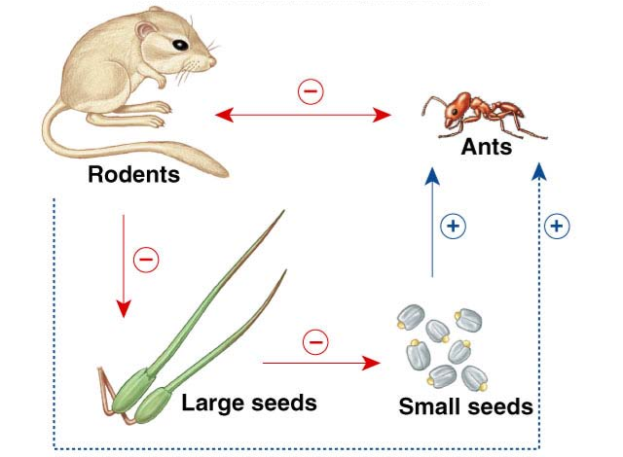

- Define a keystone species and explain why they are so important to a community. Give an example. _______________________________________________

- Define & describe ecological succession. ____________________________________________________________________________________________________________________________________________________________________________________________
- What causes ecological succession? Explain how this diagram illustrates these ecological principles. _______________________________________________
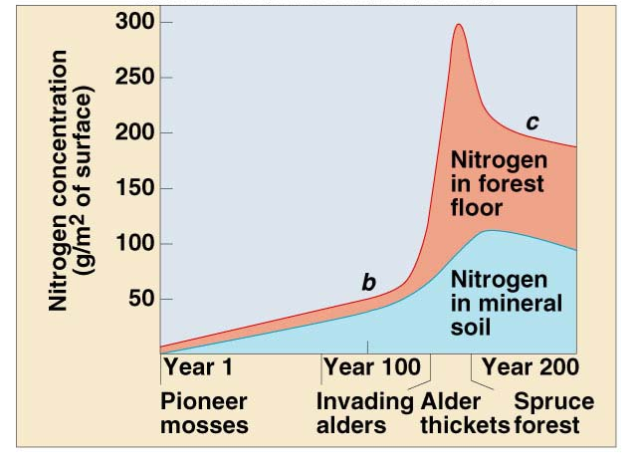

- What is the difference between primary and secondary succession? ____________________________________________________________________________________________________________________________________________________________________________________________

