RAVEN CHAPTER 56 GUIDED NOTES: POPULATION ECOLOGY
- Define ecology. ______________________________________________________________________________________________
- List the four key variables that characterize the environment in which an organism lives. a.____________________________________
b.____________________________________ c.____________________________________
d.____________________________________
- In coping with environmental changes organisms have evolved two distinct approaches. Characterize each. Give an example of each.
a. endotherm (regulator) _____________________________________________________________________________________________________________________________________________
b. ectotherm (conformer) _____________________________________________________________________________________________________________________________________________
- Define population. ______________________________________________________________________________________________
- List the 3 characteristics that can be used to describe a population.
a.__________________________________
b. ___________________________________
c. __________________________________
- List some of the factors that determine the range of a population of organisms. (In effect, explain why polar bears are found in the Arctic but not in the tropical rainforest). _______________________________________________ _______________________________________________

- Describe three patterns of population distribution.
a._____________________________________________
b._____________________________________________
c.______________________________________________
- Application: One species of birds is highly territorial, while a second lives in flocks. What is each species’ likely pattern of dispersion? Explain. _______________________________________________ _______________________________________________ _______________________________________________

- Define demography. ______________________________________________________________________________________________
- Describe how each of the following factors affect population growth rates.
a. sex ratio______________________________________
b. generation time ________________________________
c. age structure __________________________________
- What are life tables used for in population studies? _______________________________________________
- Compare the survival strategies of species and give an example of each type.
Type I ______________________________________________________________________________________________
Type II ______________________________________________________________________________________________
Type III ______________________________________________________________________________________________
Label the survivorship curves diagram.
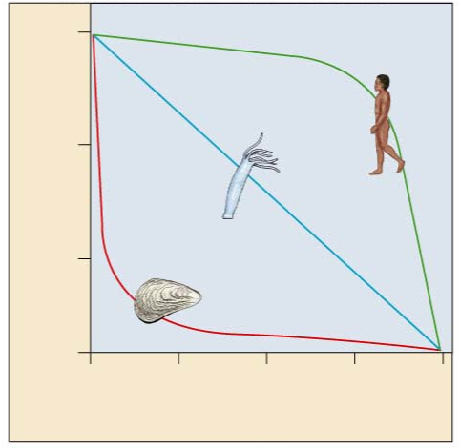

- Life history adaptations involve many trade-offs between the cost of reproduction and the investment in survival. Explain this statement. _______________________________________________
_______________________________________________
_______________________________________________
_______________________________________________

- Briefly describe the trade-offs with respect to each of these factors.
a. Investment per offspring _______________________________________________
b. Reproductive Events per Lifetime _______________________________________________
c. Age at First Reproduction _______________________________________________
- Application: Consider two rivers— One is spring fed and is constant in water volume and temperature year-round; the other drains a desert landscape and floods and dries out at seasonal intervals. Characterize the likely reproductive strategy of the animals in each environment (semelparity vs. iteroparity). Explain _______________________________________________
_______________________________________________
- Define biotic potential. ______________________________________________________________________________________________
- Explain why the exponential growth curve produces a “J-shaped” curve instead of a straight line. _______________________________________________ _______________________________________________

- Explain why an exponential growth curve is rarely seen in nature. Give examples of when it is likely to occur. _______________________________________________ _______________________________________________
- Draw and label graphs illustrating the two models of population growth.

21.Define carrying capacity ____________________________________________________________________________________________________________________________________________________________________________________________________________
- Write the formula for population growth without limits. Define the terms. ______________________________________________________________________________________________
- Write the formula for population growth with limits. Define the terms. ______________________________________________________________________________________________
- What happens to a population when the number of individuals approaches carrying capacity?
___________________________________________________
___________________________________________________

- Identify factors that regulate population size. ______________________________________________________________________________________________
- Compare density-independent and density-dependent factors limiting populations. _______________________________________________
- Compare K-selected to r-selected species. Give examples of each.
a. K-selected ______________________________________________________________________________________________
b. r-selected ______________________________________________________________________________________________
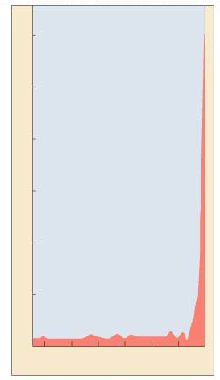
- Look at the growth curve
of the human population.
How does it compare to the
growth curves earlier in the chapter? __________________________________

____________________________________________________________________________________ _______________________________________________ _______________________________________________

- Have humans reached K? What factors are significant when explaining our growth curve? Label the graph. _______________________________________________ _______________________________________________

- Look at the age structure diagrams (population pyramids) of different countries. What will the population distributions look like in 20 years? Application: How might the age structure influence policy?
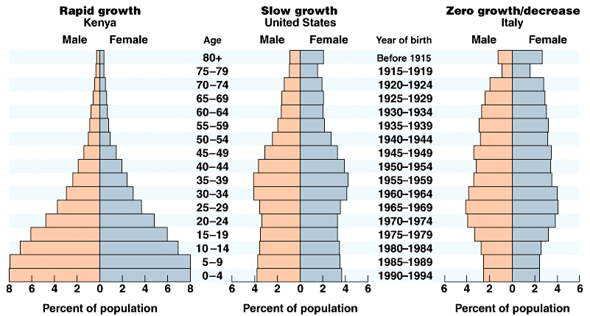 _______________________________________________ _______________________________________________
_______________________________________________

- Explain ecological footprint. ______________________________________________________________________________________________
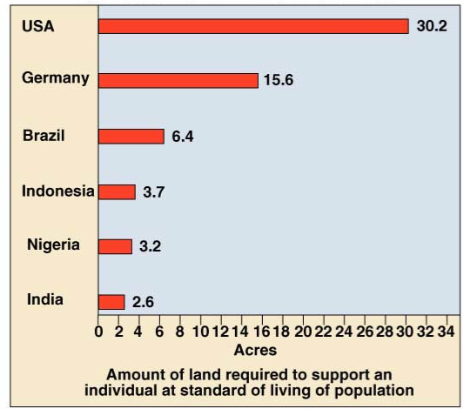
- Explain the significance of this diagram. Application: What is the more significant cause of resource depletion— overpopulation or overconsumption? _______________________________________________
_______________________________________________ _______________________________________________ _______________________________________________
_______________________________________________

