RAVEN CHAPTER 51 GUIDED NOTES: OSMOTIC REGULATION AND THE URINARY SYSTEM
Raven 9th edition
- Define homeostasis. ______________________________________________________________________________________________________________________
- Explain how negative feedback works to maintain homeostasis. _________________________________________________________________________________________________________________________________________________________________________________
- Describe the negative feedback system that humans use to maintain body temperature (thermoregulation). ___________________________________________________________
___________________________________________________________

- Explain the difference between endotherms and ectotherms. _________________________________________________________________________________________________________________________________________________________________________________
- List some examples of how an ectotherm moderates body temperature so that it is not at the extremes of environmental temperatures. ___________________________________________________________
__________________________________________________________
___________________________________________________________

- What are positive feedback loops? Give two examples. ______________________________________________________________________________________________________________________ ___________________________________________________________
- Osmoregulation refers to the maintenance of what bodily materials? ______________________________________________________________________________________________________________________
- Explain the difference between osmoconformers and osmoregulators. ____________________________________________________________________________________________________________________________________________________________________________________________________________________________________________
- Make brief notes on the ways different organisms excrete metabolic wastes and manage water and ion balance.
a. Protists ______________________________________________________________________________________________________________________
b. Flatworms ______________________________________________________________________________________________________________________
c. Annelids
______________________________________________________________________________________________________________________
d. Arthropods ______________________________________________________________________________________________________________________
e. Vertebrates ______________________________________________________________________________________________________________________
10. Briefly list the osmoregulatory problems faced by the following organisms and explain how they are addressed.
a. Freshwater fish __________________________________________________________ ______________________________________________________________________________________________________________________
b. Marine fish _________________________________________________________________________________________________________________________________________________________________________________
c. Cartilaginous fish (sharks & rays) ___________________________________________________________ ______________________________________________________________________________________________________________________
d. Amphibians ___________________________________________________________ ______________________________________________________________________________________________________________________
e. Reptiles _________________________________________________________________________________________________________________________________________________________________________________
f. Land mammals __________________________________________________________ ______________________________________________________________________________________________________________________
g. Marine birds _________________________________________________________________________________________________________________________________________________________________________________
11. What cellular process produces nitrogenous waste?_______________

- List the three nitrogen waste products and describe the influence of habitat on which type is produced by animals.
a. ______________________________________________________________________________________________________________________
b. ______________________________________________________________________________________________________________________
c. ______________________________________________________________________________________________________________________
- Define each of the key functions of the excretory process.
- Filtration
__________________________________________________________________________________________________________
b. Reabsorption ________________________________________________________________________________________________________________
c. Secretion ________________________________________________________________________________________________________________
d. Excretion ________________________________________________________________________________________________________________
- What is the relationship between the kidney (excretory system) and circulatory system? ______________________________________________________________________________________________________________________
15. Label the diagram of the human urinary system.
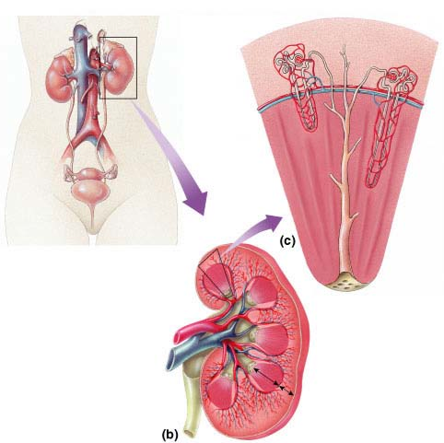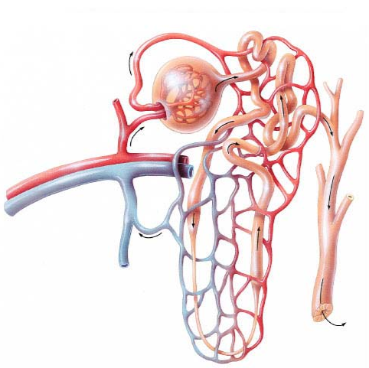
16. Using the diagram of the nephron, note the major exchanges that occur along the various sections. Indicate the osmolarity (salt conditions) in each region.
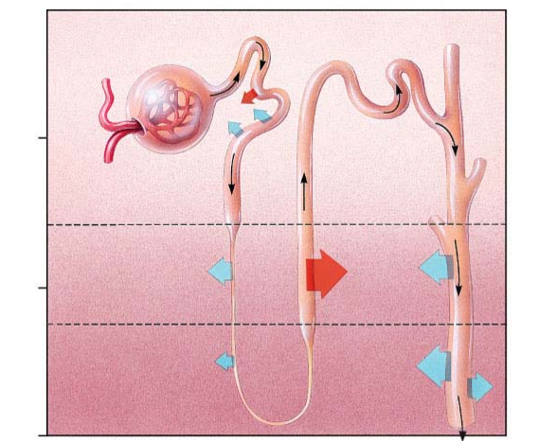
17. Explain how the descending limb and the ascending limb of the loop of Henle differ.

________________________________________________________________
18. Explain how these structural differences make it possible for the kidney to produce concentrated urine.
___________________________________________________________

- Describe the feedback mechanisms that regulate the kidney.
a. ADH ____________________________________________________________________________________________________________________________________________________________________________________________________________________________________________
b. Aldosterone ____________________________________________________________________________________________________________________________________________________________________________________________________________________________________________
c. ANH _________________________________________________________________________________________________________________________________________________________________________________

