RAVEN CHAPTER 50 GUIDED NOTES: THE CIRCULATORY SYSTEM
Raven 9th edition
- Why aren’t diffusion and active transport sufficient for transport in multicellular animals? ______________________________________________________________________________________________________________________
- Briefly describe circulation in the cnidarians and flatworms

- Compare the circulatory systems of higher animals.
- Open ______________________________________________________________________________________________________________________
Who has one? ___________________________________________________________
- Closed ______________________________________________________________________________________________________________________
Who has one? ___________________________________________________________
4. List and describe the three principal functions of the vertebrate circulatory system.
a. ________________________________________________________________________________________________________________________________
b. ________________________________________________________________ ________________________________________________________________
c. ________________________________________________________________________________________________________________________________
- Briefly describe the components of the blood.
a. Plasma _________________________________________________
b. Erythrocytes _____________________________________________
c. Leukocytes ______________________________________________
d. Platelets ________________________________________________
- Compare the structure of each vessel. Pay particular attention to structure-function correlations:
a. Artery ________________________________________________________________________________________________________________________________
b. Capillary ________________________________________________________________ ________________________________________________________________
c. Vein ________________________________________________________________________________________________________________________________
- How do precapillary sphincters help regulate capillary blood flow, blood pressure, and body temperature? ___________________________________________________________

- What happens to blood pressure and velocity as the blood flows through:
  - Artery____________________________________________________
  - Capillary __________________________________________________
  - Vein _____________________________________________________
- If blood pressure in veins is so low, how does blood return to the heart from the legs? ______________________________________________________________________________________________________________________
- Discuss the role of the lymphatic system in returning interstitial blood to the circulatory system. Discuss the role of osmosis in the movement of fluid between capillaries and interstitial fluid ___________________________________________________________ ___________________________________________________________

- What is the adaptive value of the four chambered heart? ______________________________________________________________________________________________________________________
- Answer the following regarding the structure of the human heart.
  - Which side is oxygen rich _____________________ ...
      - oxygen poor__________________
  - Which chambers create the blood pressure in the arteries? ________________________
- What causes the heart sounds? ___________________________________________________________
___________________________________________________________

- How is heart rate regulated? ___________________________________________________ ______________________________________________________________________________________________________________________
- Discuss the homeostatic regulation of blood pressure and the role of:
a. baroreceptor reflex ________________________________________________________ ___________________________________________________________
b. ADH ______________________________________________________________________________________________________________________
c. aldosterone ______________________________________________________________________________________________________________________

d. atrial natriuretic hormone ___________________________________________________ ___________________________________________________________
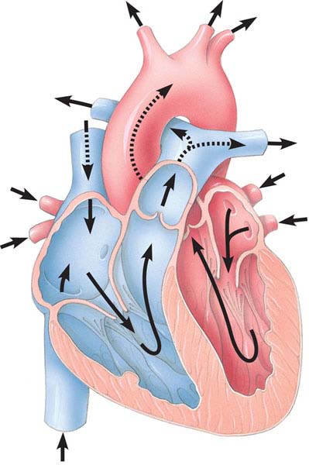
e. nitric oxide ______________________________________________________________________________________________________________________
- Label the diagram of the heart.

- Describe the types of cardiovascular diseases that are leading causes of death in US:
a. Stroke ______________________________________________________________________________________________________________________
b. Heart attack
______________________________________________________________________________________________________________________
c. Atherosclerosis ___________________________________________________________ ___________________________________________________________
d. Arteriosclerosis ___________________________________________________________ ___________________________________________________________

- Discuss the role of zymogens in blood clotting. ___________________________________________________________ ___________________________________________________________
- Hypothesize why clotting is referred to as a “cascade reaction”. ___________________________________________________________

