RAVEN CHAPTER 4 GUIDED NOTES: CELL STRUCTURE
Raven 9th edition
- What are the three features all cells have in common?
a. _____________________________________________
b. _____________________________________________
c. _____________________________________________
- What are the three principles of the Cell Theory?
a. _____________________________________________
b. _____________________________________________
c. _____________________________________________
- What is a limiting factor to cell size?
________________________________________________________________________________________________________________________________________________________
4. The tool that lead to the understanding that cells are the basic unit of life was the... ___________________________________________________
5. The smallest structures visible with the light microscope are the .... ___________________________________________________
6. What is the advantage of the electron microscope? ______________________________________________________________________________________________________
7. How do prokaryotic and eukaryotic cells differ? _________________________________________________________________________________________________________________________________________________________
8. For each of the cellular structures, indicate a few significant aspects. Include major functions and structural description.
Nuclear membrane
Nuclear pores
Chromatin
Nucleolus
Ribosome
Smooth ER
Rough ER
Golgi apparatus
Lysosome
Vacuole
Mitochondria
Chloroplast
Peroxisome
Cytoskeleton
Microtubule
Actin Microfilament
Intermediate filament
Centrioles
Extracellular matrix
9. Trace the path of production of a protein-based secretion from a secretory cell. (Label the organelles involved)
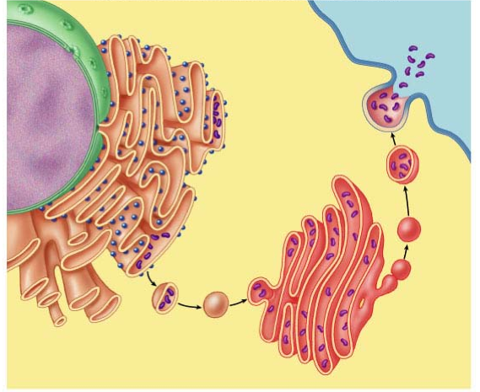
10. Describe the Theory of Endosymbiosis and explain its relevance to eukaryotic cell structure. ______________________________________________________________________________________________________ ______________________________________________________________________________________________________

