RAVEN CHAPTER 49 GUIDED NOTES: RESPIRATION
Raven 9th edition

Gas Exchange
- Describe the relationship of the respiratory surface to the transport (circulatory) system. ___________________________________________________________________________ ___________________________________________________________________________
- Through what process do gases move across the cell membrane? ___________________________________________________________________________
- What are two characteristics typical of a respiratory surface? a. ________________________________________________________________________ b. ________________________________________________________________________
- Why must all animals constantly move either water (for aquatic animals) or air (for terrestrial animals) across their respiratory surface ___________________________________________________________________________
- ___________________________________________________________________________

- How do partial pressures of gases influence the exchange of gas? ___________________________________________________________________________ ___________________________________________________________________________
- Why do terrestrial animals have internal respiratory surfaces? ___________________________________________________________________________
5 of 8
Name _____________________________ AP Biology
- What is countercurrent about the function of a fish’s gills? ___________________________________________________________________________ ___________________________________________________________________________
- What adaptive value is the countercurrent exchange system of gills? ___________________________________________________________________________ ___________________________________________________________________________
- List some features that show how tracheal tubes and lungs are adapted for gas exchange? ___________________________________________________________________________ ___________________________________________________________________________
- Label the diagram of the human respiratory system.
What should be drawn here in the diagram?
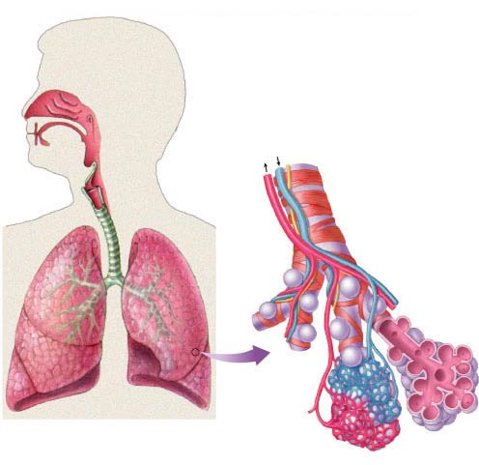
6 of 8
% oxyhemoglobin saturation
Name _____________________________ AP Biology
- What is the role of the alveoli? ___________________________________________________________________________ ___________________________________________________________________________
- Describe how breathing is regulated. Include the role of each of the following.
  - medulla _________________________________________________________________
  - pH _____________________________________________________________________
  - carotid & aortic arteries ____________________________________________________
- ___________________________________________________________________________

- Explain the mechanics of human breathing. How does the diaphragm enable breathing? ___________________________________________________________________________ ___________________________________________________________________________ ___________________________________________________________________________
- What is the adaptive value of hemoglobin? ___________________________________________________________________________ ___________________________________________________________________________
- Review the dissociation curves for hemoglobin. Explain what they illustrate.
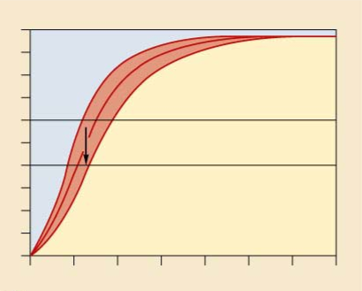
PO2 (mm Hg)
7 of 8
Name _____________________________ AP Biology
- How does lowering pH influence oxygen release from the blood? ___________________________________________________________________________ ___________________________________________________________________________
- Why does oxygen leave the hemoglobin when it passes through the resting tissues? ___________________________________________________________________________ ___________________________________________________________________________
- How is CO2 carried in the blood? ___________________________________________________________________________ ___________________________________________________________________________
- Outline the reactions showing the path of carbon dioxide produced in body cells, then transported as bicarbonate ion in the plasma, to the carbon dioxide released into the alveoli. ___________________________________________________________________________
- ___________________________________________________________________________
- ___________________________________________________________________________
- ___________________________________________________________________________

8 of 8

