RAVEN CHAPTER 45 GUIDED NOTES: THE SENSORY SYSTEM
Raven 9th edition

1. List and describe three types of receptors
- _______________________________________________
- _______________________________________________
- _______________________________________________

2. Summarize the four step sensory process:
- _______________________________________________
- _______________________________________________
- _______________________________________________
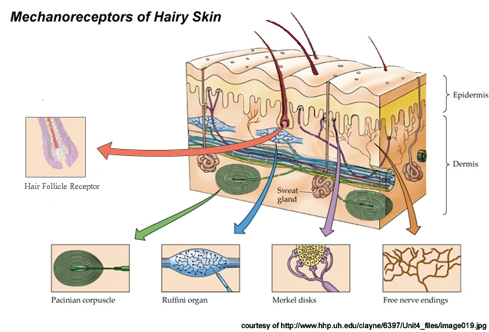
- _______________________________________________

3. 5 Types of mechanoreceptors are discussed in section 45.2. Choose 1 and explain briefly what adaptive advantage it offers,
_______________________________________________
_______________________________________________
4. Explain how a fish uses a lateral line system
_______________________________________________
_______________________________________________
5. How are the ears of fish similar to those of humans?
_______________________________________________
_______________________________________________
6. What is the evolutionary benefit of chemoreceptors in the nose and mouth?
_______________________________________________
_______________________________________________
7.Figure 45.2 shows a signal transduction pathway in the vertebrate eye. How are signals sent at the cellular level? _______________________________________________
_______________________________________________
8. List the steps in the visual information pathway

