RAVEN CHAPTER 44 GUIDED NOTES: THE NERVOUS SYSTEM
Raven 9th edition
How does a sensory neuron link to a motor neuron?

Two Divisions of the Nervous System:
- Central nervous system

b. Peripheral nervous system _________________________________________________ ______________________________________________________________________________________________________
3. Label this diagram of a typical neuron:
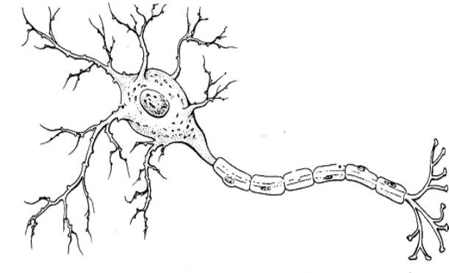
A: cell body
B: axon
C: dendrite
D: Myelin Sheath
E: Schwann cell
F: Node of Ranvier

- Explain how a neuron maintains a -70 mV potential. _____________________________________________________________________________________________________________________________________________
- Detail the stages of the “action potential.” Use the graph and diagrams below to indicate what is happening at the membrane in each stage.
1. _____________________
2. ________________________
3. __________________________
4. _________________________
5. __________________________
6. _________________________
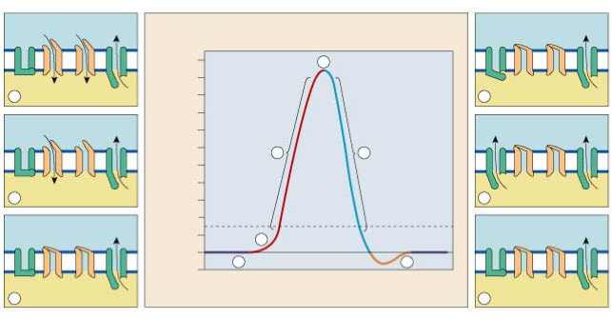

- Describe what happens in the pre-synaptic axon when an impulse reaches the terminal end of the axon. _______________________________________________

- How does an impulse propagate down the axon? ______________________________________________________________________________________________
- Describe what happens at the synapse. _____________________________________________________________________________________________________________________________________________
- How are “messages” carried...
a. in neurons _______________________________________________
b. between neurons _______________________________________________
10. Make some brief notes about the differential action of neurotransmitters
a. norepinephrine _______________________________________________
- Epinephrine
_______________________________________________
11. Take notes on the relationship between drug addiction and neurotransmitters
___________________________________________________
___________________________________________________
___________________________________________________
___________________________________________________

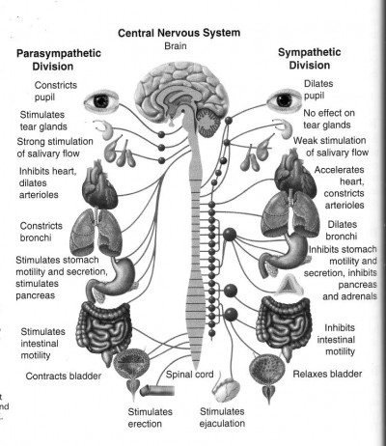
14. Use the following diagram to explain how the sympathetic and parasympathetic divisions of the autonomic nervous system work together.
_____________________________
_____________________________
_____________________________
_____________________________
_____________________________
_____________________________
_____________________________
_____________________________

15. Explain the fight-or-flight mechanism. _________________________________________________________________________________________________________________________________________________________
16. List the major components of the human brain and indicate their functions.










