RAVEN CHAPTER 43 GUIDED NOTES: THE ANIMAL BODY & PRINCIPLES OF REGULATION
Raven 9th edition
- Describe the overall body plan of vertebrates. _________________________________________________________________________________________________________________________________________________________________________________
- List and briefly define the 4 levels of organization of the vertebrate body.
a. ________________________________________________________
b. _________________________________________________________
c. _________________________________________________________
d. _________________________________________________________
- List the 4 primary tissues in vertebrates:
  - . _______________________
  - _______________________
  - _______________________
  - _______________________

- List the 11 principal organ systems of the vertebrate body. 1._____________________________________ 2._____________________________________ 3._____________________________________ 4._____________________________________ 5._____________________________________ 6._____________________________________ 7.______________________________________ 8.______________________________________ 9.______________________________________ 10._____________________________________ 11._____________________________________

- List some examples of epithelial tissues in the vertebrate body. ______________________________________________________________________________________________________________________
- From which embryonic germ layer(s) is epithelial tissue derived? ______________________________________________________________________________________________________________________
- Describe the functions of epithelial tissues. ______________________________________________________________________________________________________________________
- Discuss the remarkable regenerative property of epithelial tissue. How does this make the liver different from other organs? ___________________________________________________________
___________________________________________________________

- List some examples of connective tissue proper in the vertebrate body. ______________________________________________________________________________________________________________________
- From which embryonic germ layer is connective tissue derived? ___________________________________________________________
- Describe the functions of connective tissues. ______________________________________________________________________________________________________________________
- What characteristic distinguishes special connective tissue? ___________________________________________________________
- List some examples of special connective tissue in the vertebrate body. ___________________________________________________________
- Briefly describe the structure, development, and function of each of the special connective tissues.
a. cartilage _________________________________________________________________________________________________________________________________________________________________________________
b. bone ______________________________________________________________________________________________________________________
c. blood ______________________________________________________________________________________________________________________
15. Briefly describe the characteristics and functions of the 3 types of muscle tissues.
a.smooth______________________________________________________________________________________________________________
b.skeletal______________________________________________________________________________________________________________
c.cardiac_______________________________________________________________________________________________________________

- Briefly describe the characteristics and functions of nerve tissues. ______________________________________________________________________________________________________________________
- List and briefly describe the function of the 3 types of nerve tissue.
a._________________________________________________________ ___________________________________________________________
b._________________________________________________________ ___________________________________________________________
c._________________________________________________________ ___________________________________________________________
- Distinguish between an exoskeleton and an endoskeleton. ______________________________________________________________________________________________________________________
- Explain how the skeleton combines with an antagonistic muscle arrangement to provide a mechanism for movement. ___________________________________________________________
___________________________________________________________
___________________________________________________________

- Describe the structure of a skeletal muscle. ______________________________________________________________________________________________________________________
21. Label the structure of a sarcomere on the diagram below:
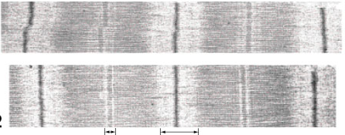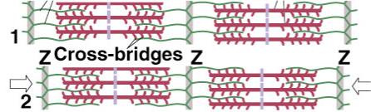
- Explain the sliding filament mechanism of muscle contraction. _________________________________________________________________________________________________________________________________________________________________________________
- Label the diagram below and explain the cross-bridge cycle in muscle contraction. Be sure to highlight the role of ATP.
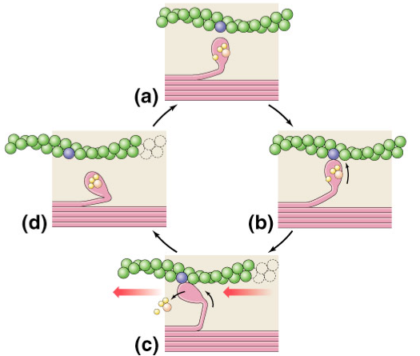

- Label the diagram below and explain how a muscle contraction is controlled. Be sure to discuss the role of calcium. 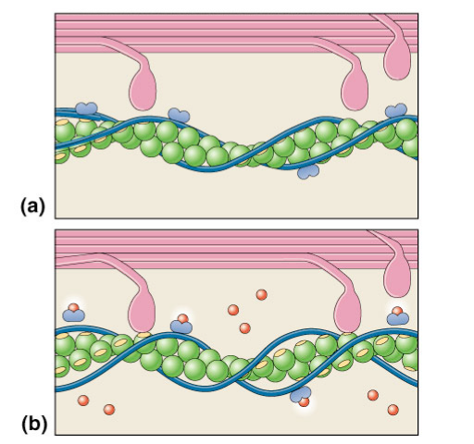
- Explain how a motor neuron stimulates a muscle to contract. _________________________________________________________________________________________________________________________________________________________________________________
26. Explain how the nervous system produces graded contractions of whole muscles. ________________________________________________________________________________________________________________________________________________________________________________________________
27. Distinguish between fast twitch and slow twitch muscles. ________________________________________________________________________________________________________________________________ ________________________________________________________________

