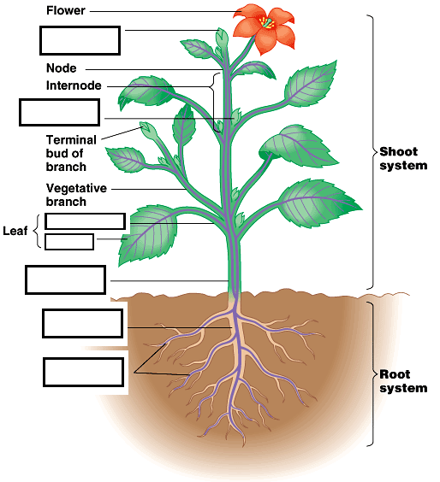
RAVEN CHAPTER 36 GUIDED NOTES: PLANT FORM Raven 9th edition
36.1
Roots
-Function _____________________________
Shoots -
Function__________________

They are made of three types of tissues
______________
_____________
_____________

- Explain the structure and function of meristematic tissue in plants. How do they provide for renewable growth in plants? _______________________________________________________________________
_______________________________________________________________________

- Where are apical meristems located? Briefly describe the structure and function of the apical meristems of a plant. _______________________________________________________________________

- How are lateral meristems distinguished from apical meristems? What type of growth do they create in the tree? _______________________________________________________________________
- Distinguish between cork cambium and vascular cambium.

_______________________________________________________________________
- How is the growing root tip protected from damage as it moves through the soil?
_______________________________________________________________________

- How is the apical meristem protected in a growing seedling as the new shoot moves through the soil? _______________________________________________________________________

- List the two system that make up the plant body: ___________________________________
- Identify and briefly describe the four tissue types that exist in plants
a. _______________________________________________________________________
b. _______________________________________________________________________
c. _______________________________________________________________________
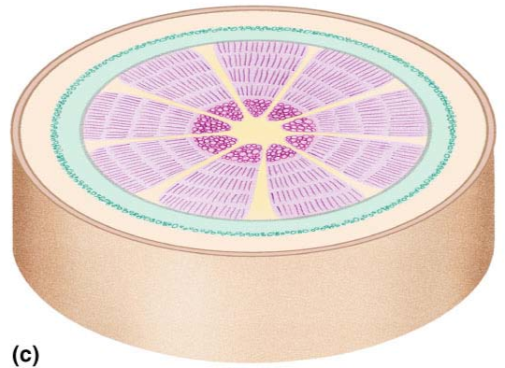
d. _______________________________________________________________________
- Label the diagram of the cross section through a woody stem and indicate the function of each of the tissues.

- Identify and describe three specialized cell types which occur in the dermal tissue of a plant.
a. ___________________________________________________________________
b. ___________________________________________________________________
c. ___________________________________________________________________
- Identify and describe three specialized cell types which occur in the ground tissue of a plant.
a. _____________________________________________________________________
b. ___________________________________________________________________
c. ____________________________________________________________________
- Describe the structure and function of xylem. What cells make up this vascular tissue? ______________________________________________________________________
- Describe the structure and function of phloem. What cells make up this vascular tissue? _______________________________________________________________________
- What are plasmodesmata? ____________________________________________________
- Identify and describe the four regions of the developing root. Explain their function.
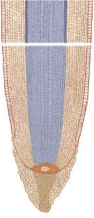
- a. ____________________________________________________________________
b. ____________________________________________________________________
c. _____________________________________________________________________
d. _____________________________________________________________________
- What is the function of the Casparian strip? _______________________________________
- What is the adaptive value of root hairs? _________________________________________
_______________________________________________________________________
- Review some modifications of roots seen in plants.
a. _____________________________________________________________________
b. ___________________________________________________________________
c. ___________________________________________________________________
- Review some modifications of stems seen in plants.
a. __________________________________________________________________
b. ___________________________________________________________________
c. ___________________________________________________________________
d. ________________________________________________________________

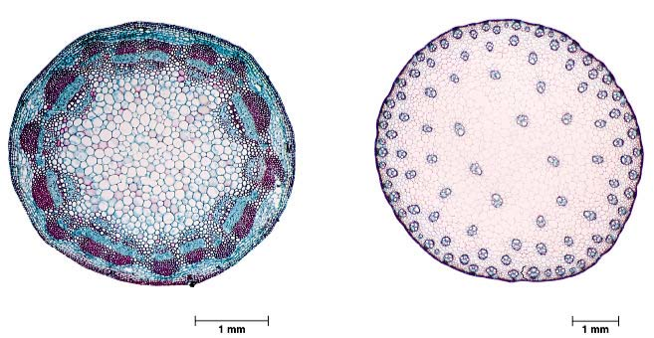
- Label the diagrams of the stems and indicate the functions of the tissues.

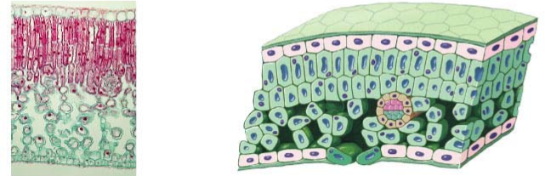
- Label the diagram of the leaf and indicate the function of the tissues.

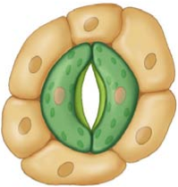
- What is the role of the stomata?

- Review some modifications of leaves seen in plants.
a. ___________________________________________________________________
b. ____________________________________________________________________
c. __________________________________________________________________
d. ___________________________________________________________________

