RAVEN CHAPTER 31 GUIDED NOTES: FUNGI
Raven 9th edition
- How common are fungi on earth? ___________________________________________________________________________ ___________________________________________________________________________
- How do fungi acquire nutrients? ___________________________________________________________________________ ___________________________________________________________________________ ___________________________________________________________________________
- Because of their mode of nutrition, fungi have evolved what structure to provide for both extensive surface area for absorption and rapid growth? ___________________________________________________________________________
- ___________________________________________________________________________

- What is a mycelium? ___________________________________________________________________________ ___________________________________________________________________________
- How are fungi capable of digesting wood? ___________________________________________________________________________ ___________________________________________________________________________
- How does cell division in fungi differ from prokaryotes and from the other eukaryotes? ___________________________________________________________________________ ___________________________________________________________________________ ___________________________________________________________________________
- How do the cell walls of fungi differ from the cell walls of plants? ___________________________________________________________________________ ___________________________________________________________________________
- How do fungi contribute to an ecosystem? ___________________________________________________________________________ ___________________________________________________________________________
- Give three examples of how fungi are beneficial to humans.
a. ________________________________________________________________________
b. ________________________________________________________________________
c. ________________________________________________________________________
- Give three examples of how fungi are harmful to plants and animals.
a. ________________________________________________________________________
b. ________________________________________________________________________
c. ________________________________________________________________________
- Describe the nature of these mutualistic symbioses:
a. lichens __________________________________________________________________ ___________________________________________________________________________ ___________________________________________________________________________
b.mycorrhizae______________________________________________________________ ___________________________________________________________________________ ___________________________________________________________________________
c. fungal gardens of leaf cutter ants _____________________________________________ ___________________________________________________________________________
12. The diagrams below depict the life cycles of the Zygomycetes and the Basidiomycetes. They illustrate the varied reproductive strategies of the fungi. Label the two diagrams and add the terms monokaryotic, dikaryotic, diploid, and haploid to the appropriate stages to describe the state of the nucleus and the cell’s genome.
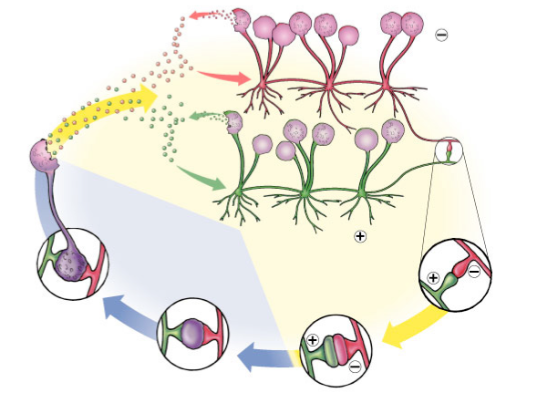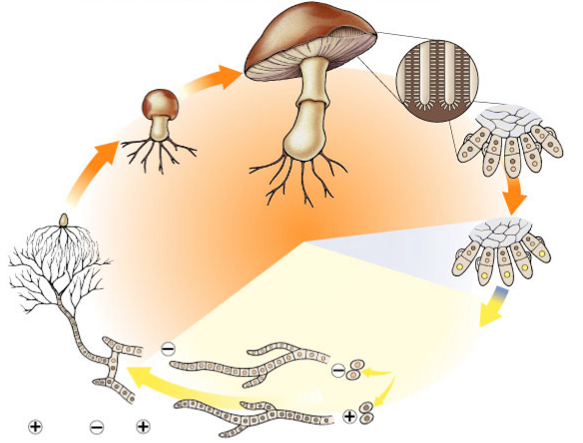
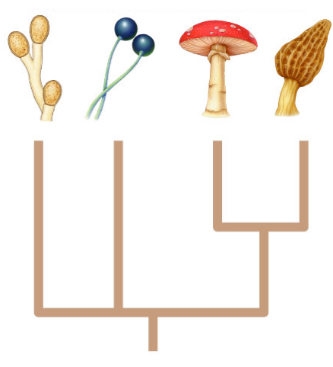
13. Outline the key characteristics of each branch of the Kingdom Fungi as depicted on the diagram at the right. Include the name of the group, key characteristics, several examples of organisms in each division, and the approximate number of living species. Place the letters A, B, C, or D from the table below on the appropriate branch of the diagram to the right.
GROUP | CHARACTERISTICS | EXAMPLES & APPROX. NUMBER OF LIVING SPECIES
A.
B.
C.
D.

