RAVEN CHAPTER 30 GUIDED NOTES: GREEN PLANTS
Raven 9th edition
- Chart the four phyla of the plant kingdom. Include common names of each, the approximate number of species in the phylum, and the major characteristics.
a. _______________________________________________________________________ ___________________________________________________________________________ ___________________________________________________________________________
b. ________________________________________________________________________ ___________________________________________________________________________ ___________________________________________________________________________
c. ________________________________________________________________________ ___________________________________________________________________________ ___________________________________________________________________________
d. ________________________________________________________________________ ___________________________________________________________________________ ___________________________________________________________________________
- What organisms are thought to be the ancestors of the land plants. What evidence supports this? ___________________________________________________________________________
- ___________________________________________________________________________

- List several adaptations of land plants significant for terrestrial survival. ___________________________________________________________________________ ___________________________________________________________________________ ___________________________________________________________________________
- Explain Alternation of Generations in plants and distinguish it from sexual reproduction in animals. Label the generic diagram below as well. ___________________________________________________________________________
- ___________________________________________________________________________

- Describe a few features common to Bryophytes. ___________________________________________________________________________ ___________________________________________________________________________
- What is the dominant phase of the moss life cycle? ___________________________________________________________________________ ___________________________________________________________________________
- What is the dominant phase of the Pteridophyte (fern) life cycle? ___________________________________________________________________________
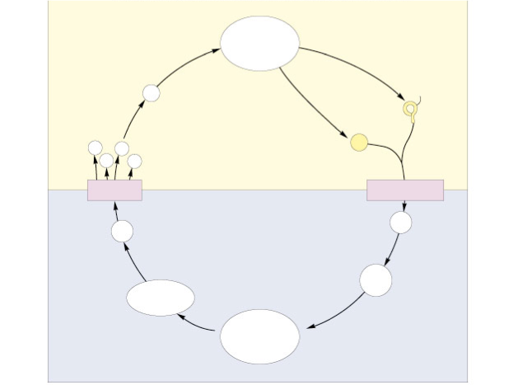
- List the key adaptations of Pteridophytes (ferns) not seen in Bryophytes. ___________________________________________________________________________ ___________________________________________________________________________
- How is the reduced gametophyte an adaptation for seeded plants? ___________________________________________________________________________ ___________________________________________________________________________
- What is the significance of the seed? ___________________________________________________________________________ ___________________________________________________________________________
- What was the advantage of pollen? ___________________________________________________________________________ ___________________________________________________________________________
- List the four phyla of gymnosperms. Which is the most common? ____________________________________ _____________________________________ ____________________________________ _____________________________________ ___________________________________________________________________________
13. Identify five differences between monocots and dicots (eudicots).
Monocots
Dicots
1. 2. 3. 4. 5.
- What is the adaptive value of the flower to plants? ___________________________________________________________________________ ___________________________________________________________________________
- Describe the role of ovaries and ovules in the flowering plants. ___________________________________________________________________________ ___________________________________________________________________________
- How many sperm are in a mature pollen grain in the flowering plants? __________________
- What is the fate of each of these sperm nuclei during fertilization? ___________________________________________________________________________ ___________________________________________________________________________
- What is this fertilization process called? __________________________________________
- What is the chromosome copy number (ploidy) of the endosperm? ____________________ How does this ploidy state come about? ___________________________________________________________________________
- ___________________________________________________________________________

- What is the function of endosperm? ___________________________________________________________________________ ___________________________________________________________________________

