RAVEN CHAPTER 29 GUIDED NOTES: PROTISTS
Raven 9th edition
- How long ago did the eukaryotes evolve? _________________________________________
- What distinguishing characteristic is used to place organisms in the Protist Kingdom. ___________________________________________________________________________ ___________________________________________________________________________
- What is considered the key event in the evolution of eukaryotes from prokaryotes? ___________________________________________________________________________
- Explain the Theory of Endosymbiosis. ___________________________________________________________________________ ___________________________________________________________________________
- Give four lines of evidence that support the Theory of Endosymbiosis.
a. ________________________________________________________________________
b. ________________________________________________________________________
c. ________________________________________________________________________
d. ________________________________________________________________________
- Why are Protists said to be the most diverse of all eukaryotes? ___________________________________________________________________________ ___________________________________________________________________________
- Why do most taxonomists currently working on eukaryotic relationships consider the Protist Kingdom not an evolutionarily accurate grouping? ___________________________________________________________________________
- ___________________________________________________________________________

8. Make some notes on the general biology of the Protists:
a. cell structure _____________________________________________________________ ___________________________________________________________________________
b. locomotion _______________________________________________________________ ___________________________________________________________________________
c. cyst formation ____________________________________________________________ ___________________________________________________________________________
d. nutrition _________________________________________________________________ ___________________________________________________________________________
e. reproduction _____________________________________________________________ ___________________________________________________________________________
9. Label the diagram below illustrating the evolutionary relationships between the Protist lineages.
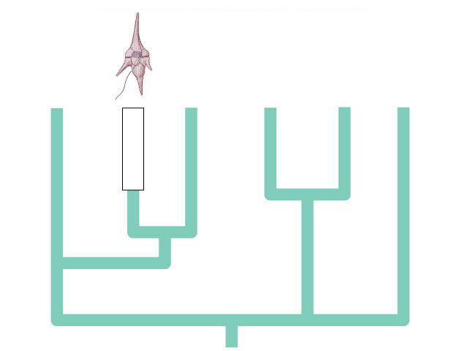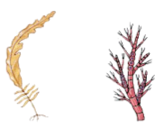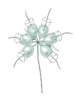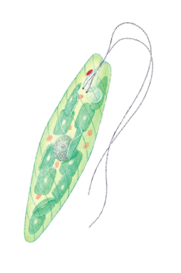

10. Review the six lineages of the Protists and take notes on their key characteristics as well as listing an example organism.
a. name: ______________________________
example ___________________________ ___________________________________________________________________________ ___________________________________________________________________________ ___________________________________________________________________________ ___________________________________________________________________________
b. name: ______________________________
example ___________________________ ___________________________________________________________________________ ___________________________________________________________________________ ___________________________________________________________________________ ___________________________________________________________________________
c. name: ______________________________
example ___________________________ ___________________________________________________________________________ ___________________________________________________________________________ ___________________________________________________________________________
d. name: ______________________________
example ___________________________ ___________________________________________________________________________ ___________________________________________________________________________ ___________________________________________________________________________
e. name: ______________________________
example ___________________________ ___________________________________________________________________________ ___________________________________________________________________________ ___________________________________________________________________________

