RAVEN CHAPTER 23 GUIDED NOTES: SYSTEMATICS AND THE PHYLOGENETIC REVOLUTION
Raven 9th edition
- Briefly explain the binomial nomenclature system developed by Carolus Linnaeus _________________________________________________________________________________________________________________________________________________________________________________
- What is taxonomy? ______________________________________________________________________________________________________________________
- What is a taxon? Give an example. ______________________________________________________________________________________________________________________
- List the eight levels of taxonomic categories in order from most inclusive to most specific.
- __________________________________
- __________________________________
- __________________________________
- __________________________________
- __________________________________
- __________________________________
- __________________________________
- __________________________________
- What is systematics? ______________________________________________________________________________________________________________________
- What is a phylogeny? ___________________________________________________________
- Why is similarity in appearance and structure not a sound way of building accurate family trees? ________________________________________________________________________________________________________________________________________________________________________________
- What is cladistics? _________________________________________________________________________________________________________________________________________________________________________________
- What is a cladogram? ______________________________________________________________________________________________________________________
- What is the difference between ancestral and derived characteristics? ____________________________________________________________________________________________________________________________________________________________________________________________________________________________________________
- Why is an outgroup necessary for building a cladogram? _________________________________________________________________________________________________________________________________________________________________________________
- What is a clade? ___________________________________________________________
13. Explain how the chart below was used to build the cladogram that follows.
________________________________________________________________________________________________________________________________ ________________________________________________________________ ________________________________________________________________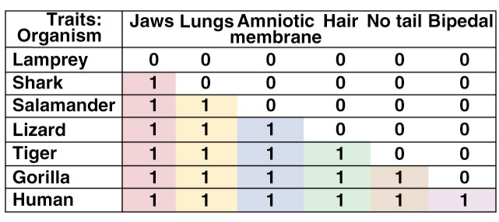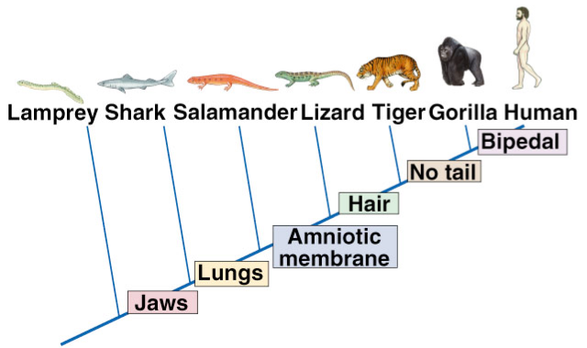
14. What is the principle of parsimony and how is it used to help build cladograms? ________________________________________________________________________________________________________________________________________________________________________________________________
- Distinguish between the following terms:
a. monophyletic: ___________________________________________________________ __________________________________________________________
b. paraphyletic: ______________________________________________________________________________________________________________________
c. polyphyletic: ______________________________________________________________________________________________________________________
- What was the main points of this illustration? __________________________________________________________________________________________________________________________________________________________________________________________________________________________________________________________________________________________________________________________________________________________________ 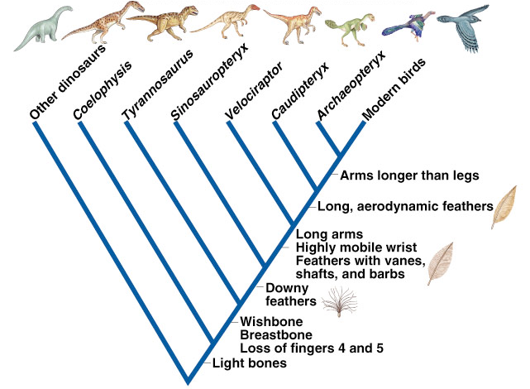
- List the three domains in the classification of living organisms and briefly describe them.
a. __________________________________________________________________________________________________________
b. __________________________________________________________________________________________________________
c. __________________________________________________________________________________________________________

List the six kingdoms in the classification of living organisms and briefly describe them.
1. ________________________________________________________________________________________________________________________________
2. ________________________________________________________________________________________________________________________________
3. ________________________________________________________________________________________________________________________________
4. ________________________________________________________________ ________________________________________________________________
5. ________________________________________________________________________________________________________________________________
6. ________________________________________________________________________________________________________________________________

- What is the issue with fitting viruses into this classification system? _________________________________________________________________________________________________________________________________________________________________________________
- What is the problem with the kingdom Protista? _________________________________________________________________________________________________________________________________________________________________________________

