CHAPTER 20 GUIDED NOTES: GENES WITHIN POPULATIONS
Raven 9th edition
- Define “descent with modification” _______________________________________________ _______________________________________________
- Evolution was not an idea original to Darwin, so what was Darwin’s key contribution to this theory. _______________________________________________
- Distinguish between Lamarck’s concept of evolution and Darwin’s. ______________________________________________________________________________________________
- What is the raw material of evolution? ___________________________________________
- List the five conditions that must be met by a population for genotypes to remain unchanged from generation to generation (i.e., a population in Hardy-Weinberg equilibrium).
  - ______________________________________________
  - ______________________________________________
  - ______________________________________________
  - ______________________________________________
  - ______________________________________________

- Assuming a population is in Hardy-Weinberg equilibrium, write the equation that describes genotype frequencies.
_______________________________________________

- In reference to the Hardy-Weinberg Principle, define the following:
a. p2 ___________________________________________
b. 2pq_________________________________________
c. q2 ___________________________________________
- Work out these practice problems. Assuming H-W equilibrium, find both the allele and genotype frequencies.
  - In Drosophilia, the allele for normal length wings is dominant over the allele for vestigial wings. In a population of 1,000 individuals, 160 show the recessive phenotype.
1. allele frequencies: dominant allele (W) = _______; recessive allele (w) = _______
2. genotype frequencies: WW = ________; Ww = ________; ww = ________
  - The allele for the hair pattern called "widow's peak" is dominant over the allele for no "widow's peak." In a population of 1,000 individuals, 360 show the dominant phenotype.
1. allele frequencies: dominant allele (___) = _______; recessive allele (___) = _______
2. genotype frequencies: ______ = ______; ______ = ______; ______ = ______
- What is the value of using the Hardy-Weinberg equation when researching evolution in a population? ______________________________________________________________________________________________
- List and briefly explain the five agents of evolutionary change.
a.____________________________________________
b._____________________________________________
c.______________________________________________
d._____________________________________________
e._____________________________________________
- How does genetic drift apply to each of the following? Give an example of each.
a. Founders effect ______________________________________________________________________________________________________
b. Bottleneck effect ______________________________________________________________________________________________________
12. On page 441, the book states, “only selection regularly produces adaptive evolutionary change, but the genetic constitution of populations, and thus the course of evolution, can also be affected by mutations, gene flow, nonrandom mating, and genetic drift.” Explain the distinction.
___________________________________________________

___________________________________________________

- Describe two examples of documented cases of selection in natural populations which have resulted in evolutionary change of a population.
a._____________________________________________ _______________________________________________
b._____________________________________________ _______________________________________________
- Define fitness (as it is used in evolutionary biology). ______________________________________________________________________________________________
- Explain “heterozygote advantage” and give an example. _______________________________________________ _______________________________________________

Original population
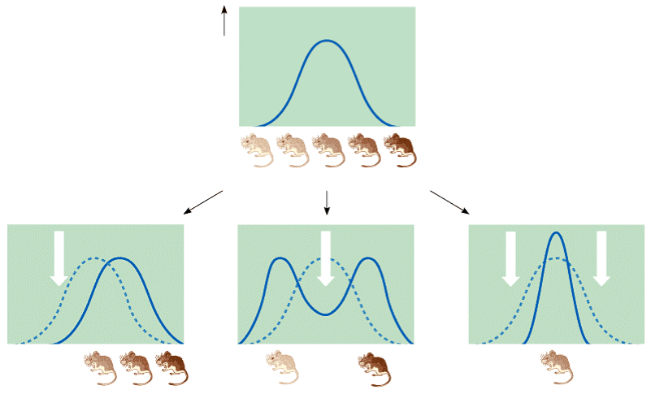
16. Distinguish between the three types of selection illustrated in these graphs of the distribution of coat color in mice.

