RAVEN CHAPTER 16 GUIDED NOTES: CONTROL OF GENE EXPRESSION
Raven 9th edition
- What is meant by the phrase “control of gene expression”? ___________________________________________________________________________ ___________________________________________________________________________
- What is the value of controlling gene expression for a prokaryote (a single-celled organism)? ___________________________________________________________________________ ___________________________________________________________________________
- What is the value of controlling gene expression for a multi-celled eukaryote? ___________________________________________________________________________ ___________________________________________________________________________
- Explain the different evolutionary forces that have caused the development of distinctly different systems of regulation for the control of gene expression in prokaryotes and in eukaryotes.
a. prokaryotes ______________________________________________________________ ___________________________________________________________________________ ___________________________________________________________________________
b. eukaryotes ______________________________________________________________ ___________________________________________________________________________ ___________________________________________________________________________
5. What is a gene’s promoter? What role does it serve in regulating transcription? ___________________________________________________________________________ ___________________________________________________________________________ ___________________________________________________________________________
Control of Transcription in Prokaryotes
- Prokaryotes use a regulatory system called an operon. Explain what an operon is, label the following diagram, and identify the function of the following components: promoter, operator, repressor. ___________________________________________________________________________
- ___________________________________________________________________________
- ___________________________________________________________________________

- Although the following diagram is not from your text, but it is included here because it is a more straightforward representation of the tryptophan (trp) operon system. Label the diagram and use it to explain how this system regulates the synthesis of tryptophan in a bacterium. ___________________________________________________________________________
- ___________________________________________________________________________
- ___________________________________________________________________________
- ___________________________________________________________________________

- Describe how the trp operon is an example of a repressible operon. ___________________________________________________________________________ ___________________________________________________________________________
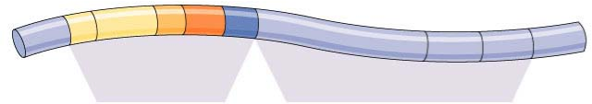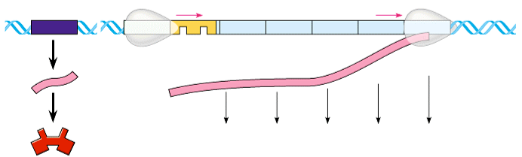
- Although the following diagram is not from your text, but it is included here because it is a more straightforward representation of the lacose (lac) operon system. Label the diagram and use it to explain how this system regulates the digestion of lactose in a bacterium. ___________________________________________________________________________
- ___________________________________________________________________________
- ___________________________________________________________________________
- ___________________________________________________________________________

- Does the diagram above represent the condition for the absence or presence of lactose? ___________________________________________________________________________ ___________________________________________________________________________
- Describe what happens when lactose is absent. ___________________________________________________________________________ ___________________________________________________________________________
- Describe how the lac operon is an example of an inducible operon. ___________________________________________________________________________ ___________________________________________________________________________
- Summarize how the presence and absence of glucose influences the lac operon. ___________________________________________________________________________ ___________________________________________________________________________
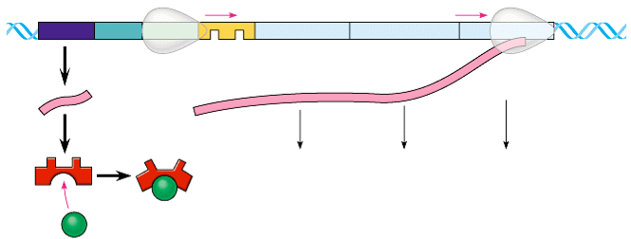
Control of Transcription in Eukaryotes
14.Briefly outline why control of transcription is more complex in eukaryotes than in prokaryotes.
___________________________________________________________________________
___________________________________________________________________________
___________________________________________________________________________
- Explain the general function of transcription factors. Briefly distinguish between the functions of basal transcription factors and specific transcription factors (activators). ___________________________________________________________________________
- ___________________________________________________________________________
- ___________________________________________________________________________

- Use the following diagram to explain the coordinated functions of the enhancer and the promoter regions of the DNA.
- Briefly describe the organization of DNA in the eukaryotic nucleus.
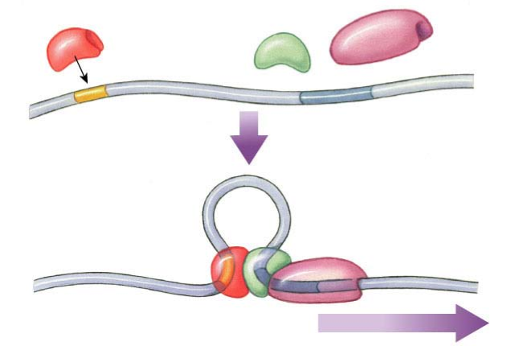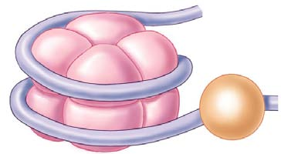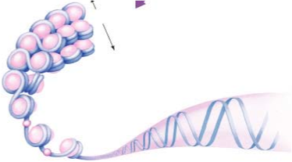
from Ch. 11
18.Transcription can also be regulated by chemically modifying chromosomes. Briefly described the effect on transcription of DNA methylation and histone acteylation.
___________________________________________________________________________
___________________________________________________________________________
___________________________________________________________________________
Posttranscriptional Control
- RNA interference is an exciting new area of research in molecular biology. Make some brief notes about the roles of small RNA molecules (siRNAs and miRNAs) in gene control ___________________________________________________________________________
- ___________________________________________________________________________
- ___________________________________________________________________________

- How does alternative RNA splicing affect gene expression? ___________________________________________________________________________ ___________________________________________________________________________ ___________________________________________________________________________
- Make notes on these additional methods of post-transcriptional control mechanisms.
a. Transport of mRNA out of nucleus ___________________________________________ ___________________________________________________________________________ ___________________________________________________________________________
b. Initiation of translation _____________________________________________________ ___________________________________________________________________________ ___________________________________________________________________________
c. Stability of mRNA transcripts ________________________________________________ ___________________________________________________________________________

