RAVEN CHAPTER 15 GUIDED NOTES: GENES AND HOW THEY WORK
Raven 9th edition
- Briefly describe the function of each type of RNA.
a. rRNA ______________________________________________________________________________________________________________________
b. mRNA ______________________________________________________________________________________________________________________
c. tRNA ___________________________________________________________ ___________________________________________________________
- Explain the “Central Dogma” of biology. ______________________________________________________________________________________________________________________
- Give an overview of transcription. _________________________________________________________________________________________________________________________________________________________________________________
- Give an overview of translation. _________________________________________________________________________________________________________________________________________________________________________________
- Out of the work of a number of scientists, we have now determined that the four “letters” of the DNA “alphabet” translates to the twenty “letters” of the amino acid “alphabet”. Briefly explain how this works. ___________________________________________________________
___________________________________________________________

- Briefly describe how the experimental works of Francis Crick and Marshall Nirenberg “cracked the genetic code”. ___________________________________________________________
___________________________________________________________

- Why is the genetic code said to be universal? What is the significance of this? _________________________________________________________________________________________________________________________________________________________________________________
- The enzyme which transcribes the DNA is_____________________________
- The strand of DNA that is transcribed is called______________________
- The strand of DNA that is not transcribed is called___________________
- List the highlights of the three stages of transcription.
a. Initiation ___________________________________________________________ __________________________________________________________
b. Elongation _________________________________________________________________________________________________________________________________________________________________________________
c. Termination ______________________________________________________________________________________________________________________
- Describe the significant differences between transcription in prokaryotes and eukaryotes. ___________________________________________________________ ______________________________________________________________________________________________________________________

- Make notes on the following diagram to describe the model of a transcription bubble.
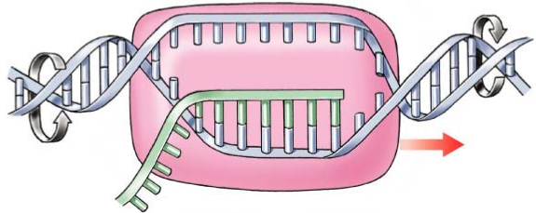

- Describe what happens to the RNA transcript, in eukaryotes, before it leaves the nucleus. _________________________________________________________________________________________________________________________________________________________________________________
- What is the advantage of the 5’ cap and poly A tail? _________________________________________________________________________________________________________________________________________________________________________________
- Identify and briefly describe the steps of translation.
a. Initiation ___________________________________________________________ __________________________________________________________
b. Elongation ___________________________________________________________ ___________________________________________________________
c. Translocation ______________________________________________________________________________________________________________________
d. Termination ______________________________________________________________________________________________________________________
17. Identify the roles of the players of the translation process.
a. Transfer RNA ___________________________________________________________
___________________________________________________________
b. Aminoacyl-tRNA synthetase ___________________________________________________________ ___________________________________________________________
c. Ribosomes ______________________________________________________________________________________________________________________

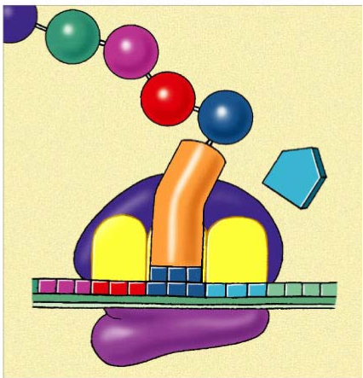
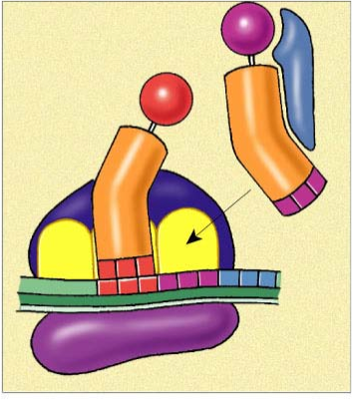
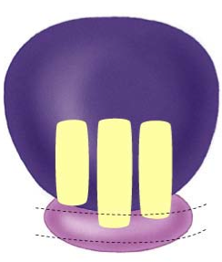
- Make notes on the following diagrams to describe the process of translation

- Distinguish between exons and introns. ______________________________________________________________________________________________________________________
- Describe the mechanism for splicing RNA. _________________________________________________________________________________________________________________________________________________________________________________

- What does alternative RNA processing do for cells? ______________________________________________________________________________________________________________________
- How does protein synthesis differ between prokaryotes and eukaryotes?
  - _________________________________________________________
  - _________________________________________________________
  - _________________________________________________________
  - _________________________________________________________
  - _________________________________________________________
  - _________________________________________________________

21. Use the diagram to trace the flow of chemical information from a gene to its protein product.
