RAVEN CHAPTER 14 GUIDED NOTES: DNA, THE GENETIC MATERIAL
Raven 9th edition
Throughout the early 1900s, a succession of scientists performed experiments to clarify where the genetic information is stored in a cell and to determine specifically which molecule served as the hereditary material. This chapter reviews those experiments and their contributions.
- After Morgan and fellow scientists developed the Chromosomal Theory of Inheritance, the search was on for the chemical mechanism of inheritance. What are the two components of the chromosome? ____________________________________ _____________________________________

- From initial logic, which component would be the most likely candidate for the genetic material and why? ___________________________________________________________
___________________________________________________________

- What did Frederick Griffith’s experiments show? _________________________________________________________________________________________________________________________________________________________________________________
- Define transformation. ________________________________________________________ ___________________________________________________________
- What did the experiments of Oswald Avery, Colin MacLeod and Maclyn McCarty show? _________________________________________________________________________________________________________________________________________________________________________________
- What did the experiments of Alfred Hershey and Martha Chase show? ______________________________________________________________________________________________________________________

7. Use the following diagrams to describe the structure of DNA. Include comments about:
- the 3 main elements of a nucleotide
- the two classes of nitrogenous bases and which bases belong in each class
- the bonding within the molecule
- the numbering of carbons within the molecule
- the structural arrangement of the molecule
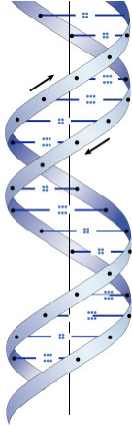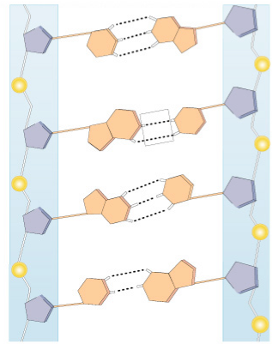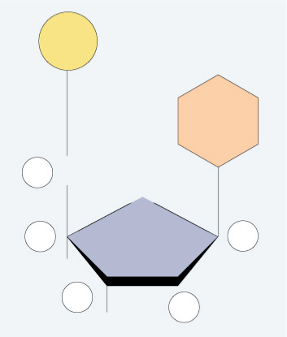
- What are Chargaff’s rules? ______________________________________________________________________________________________________________________
- If a species has 35% adenine in its DNA, determine the percent of the other three bases. ___________________________________________________________
- Who is credited with the discovery of the structure of DNA?___________________________
- What was the role of Maurice Wilkins and Rosalind Franklin in determining the structure of DNA? ___________________________________________________________
___________________________________________________________
- Explain the antiparallel configuration of the DNA molecule ______________________________________________________________________________________________________________________
- What is the advantage of the double-stranded (complementarity) aspect of the DNA? ______________________________________________________________________________________________________________________
- What did the experiments of Matthew Meselson and Franklin Stahl show? ______________________________________________________________________________________________________________________ ___________________________________________________________
- Make a list of the enzymes and “helper” molecules involved in replication and their role.
a.____________________________________________________________________________________________________________________
b._________________________________________________________ ___________________________________________________________
c._________________________________________________________ ___________________________________________________________
d._________________________________________________________ ___________________________________________________________
e._________________________________________________________ ___________________________________________________________
f.__________________________________________________________ ___________________________________________________________
- Why does the DNA have to add nucleotides in the 5’ to 3’ direction? ______________________________________________________________________________________________________________________

- Label the diagram of DNA replication. Include the directions and the identifying terms.
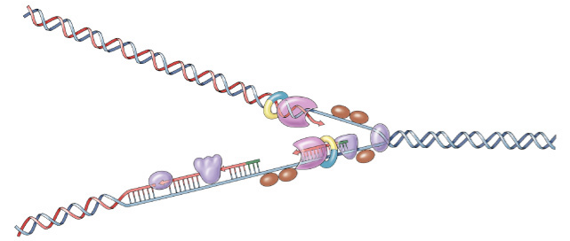
- Describe the role of the primer in DNA replication. ______________________________________________________________________________________________________________________
- Explain the difference between the leading and the lagging strand. What are Okazaki fragments? ___________________________________________________________ ___________________________________________________________ ___________________________________________________________

- How do eukaryotes solve the challenge of having to copy a lot more DNA than prokaryotes during cell division? ___________________________________________________________

- How did diseases involving metabolic pathways lead to hypotheses about the nature of genes? ___________________________________________________________ ___________________________________________________________

- Identify some genetic diseases that occur along metabolic pathways. ______________________________________________________________________________________________________________________
- What did the experiments of George Beadle and Edward Tatum show? ______________________________________________________________________________________________________________________
- What was Beadle and Tatum’s hypothesis regarding enzymes? ______________________________________________________________________________________________________________________
- How has that hypothesis been modified? ______________________________________________________________________________________________________________________
- What was Fred Sanger’s great scientific achievement? (BTW, this was only Sanger’s first of two Nobel Prize winning scientific achievements) ___________________________________________________________ ___________________________________________________________

- What scientific understanding came out of the works of Fred Sanger and Vernon Ingram? ___________________________________________________________ ___________________________________________________________

