RAVEN CHAPTER 12 GUIDED NOTES: PATTERNS OF INHERITANCE
Raven 9th edition
- In what way did both the “constancy hypothesis” and the “blending hypothesis” for the transmission of traits differ from observable patterns of inheritance? _______________________________________________ _______________________________________________

- Why was Mendel’s genetics research so much more valuable than his predecessors? ______________________________________________________________________________________________
- List a few of the advantages of Mendel’s choice of the garden pea as a model organism.
a. ____________________________________________
b. ____________________________________________
c. _____________________________________________
d. _____________________________________________

- Use the diagram to label the generations: P, F1, F2, pure, hybrid, and make notes of Mendel’s observations. Complete a Punnett square for each of the crosses.
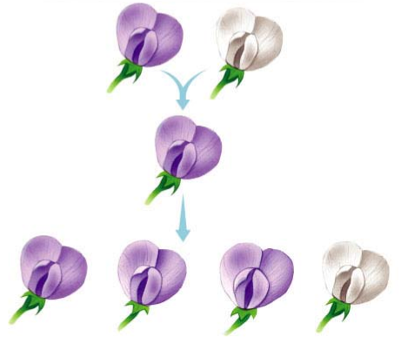

5. What is the difference between an allele, a gene and a locus?
a. allele __________________________________________________
___________________________________________________
b. gene ______________________________________________________________________________________________________
c. locus ___________________________________________________ ___________________________________________________
- Briefly define the following terms:
a. homozygous __________________________________
b. heterozygous __________________________________
c. phenotype ____________________________________
d. genotype ___________________________________
- Explain Mendel’s First Law of Heredity, the Law of Segregation. ____________________________________________________________________________________________________________________________________________________________________________________________
- Using the diagram in Question 4, describe how the Law of Segregation applies to the F1 and to the F2 generations. _______________________________________________ _______________________________________________ ______________________________________________________________________________________________

- When does the segregation of alleles occur? _____________________________________

- What is the purpose of a test cross? ______________________________________________________________________________________________ _______________________________________________
- Explain Mendel’s First Law of Heredity, the Law of Segregation. In other words, when two traits are on different (non-homologous) chromosomes, how are they inherited? _______________________________________________
_______________________________________________
_______________________________________________

- Indicate the phenotypic ratios that result in the F2 from the F1 cross (dihybrid cross)
- Use the rules of probability to determine the expected ratio of offspring showing two recessive traits in the trihybrid cross (PpYyRr X Ppyyrr).

- Explain what a quantitative trait is. Give an example. What causes a trait to exhibit continuous variation? ______________________________________________________________________________________________ _______________________________________________

- Define and give an example of pleiotropy. ______________________________________________________________________________________________
- Describe and give an example of incomplete dominance. ______________________________________________________________________________________________
- Describe and give an example of environmental effects on gene expression. ______________________________________________________________________________________________
- Define and give an example of epistasis. ______________________________________________________________________________________________
- Briefly describe each of the following genetic disorders:
a. Tay-Sachs _______________________________________________ ______________________________________________
b. Huntington disease ______________________________________________________________________________________________
c. Hemophilia ______________________________________________________________________________________________
d. Sickle cell anemia ______________________________________________________________________________________________
- Why are most genetic defects related to enzyme function recessive disorders? _______________________________________________

- Are most genetic disorders recessive? _____________________________________________
- Describe and give an example of codominance. ______________________________________________________________________________________________
- How is blood type an example of multiple alleles? ______________________________________________________________________________________________

- Describe some of the pieces of information that scientists discovered that contributed to the “Chromosome Theory of Inheritance”? ______________________________________________________________________________________________

- Summarize the Chromosomal Theory of Inheritance. ______________________________________________________________________________________________
- Describe Thomas Hunt Morgan’s first mutant fruit fly. Why was this fly so significant? ______________________________________________________________________________________________
- Show the cross P, F1, F2 for the white-eyed male mutant.

28. What is meant by a trait being sex-linked? ______________________________________________________________________________________________________
29. Why are sex-linked recessive traits more common in males than females? ______________________________________________________________________________________________________
30. What happens when we trace the inheritance of traits found on the same chromosome? ______________________________________________________________________________________________________
31. Explain how two genes on the same chromosome can still assort independently. _____________________________________________________________________________________________________ ___________________________________________________
32. What is genetic recombination and when does it occur? ______________________________________________________________________________________________________
33. How is recombination frequency used to develop a genetic map? ______________________________________________________________________________________________________
34. Explain the difference between autosomal chromosomes and sex chromosomes. ______________________________________________________________________________________________________

- What determines sex in humans? ______________________________________________ _______________________________________________
- How many X chromosomes are typically expressed in humans? ______________________
- What happens to X chromosomes that are inactivated? How does this inactivation affect the expression of sex-linked traits in females? _______________________________________________ _______________________________________________ _______________________________________________

- How many Barr bodies would be found in a person with: XXY_____ XO_____ XXX_____.
- List and describe a few specific examples of non-disjunctions that occur in humans.
a. _______________________________________________
b. _______________________________________________
c. _______________________________________________
d. _________________________________________________
- How can a parent learn the risks of having a child with a genetic disorder? ______________________________________________________________________________________________ _______________________________________________
- Explain procedures that can be used to detect genetic defects early in pregnancy.
a. ______________________________________________________________________________________________
b. ______________________________________________________________________________________________

