RAVEN CHAPTER 11 GUIDED NOTES: SEXUAL REPRODUCTION & MEIOSIS
Raven 9th edition
- Define the following terms.
  - gametes ___________________________________
  - somatic cells ___________________________________
  - zygote _______________________________________
  - fertilization _____________________________________
  - diploid _______________________________________
  - haploid ______________________________________
- Why is meiosis called “reduction division”? Why is this process necessary for sexual reproduction? _____________________________________________ _______________________________________________ _______________________________________________

- Label the diagram of the human lifecycle. Include the chromosome numbers at each stage.
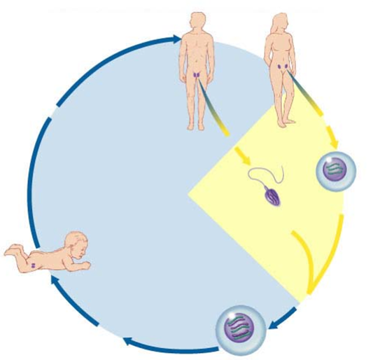

- Explain synapsis. _____________________________________________________________________________________________________________________________________________
- Use the diagrams below to distinguish mitosis from meiosis. For an organism where 2n=4, draw a cell at metaphase of mitosis and a cell at metaphase 1 of meiosis.

Metaphase of mitosis Metaphase 1 of meiosis
- Meiosis is said to be a double division. Explain. ______________________________________________________________________________________________
- Draw a pair of homologous chromosomes in synapsis and then illustrate a crossing over event and the products of crossing over. Label the chiasmata.

- At what stage of meiosis does crossing over occur?

- Compare the products of mitosis with meiosis.
a. Mitosis ______________________________________
b. Meiosis ______________________________________
- Summarize the significant differences between mitosis and meiosis.
11. Meiosis is an important source of variation. Define and describe how each of the following contributes to variation within a species.
a. independent assortment ___________________________________________________ ___________________________________________________
b. crossing over ______________________________________________________________________________________________________
c. random fertilization ___________________________________________________ ___________________________________________________
12. What is the significance of genetic variation to natural selection and evolution? _________________________________________________________________________________________________________________________________________________________

