RAVEN CHAPTER 10 GUIDED NOTES: HOW CELLS DIVIDE
Raven 9th edition

- List the three essential steps of any form of cell division.
a. _______________________________________________________________________
b. _______________________________________________________________________
c. _______________________________________________________________________
- Prokaryotes divided through the process of _______________________________________
- Eukaryotes divided through the process of ________________________________________
- List the key differences between prokaryotes and eukaryotes that make these two processes different. __________________________________________________________________________
- __________________________________________________________________________
- __________________________________________________________________________

- Label and make notes on the diagram below to describe the organization of the eukaryotic chromosome.
- Define the following terms.
a. karyotype _______________________________________________________________
b. haploid _________________________________________________________________
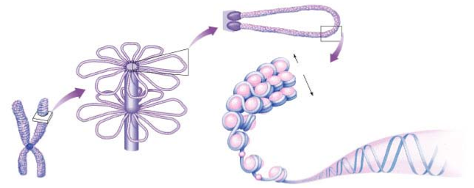

c. diploid __________________________________________________________________
- homologous _____________________________________________________________
- centromere ______________________________________________________________
- chromatid _______________________________________________________________
- Make notes on the following diagram to distinguish between homologous chromosomes and sister chromatids
- Why is DNA coiled into chromosomes in eukaryotes? __________________________________________________________________________ __________________________________________________________________________
- Below is a list of the phases of the cell cycle. Write a brief description of what occurs in each phase.
  - G1 _____________________________________________________________________
  - S ______________________________________________________________________
  - G2 _____________________________________________________________________
  - M ______________________________________________________________________
  - C ______________________________________________________________________
- How does interphase fit into this cell cycle organization listed above? __________________________________________________________________________ __________________________________________________________________________
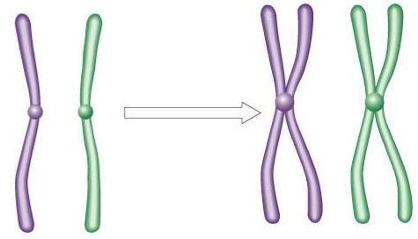

11. What is meant by the concept that cells go through a cell cycle? __________________________________________________________________________ __________________________________________________________________________
12. Do all cells go through the cell cycle at the same rate or at the same frequency? Explain. __________________________________________________________________________ __________________________________________________________________________
13. What is meant by the G0 phase. __________________________________________________________________________ __________________________________________________________________________
14. What is the significance of cells that are permanently in G0 phase? __________________________________________________________________________ __________________________________________________________________________
15. Label the diagram of the cell cycle.
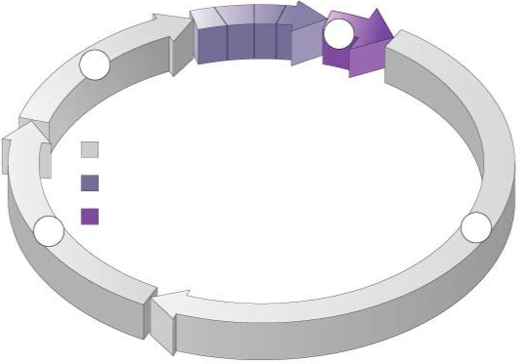
16. Although these are not the diagrams from your text, I think they better illustrate the stages of mitosis. Label the stages and list the key features of each stage.
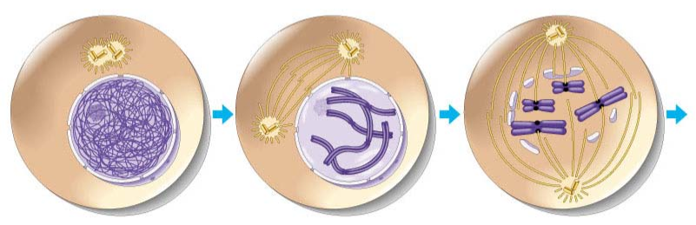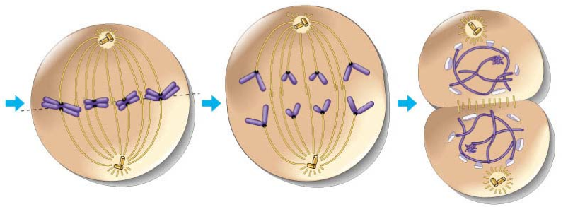
4 of 7
Telophase & Cytokinesis
17. Explain the role of the centromere, kinetochores, and the microtubules in mitosis. __________________________________________________________________________ __________________________________________________________________________ __________________________________________________________________________
18. How does cytokinesis differ in animal and plant cells? Label the diagrams below. __________________________________________________________________________ __________________________________________________________________________ __________________________________________________________________________ __________________________________________________________________________
19. Describe the two irreversible points in the cell cycle. __________________________________________________________________________ __________________________________________________________________________
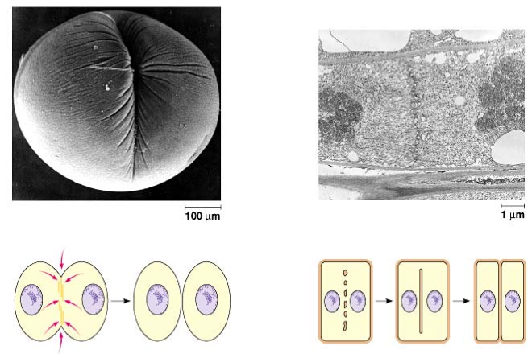
20. What is the G1/S checkpoint and where does it fit into the cell cycle? __________________________________________________________________________ __________________________________________________________________________
21. What cell conditions are being monitored at the G1/S checkpoint? __________________________________________________________________________ __________________________________________________________________________
22. What is the G2/M checkpoint and where does it fit into the cell cycle? __________________________________________________________________________ __________________________________________________________________________ __________________________________________________________________________
23. What cell conditions are being monitored at the G2/M checkpoint? __________________________________________________________________________ __________________________________________________________________________
24. What is the spindle checkpoint and where does it fit into the cell cycle? __________________________________________________________________________ __________________________________________________________________________ __________________________________________________________________________
25. What cell conditions are being monitored at the spindle checkpoint? __________________________________________________________________________ __________________________________________________________________________
26.Why is the regulation of the cell cycle critical to normal function in the multicellular organism?
__________________________________________________________________________
27. For each of the following, takes notes about what type of molecule they are and their role in the cell cycle.
a.Cdk’s___________________________________________________________________ __________________________________________________________________________
b. cyclins __________________________________________________________________ __________________________________________________________________________
c. growth factors____________________________________________________________ __________________________________________________________________________
- What is the relationship between cancer and mitosis? __________________________________________________________________________ __________________________________________________________________________
- What is the role of the p53 gene? __________________________________________________________________________ __________________________________________________________________________ __________________________________________________________________________
- What are proto-oncogenes? __________________________________________________________________________ __________________________________________________________________________ __________________________________________________________________________
- What are tumor suppressor genes? __________________________________________________________________________ __________________________________________________________________________ __________________________________________________________________________

