Name _________________________________________ AP Biology Reading Guide
Fred and Theresa Holtzclaw Copyright © 2010 Pearson Education, Inc.
Chapter 9: The Cell Cycle

2) How does the genome of a prokaryotic cell differ from that of a eukaryotic cell?

3) What is a somatic cell? How many chromosomes in a human somatic cell?

4) Name the two types of gametes. How many chromosomes in a human gamete?

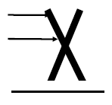
5) You are going to have to learn the difference between a number of similar-sounding terms. The sketch that looks like an X represents a replicated chromosome that has two sister chromatids. The narrow “waist” represents the location of the centromere. Students often get all these terms confused, so take time now to label the indicated areas of the figure and then define each of the terms below.
Chromosome:

Chromatid:

Centromere:

Chromatin:

6) What is the difference between mitosis and meiosis? How is the chromosome number of daughter cells different?

7) Select either mitosis or meiosis to answer the following questions.
___________________ By what process are the damaged cells in a wound replaced?
___________________ By what process are eggs formed?
___________________ By what process does a zygote develop into a multicellular organism?
___________________ In which process are identical daughter cells produced?
___________________ Which process reduces chromosome number of daughter cells?
8) A horse has 64 chromosomes in her somatic cells.
How many chromosomes are in her egg cells? ____________
How many are in her skin cells? _________________
How many are in her fertilized egg (zygote)? __________________

9) Label each of the parts of the cell cycle listed below, and give a brief explanation of what happens in each phase.
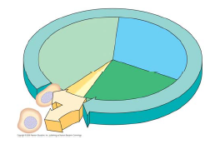
G₁

S

G₂

M

10) What is the centrosome? What happens to the centrosome during interphase and then prophase?

11) Label the stages and briefly describe each phase.
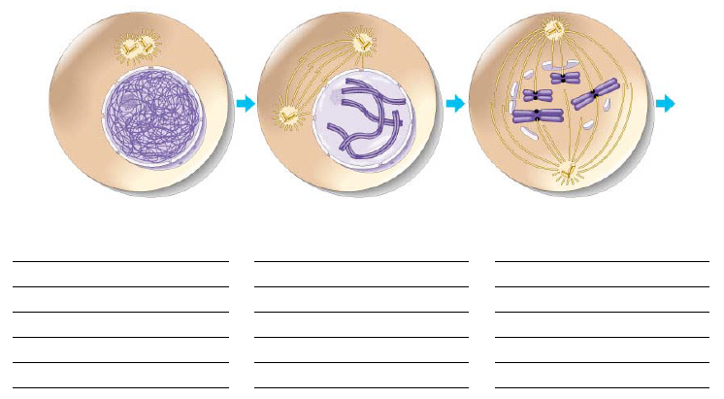

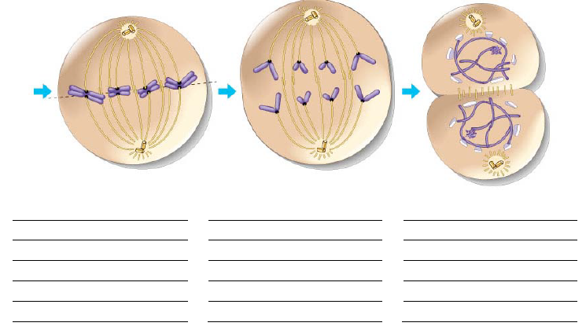

12) What is the role of the kinetochores and the microtubules?

13) How does cytokinesis differ in animal and plant cells? What is it called in each? Use a picture to help your explanation.

15) Eukaryotic mitosis is thought to have evolved from _________________________________

16) Why is the regulation of the cell cycle critical to normal cells?

17) Summarize what happens at each checkpoint. You may add to this chart as you study this section.
Checkpoint | What happens? How is it controlled?
G₁
G₂
M

18) What is the G₀ phase? Describe this phase.

19) Identify the role of the following in the cell cycle clock:

a. Kinase:

b. Cyclin:

c. Cdks:

21) Describe what triggers mitosis from G₂.

23) Cancer cells exhibit different behaviors than normal cells. Here are two normal behaviors they no longer show. Explain each behavior.

density-dependent inhibition

anchorage dependence

24) What happens when cancer develops?

25) What is transformation? Metastasis?

