Name _____________________________________________ Fred and Theresa Holtzclaw
AP Biology Chapter 8 Photosynthesis

This chapter is as challenging as the one you just finished on cellular respiration. However, conceptually it will be a little easier because the concepts learned in Chapter 7—namely, chemiosmosis and an electron transport system—will play a central role in photosynthesis.

1) As a review, define the terms autotroph and heterotroph. Give examples of each. Keep in mind that plants have mitochondria and chloroplasts and do both cellular respiration and photosynthesis!

Autotroph:

Heterotroph:

2) Label the following parts of the chloroplasts below: stroma, thylakoid, thylakoid space, inner membrane, and outer membrane. Next to the part give a brief function.
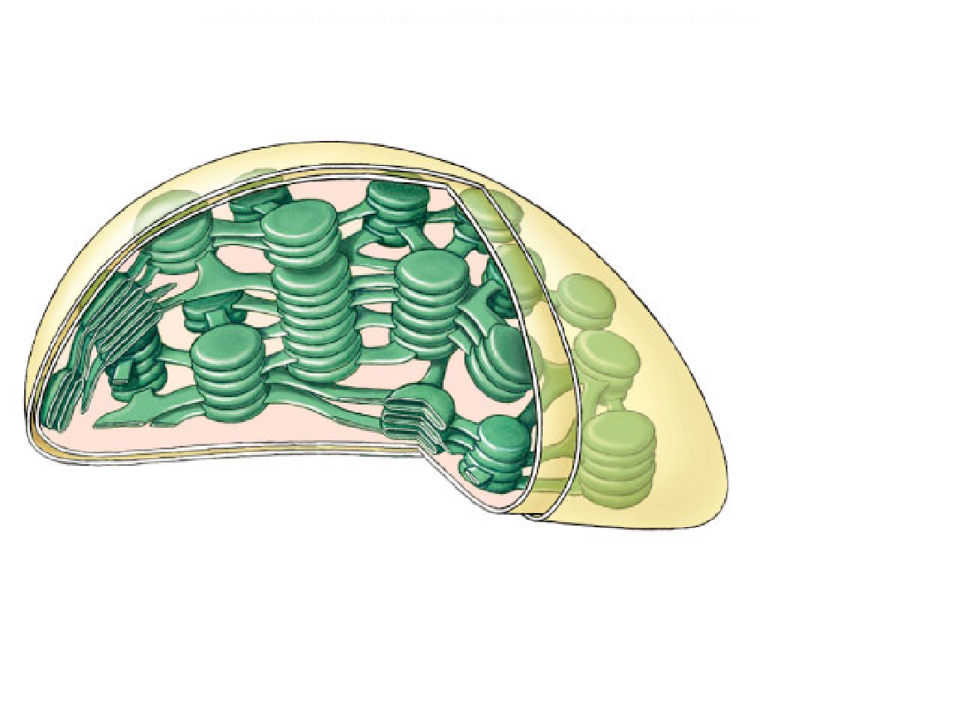

3) Use both chemical symbols and words to write out the formula for photosynthesis (use the one that indicates only the net consumption of water). The formula is the opposite of cellular respiration. You should know both formulas from memory.

4) The textbook divides the reactions of photosynthesis into 2 stages. Briefly describe their functions:
Light-dependent reactions
a. ________________________________________________________________________

Light-independent reactions (Calvin cycle)
b. ________________________________________________________________________

5) Explain why the light-dependent reactions are called as such:
____________________________________________________________________

6) Explain why the Calvin cycle is called the light-independent reaction:
___________________________________________________________________________

7) The details of photosynthesis will be easier to organize if you can visualize the overall process. Label the figure, below. As you work on this, underline the items that are cycled between the light reactions and the Calvin cycle.
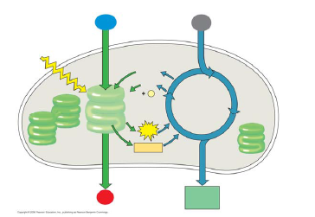

8) Read Figure 8.9 carefully; then explain the correlation between an absorption spectra and an action spectrum.

10) What other pigments exist in green leaves and what is their function?

11) What does chlorophyll do when excited by photons?

12) What is a photosystem? Explain its function.

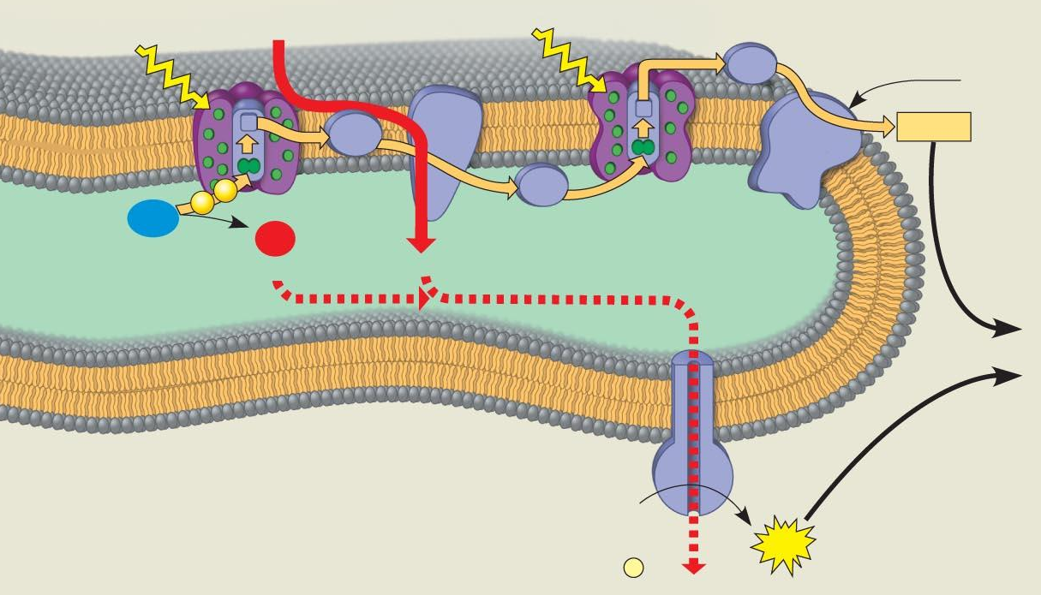
13) Linear electron flow is, fortunately, easier than it looks. It is an electron transport chain, somewhat like the one we worked through in cellular respiration. Label the diagram as you read (see figure 8.16).

16) What is the function of the electron transport chain of Photosystem II? of Photosystem I?

17) How is ATP synthesis coupled with the reactions of Photosystem II?

18) Compare how chemiosmosis is similar and how it is different in chloroplasts (photosynthesis) and mitochondria (cellular respiration).

19) As a review, note that the light reactions store chemical energy in __________ and __________, which shuttle the energy to the carbohydrate-producing __________ cycle.

20) Explain what happens during carbon fixation.

21) The products of the Calvin cycle are: ______________________________________________________

23) Why is Rubisco sometimes called the most important enzyme in the world?

24) Why do high oxygen levels inhibit photosynthesis?

25) What happens during photorespiration and why is it considered bad for plants?

26) What evolutionary adaptations to the Calvin cycle are seen in C4 plants like sugarcane?

Photosynthesis Review (anabolic--building organic molecules from inorganic)
 | Light Reactions | Calvin Cycle
General Purpose
Specific Purpose
Location
Molecules in
inorganic or organic?
Molecules out
inorganic or organic?

Respiration Review (catabolic--breaking down organic molecules into inorganic)
 | Glycolysis | Kreb’s Cycle (AKA the Citric Acid Cycle) | Oxidative Phosphorylation (AKA Electron Transport Chain and Chemiosmosis)
Location
Do all cells do this?
Requires oxygen?
how much ATP?
What goes in?
What comes out?

You MUST be able to explain how the ETC works to produce ATP for both respiration and photosynthesis. Also, explain the purpose of fermentation.

