Name_______________________ AP Biology Reading Guide Chapter 7: Cellular Respiration Fred and Theresa Holtzclaw

Concept 7.1 Catabolic pathways yield energy by oxidizing organic fuels
1. Explain the difference between fermentation and cellular respiration.

2. Give the formula (with names) for the catabolic degradation of glucose by cellular respiration ie. what’s the formula for cellular respiration?

3. Both cellular respiration and photosynthesis are redox reactions. In redox, reactions pay attention to the flow of electrons. What is the difference between oxidation and reduction?

4. The following is a generalized formula for a redox reaction:
Xe– + Y → X + Ye–

Draw an arrow showing which part of the reaction is oxidized and which part is reduced.

5. When compounds lose electrons, they _________ energy; when compounds gain electrons, they _________ energy.

6. In cellular respiration, electrons are not transferred directly from glucose to oxygen. Each electron is coupled with a proton to form a hydrogen atom. Following the movement of hydrogens allows you to follow the flow of electrons. The hydrogens are held in the cell temporarily by what electron carrier?

9. Understanding the overall map of how cellular respiration works will make the details easier to learn. Use Figure 9.2 to label the missing information in the figure below.

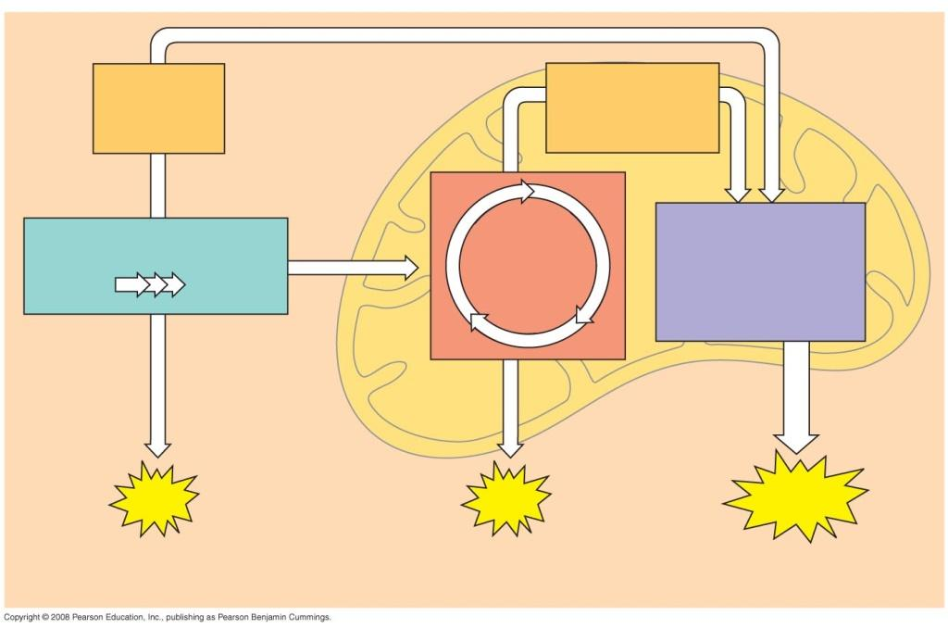

Concept 7.2 Glycolysis harvests chemical energy by oxidizing glucose to pyruvate

12. Why is glycolysis an appropriate term for this step of cellular respiration?

13. The starting product of glycolysis is the six-carbon sugar ________________, and the ending product is two

____________ carbon compounds termed ____________________.

16. This final figure shows the net gain of energy for the cell after glycolysis. Most of the energy is still present in the two molecules of pyruvate. Fill in the chart below (from bottom of figure 7.8) and show the net energy gains.

17. Notice that glycolysis occurs in the ____________________ of the cell. Does glycolysis require oxygen?

Concept 7.3 The citric acid cycle completes the energy-yielding oxidation of organic molecules
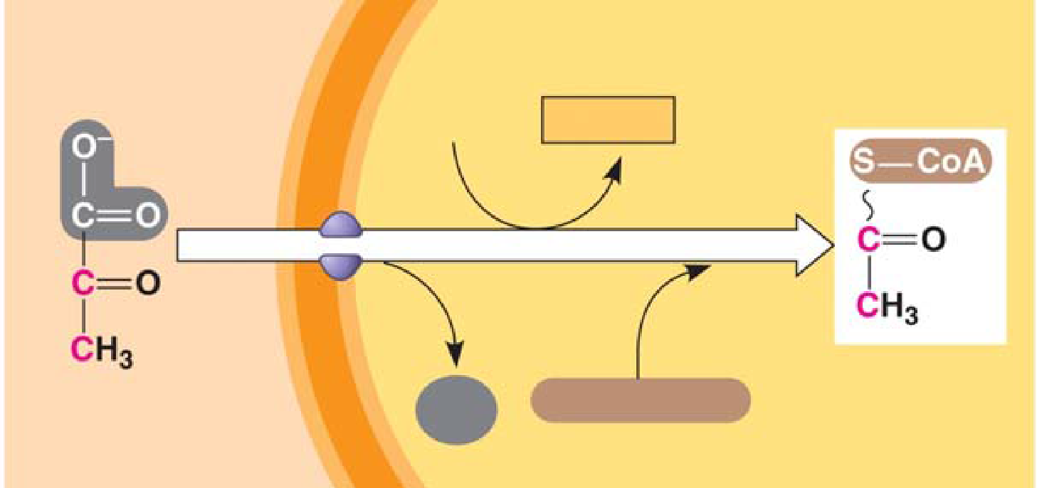
18. To enter the citric acid cycle, pyruvate must enter the mitochondria by active transport. Three things are necessary to convert pyruvate to acetyl CoA. Complete the missing parts of the chart below and then explain the three steps in the conversion process.

(1)

(2)

(3)

19. How many times does the citric acid cycle occur for each molecule of glucose?

20. Use Figure 7.10 to help you answer the following summary questions about one turn of the citric acid cycle:
a. How many NADHs are formed?

b. How many total carbons are lost as Acetyl CoA is oxidized?

c. The carbons have been lost as the molecule __________ __________ .

d. How many FADH2 have been formed?

e. How many ATPs are formed?

21. The diagram covers only one pyruvate, although two pyruvates are formed from a single glucose. How many molecules of the following are formed from the breakdown of glucose?

a. NADH = __________

b. FADH2 = __________

c. ATP = __________

22. The step that converts pyruvate to acetyl CoA at the top of the diagram also occurs twice per glucose. This step accounts for two additional reduced ____________ molecules and two carbon dioxide molecules.

23. Explain what has happened to the six carbon molecules found in the original glucose molecule.

Concept 7.4 During oxidative phosphorylation, chemiosmosis couples electron transport to ATP synthesis

24. Oxidative phosphorylation involves two components: the electron transport chain and ATP synthesis. Referring

to Figure 7.12, notice that each member of the electron transport chain is lower in free __________ than the

preceding member of the chain, but higher in _______________. The molecule at zero free energy, which is

__________, is lowest of all the molecules in free energy and highest in electronegativity.

25. Explain why oxygen is the ultimate electron acceptor. Oxygen stabilizes the electrons by combining with two hydrogen ions to form what compound?

26. The two electron carrier molecules that feed electrons into the electron transport system are ________________

and __________________.

27. Using Figure 7.13, explain the overall concept of how ATP synthase uses the flow of hydrogen ions to produce ATP.

28. What is the role of the electron transport chain in forming the H+ gradient across the inner mitochondrial membrane?

29. Two key terms are chemiosmosis and proton-motive force. Relate both of these terms to the process of oxidative phosphorylation.

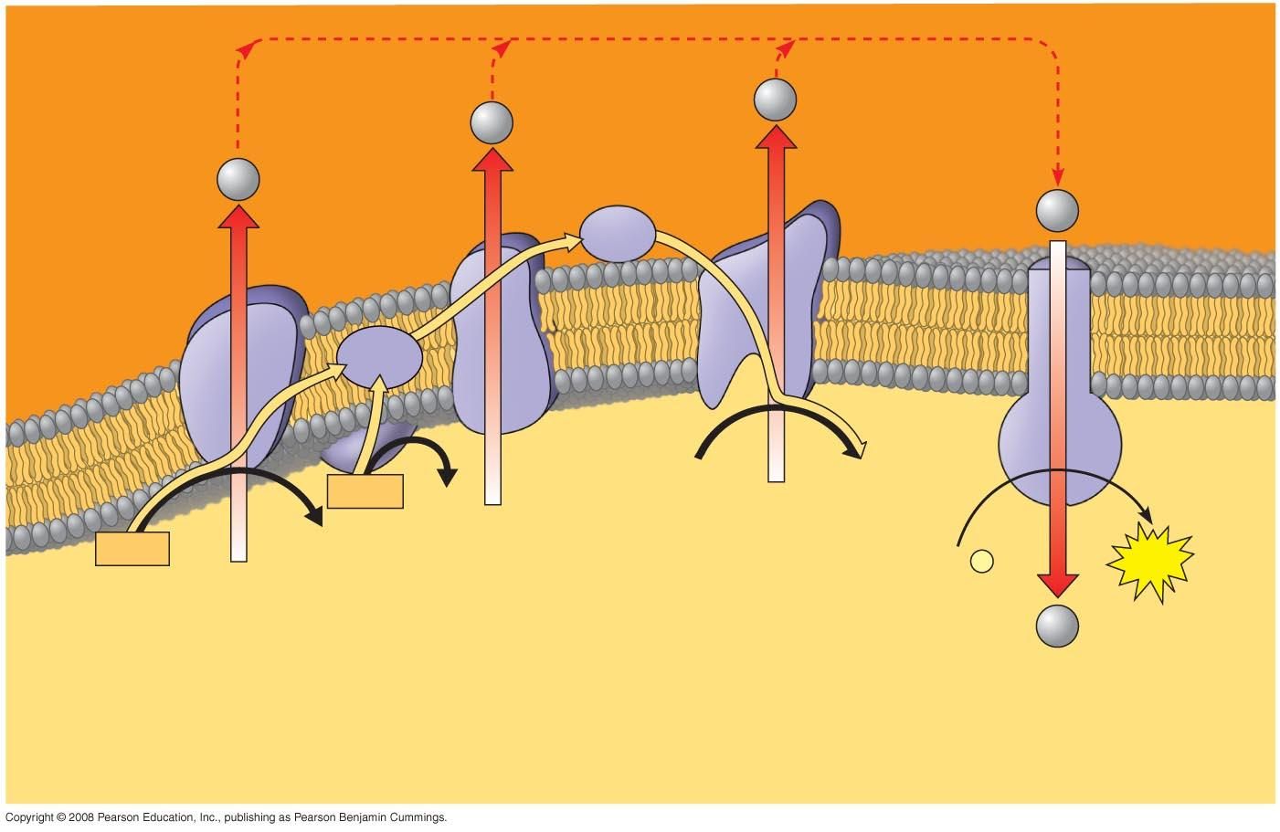
30. Figure 7.14 is a key to understanding the production of ATP in the mitochondria. In the figure below, label all locations and molecules. Then use one color to trace the flow of electrons and another color to show the flow of protons.

33. Why is the total count about 30 or 32 ATP molecules rather than a specific number?

Concept 7.5 Fermentation enables some cells to produce ATP without the use of oxygen

34. Fermentation allows for the production of ATP without using _______________.

35. For aerobic respiration to continue, the cell must be supplied with oxygen—the ultimate electron acceptor. What is the electron acceptor in fermentation?

36. Explain how alcohol fermentation starts with glucose and yields ethanol. Be sure to stress how NAD+ is recycled.

37. Explain how lactic acid fermentation starts with glucose and yields lactate. Be sure to stress how NAD+ is recycled.

38. Using Figure 7.17 as a guide, draw and explain why pyruvate is a key juncture in metabolism.

Concept 7.6 Glycolysis and the citric acid cycle connect to many other metabolic pathways

39. What three organic macromolecules are often utilized to make ATP by cellular respiration?

40. Explain the role of phosphofructokinase (PFK) in regulating respiration.

Copyright © 2010 Pearson Education, Inc.

