Name________________________________ AP Biology Reading Guide
Fred and Theresa Holtzclaw

Chapter 6B: An Introduction to Metabolism (Enzymes)

Concept 6.4 Enzymes speed up metabolic reactions by lowering energy barriers
15. What is a catalyst?
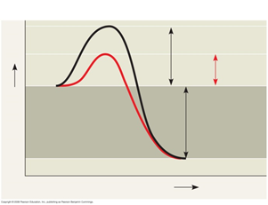

16. What is activation energy (E_{A})?

On the graph, label the x-axis “Progress of the reaction” and the y-axis “Free Energy.”

Label E_{A} on this sketch, both with and without enzyme.
a. What effect does an enzyme have on E_{A}?

b. Label ΔG. Is it positive or negative?

c. How is ΔG affected by the enzyme?

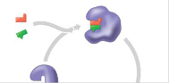
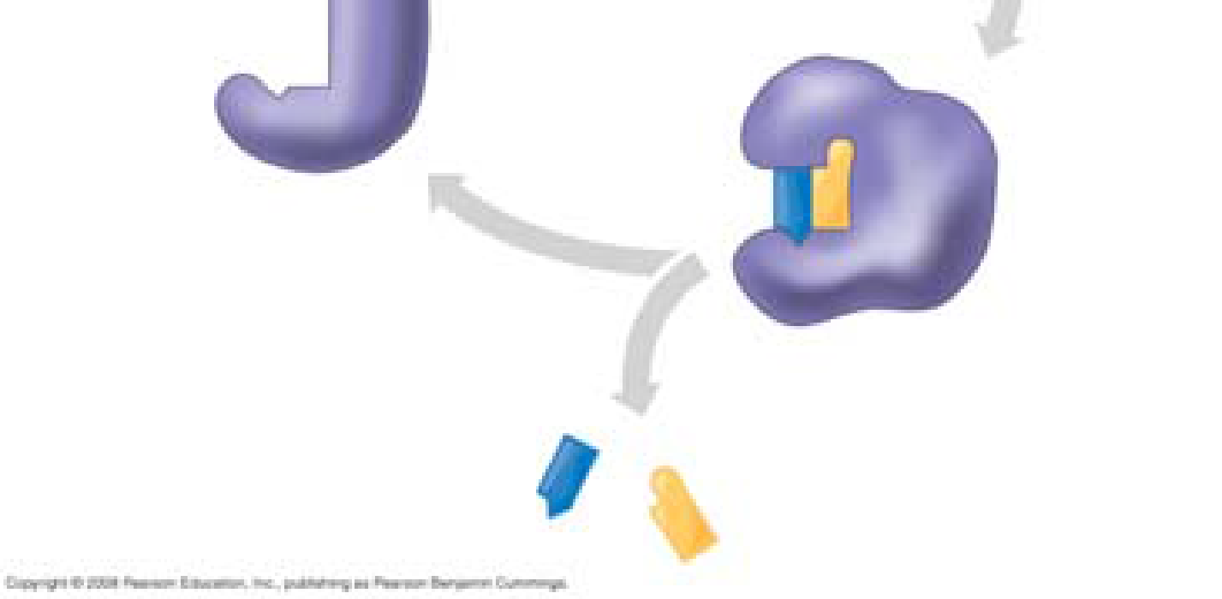
17. Label this figure while you define each of the following terms:
enzyme

substrate

active site

products

18. What is meant by induced fit? How is it shown in this figure?

19. Explain how protein structure is involved in enzyme specificity.

21. Many factors can affect the rate of enzyme action. Explain each factor listed here.
a. initial concentration of substrate
b. pH
c. temperature
22. Recall that enzymes are globular proteins. Why can extremes of pH or very high temperatures affect enzyme activity?

24. Distinguish between cofactors and coenzymes. Give examples of each.

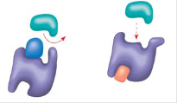
25. Compare and contrast competitive inhibitors and noncompetitive inhibitors.

Label each type of inhibitor in this figure.

Concept 6.5 Regulation of enzyme activity helps control metabolism
26. What is allosteric regulation?

27. How is it somewhat like noncompetitive inhibition? How might it be different?

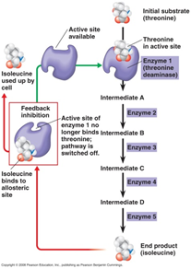
28. Explain the difference between an allosteric activator and an allosteric inhibitor.

30. Study this figure from your book (Figure 6.19).
a. What is the substrate molecule to initiate this metabolic pathway?

b. What is the inhibitor molecule?

c. What type of inhibitor is it?

d. When does it have the most significant regulatory effect?

e. What is this type of metabolic control called?

