Name______________________ AP Biology Reading Guide Chapter 6A: An Introduction to Metabolism Fred and Theresa Holtzclaw

Concept 6.1 An organism’s metabolism transforms matter and energy, subject to the laws of thermodynamics

1. Define metabolism.

2. There are two types of reactions in metabolic pathways: anabolic and catabolic.
a. Which reactions release energy?

b. Which reactions consume energy?

c. Which reactions build up larger molecules?

d. Which reactions break down molecules?

e. Which reactions are considered “uphill”?

f. What type of reaction is photosynthesis?

g. What type of reaction is cellular respiration?

h. Which reactions require enzymes to catalyze reactions?

3. Contrast kinetic energy with potential energy.

4. Which type of energy does water behind a dam have? A mole of glucose?

Concept 6.2 The free-energy change of a reaction tells us whether the reaction occurs spontaneously

5. What is free energy? What is its symbol?

6. For an exergonic reaction, is ΔG negative or positive?

7. Is cellular respiration an endergonic or an exergonic reaction? What is ΔG for this reaction?

8. Is photosynthesis endergonic or exergonic? What is the energy source that drives it?
9. To summarize, if energy is released, ΔG must be what?

6.3 ATP powers cellular work by coupling exergonic reactions to endergonic reactions

11. Here is a molecule of ATP. Label it. Use an arrow to show which bond is likely to break.

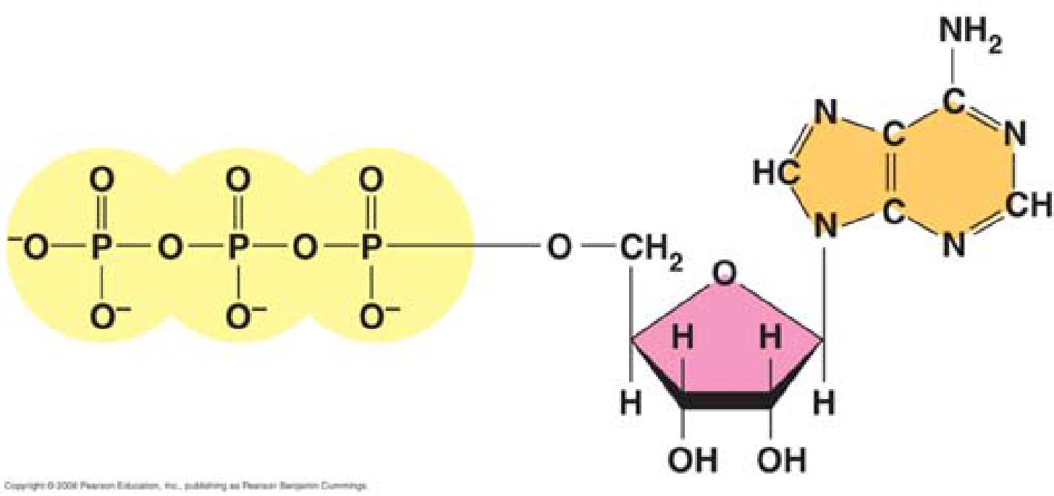

a. By what process will that bond break?

b. Explain the name ATP by listing all the molecules that make it up.

12. When the terminal phosphate bond is broken, a molecule of inorganic phosphate P i is formed, and energy is

___________________?

For this reaction: ATP → ADP + Pi, ΔG = __________________________

Is this reaction endergonic or exergonic?

13. What is energy coupling?

