Name_______________________ AP Biology Reading Guide
Fred and Theresa Holtzclaw Chapter 5B: Cell Communication

Concept 5.6 The plasma membrane plays a key role in most cell signaling

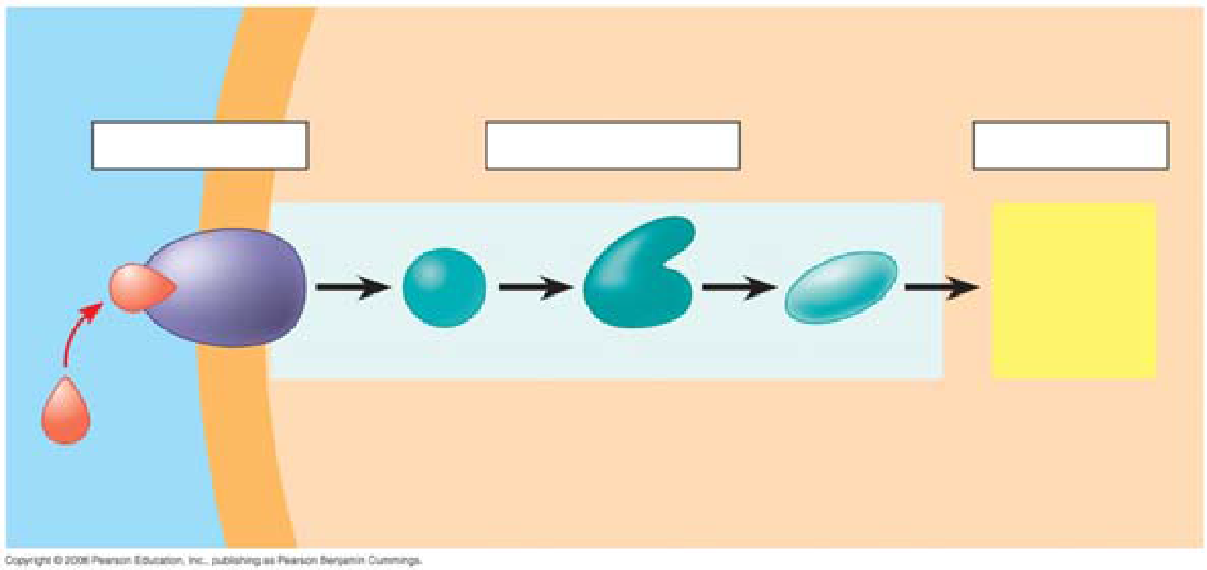
5. A signal transduction pathway has three stages. Use Figure 5.20 to label the missing parts of the preview figure below, and then explain each step.

Reception

Transduction

Response

6. Explain the terms ligand and receptor. Where are the two different locations that receptors are found and what type of ligand do each bond with? Why can’t all receptors be inside the cell?

7. The first example is a G protein-linked receptor. Equally important to starting a signal is stopping a signal. Step 4 stops the signal. (Failure to do so can lead to serious problems, like cancer.) Explain in general what is happening to get a cellular response.

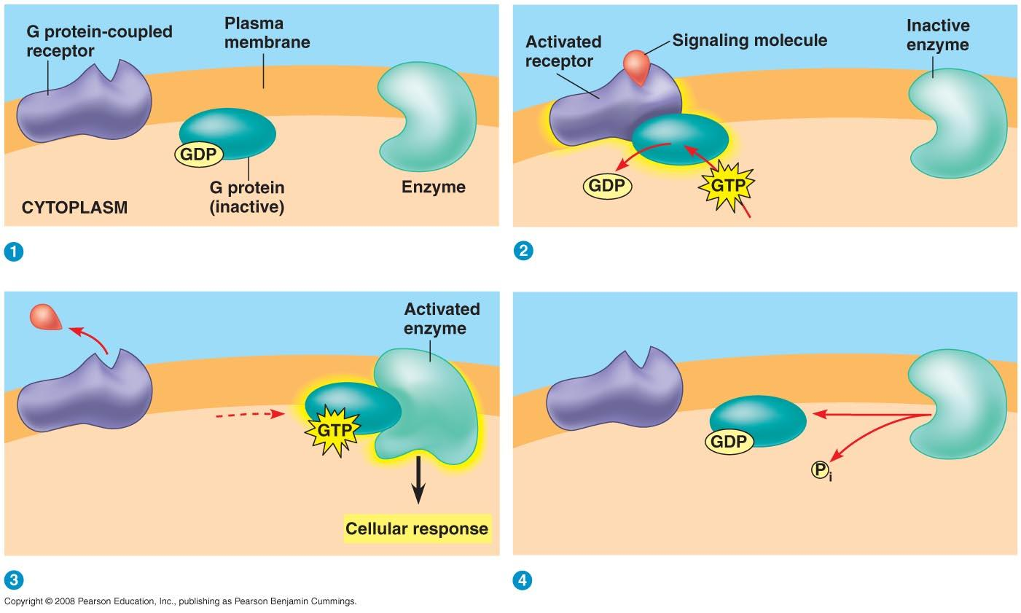

11. What activates a G protein?

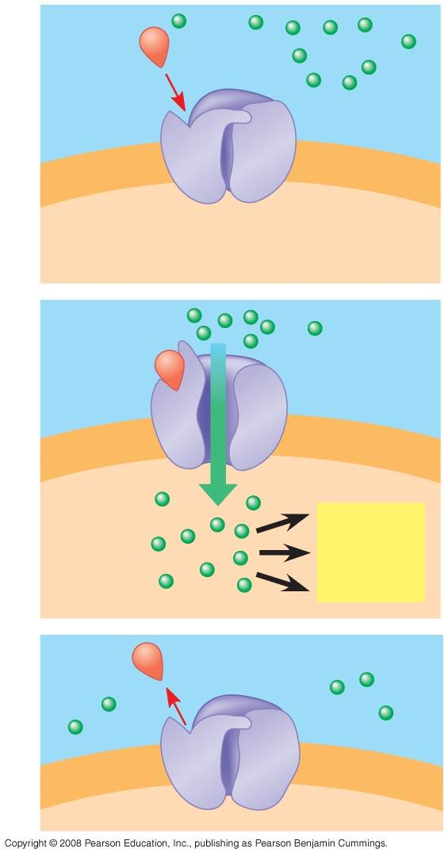
21. Moving to ion channel receptors, the example in Figure 5.22 shows the flow of ions into the cell. Ion channel receptors can also stop the flow of ions. These comparatively simple membrane receptors are explained in three steps. In the three steps, label the diagram and then explain the role of the labeled molecules.

24. In what body system are ligand-gated ion channels and voltage-gated ion channels of particular importance?

29. Explain the role of these two categories of enzymes in transduction.
Protein kinase

Protein phosphatases

31. What is the difference between a first messenger and a second messenger?

38. When cell signaling causes a response in the nucleus, what normally happens?

39. When cell signaling causes a response in the cytoplasm, what normally happens?

43. What specifically happens to a cell during the process of apoptosis and why is this important?

