Name_______________________ AP Reading Guide
Fred and Theresa Holtzclaw Chapter 5A: Membrane Structure and Function

Concept 5.1 Cellular membranes are fluid mosaics of lipids and proteins
4. Describe the fluid mosaic model of membrane structure.

7. Membrane proteins are the mosaic part of the model. Describe each of the two main categories:
embedded proteins

peripheral proteins

9. Membrane carbohydrates are important in cell-cell recognition. What is one example of this?

Concept 5.2 Membrane structure results in selective permeability

14. Peter Agre received the Nobel Prize in 2003 for the discovery of aquaporins. What are they?

15. Consider the following materials that must cross the membrane. For each, tell how it is accomplished.

Material | Method
CO2
Glucose
H+
O2
H2O
Concept 5.3 Passive transport is diffusion of a substance across a membrane with no energy investment
16. Define the following terms:
diffusion

concentration gradient

passive transport

osmosis

isotonic

hypertonic

hypotonic

18. What is facilitated diffusion? Is it active or passive? What are two ways they work?

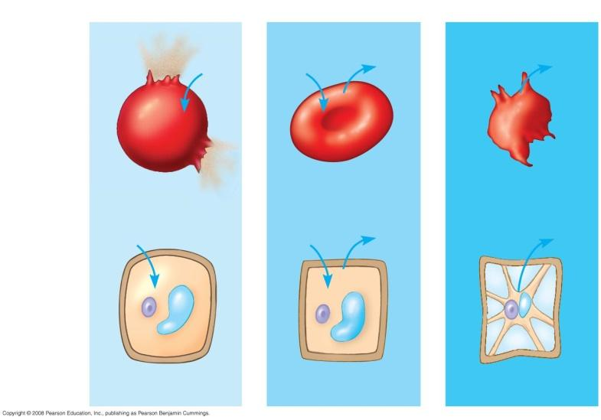

19. Label the hypotonic solution, isotonic solution, and hypertonic solution. What is indicated by the blue arrows? Why doesn’t the plant cell burst like the red blood cell does?

Concept 5.4 Active transport uses energy to move solutes against their gradients
21. Describe active transport. What is the role of ATP in the process?

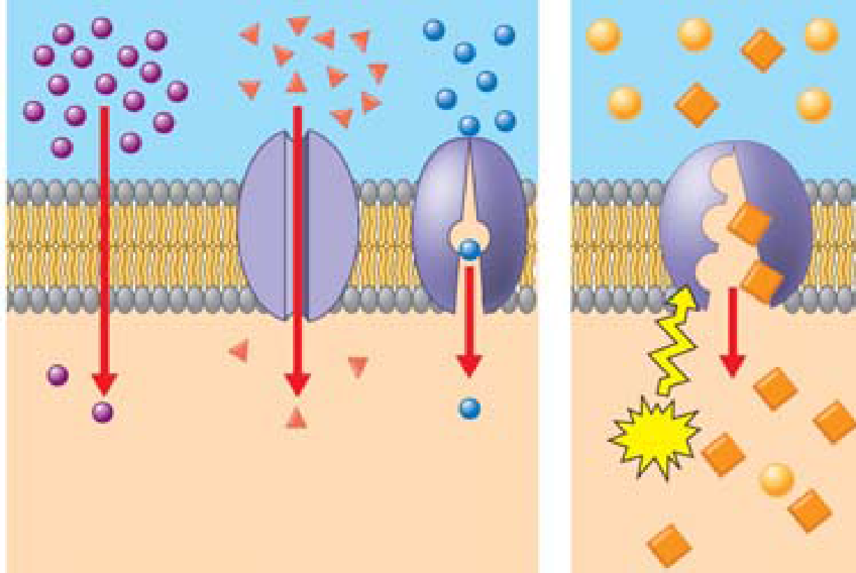
23. On the diagram below, add these labels: facilitated diffusion with a carrier protein, facilitated diffusion with a channel protein, active transport with a carrier protein, simple diffusion. For each type of transport, give an example of a material that is moved in this manner.

24. What is membrane potential? Which side of the cell membrane is positive?

25. What are the two forces that drive the diffusion of ions across the membrane? What is the combination of these forces called?

Concept 5.5 Bulk transport across the plasma membrane occurs by exocytosis and endocytosis
27. Define endocytosis and exocytosis. Are the processes passive or active transport?

