Name_______________________ AP Biology Reading Guide
Fred and Theresa Holtzclaw Copyright © 2010 Pearson Education, Inc.
Chapter 4: A Tour of the Cell

Concept 4.2 Eukaryotic cells have internal membranes that compartmentalize their functions

5. Which two domains consist of prokaryotic cells?

6. A major difference between prokaryotic and eukaryotic cells is the location of their DNA. Describe this difference. What are the other two key differences?

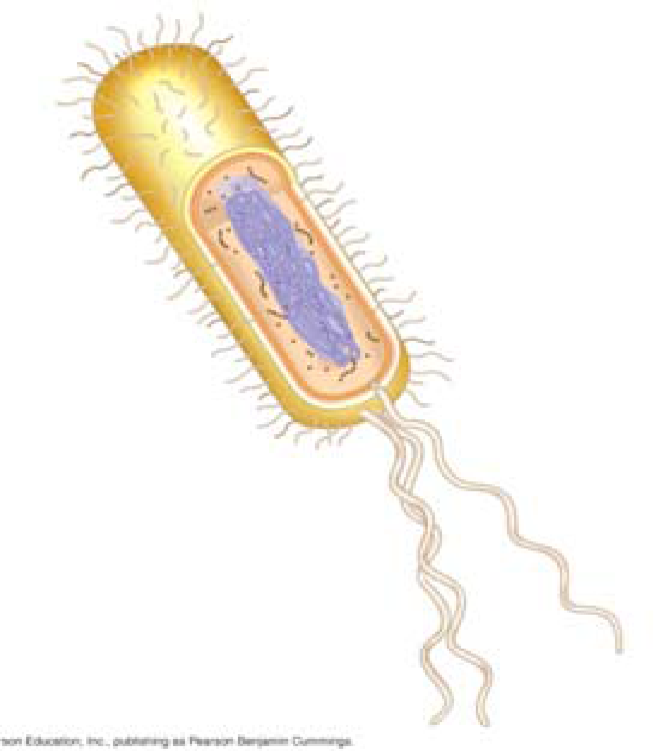
7. On the sketch of a prokaryotic cell, label each of
these features and give its function or description.

cell wall

plasma membrane

bacterial chromosome

nucleoid

cytoplasm

flagella

8. Why are cells so small? Explain the relationship of surface area to volume.

9. Describe how the shape of many neurons and intestinal cells greatly increases surface area.

Concept 4.3 The eukaryotic cell’s genetic instructions are housed in the nucleus and carried out by the ribosomes

10. In the figure below, label the nuclear envelope, and nuclear pores.

11. Describe the nuclear envelope. How many layers is it? What connects the layers?

13. Found within the nucleus are the chromosomes. They are made of chromatin. What are the two components of chromatin? When do the thin chromatin fibers condense to become distinct chromosomes?

14. When are the nucleoli visible? What are assembled here?

16. Ribosomes in any type of organism are the same, but we distinguish between two types of ribosomes based on where they are found and the destination of the protein product made. Complete this chart to demonstrate this concept.
16. Type of Ribosome | Location | Product
free ribosomes
Bound ribosomes

Concept 4.4 The endomembrane system regulates protein traffic and performs metabolic functions in the cell

19. List and describe three major functions of the smooth ER.

21. The rough ER is studded with ribosomes. As proteins are synthesized, they are threaded into the lumen of the rough ER. Some of these proteins have carbohydrates attached to them in the ER to form glycoproteins. What does the ER then do with these secretory proteins?

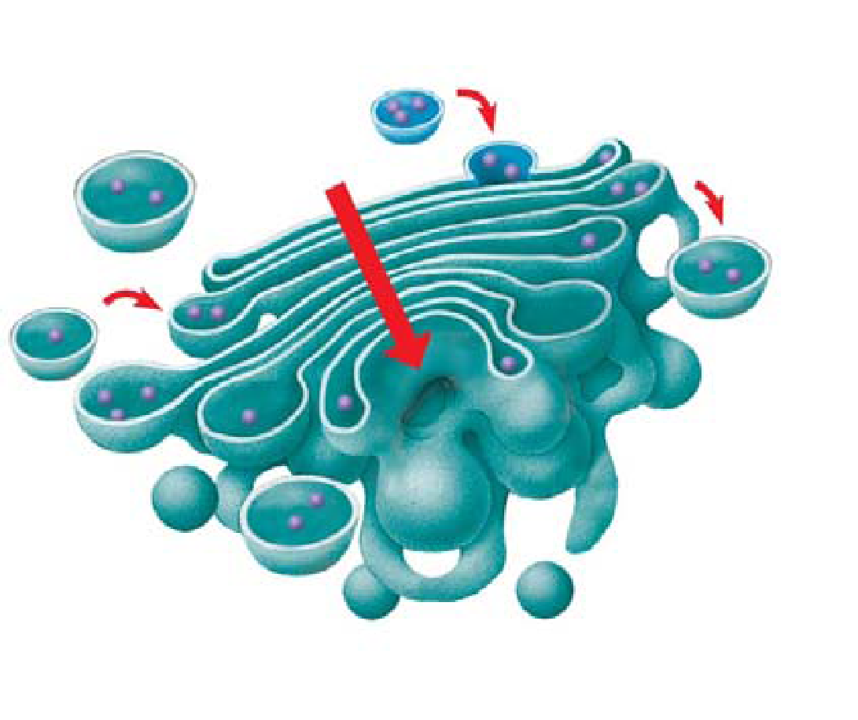

23. The transport vesicles formed from the rough ER fuse with the Golgi apparatus. Use this sketch to label the cisterna of the Golgi apparatus, and its cis and trans faces. Describe what happens to a transport vesicle and its contents when it arrives at the Golgi.

24. What is a lysosome? What do they contain? What is their pH?

28. There are many types of vacuoles. Briefly describe:
food vacuoles

contractile vacuoles

central vacuoles in plants

Concept 4.5 Mitochondria and chloroplasts change energy from one form to another

30. Mitochondria and chloroplasts are not considered part of the endomembrane system, although they are enclosed by membranes. Sketch a mitochondrion here and label its outer membrane, inner membrane, inner membrane space, cristae, matrix, and ribosomes.

32. What is the function of the mitochondria?

33. What is the function of the chloroplasts?

34. Recall the relationship of structure to function. Why is the inner membrane of the mitochondria highly folded? What role do all the individual thylakoid membranes serve? (Increasing surface area!) Chloroplasts and mitochondria both have ribosomes and their own DNA. You will learn later about their evolution, but for now hold onto these facts. They are semiautonomous organelles that grow and reproduce within the cell. And you’re lucky today— there is not a question here!

35. Explain the important role played by peroxisomes.

Concept 4.6 The cytoskeleton is a network of fibers that organizes structures and activities in the cell
36. What is the cytoskeleton?

37. What are two roles of the cytoskeleton?

38. There are three main types of fibers that make up the cytoskeleton. Name them.

39. Microtubules are hollow rods made of a globular protein called tubulin. Each tubulin protein is a dimer made of two subunits. These are easily assembled and disassembled. What are three functions of microtubules?

40. Animal cells have a centrosome that contains a pair of centrioles. Plant cells do not have centrioles. What is believed to be the role of centrioles?

43. Compare and contrast cilia and flagella. (This is a specific instruction that means you are to tell how they are alike—compare—and tell how they are different—contrast. Remember this hint when you see a similar phrase on an exam.)

Concept 4.7 Extracellular components and connections between cells help coordinate cellular activities

47. What are three functions of the cell wall?

53. Animal cells do not have cell walls, but they do have an extracellular matrix (ECM). What are some of the functions of the ECM?

54. What are the plasmodesmata in plant cells? What can pass through them?

55. Animals cells do not have plasmodesmata, but they do have three types of intercellular junctions. Name and describe the function of each.

