Name ____________________________________________________ Fred and Theresa Holtzclaw
AP Biology

Chapter 42-Ecosystems and Energy
42.1 Physical laws govern energy flow and chemical cycling in ecosystems
1) What is an ecosystem?

2) Where does energy enter most ecosystems?

a. How is it converted to chemical energy and then passed through the ecosystem?

b. How is it lost? Remember this: energy cannot be recycled.

6) What is always at the first trophic level?

7) What are detritivores? What is their importance in chemical cycling? Give some examples of detritivores

42.2 Energy and other limiting factors control primary production in ecosystems
8) What is primary production?

a. Distinguish between gross primary production and net primary production.

9) You may recall from Chapter 41 that biomass is the total mass of all individuals in a trophic level. Another way of defining net primary production is as the amount of new biomass added in a given period of time. Why is net primary production, or the amount of new biomass/unit of time, the key measurement to ecologists?

13) What is eutrophication? What are factors that contribute to eutrophication?

42.3 Energy transfer between trophic levels is typically only 10% efficient
14) What is trophic efficiency?

a. Generally, what percentage of energy available at one trophic level is available at the next? ________________ (IMPORTANT!!!!)

15) Consider a food chain with 1,000 joules (an energy unit) available at the producer level. If this food chain is grass → grasshopper →lizard → crow, how much energy is found at the level of the crow? Show your work here.

16) Notice that most biomass pyramids have greatest biomass on the bottom of the pyramid. Label the trophic levels on the figure. Explain why the second pyramid of biomass is inverted. (see figure 42.11 in your text for help)

42.4 Biological and geochemical processes cycle nutrients and water in ecosystems
17) For each of the nutrient cycles identify these key components
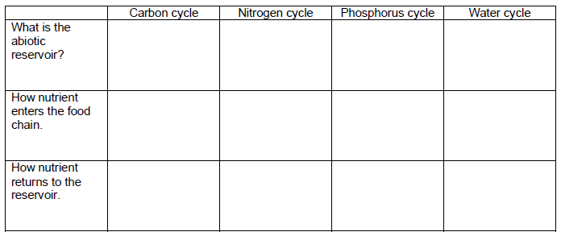

18) What are the two major processes that move carbon through the ecosystem? List their equations also.
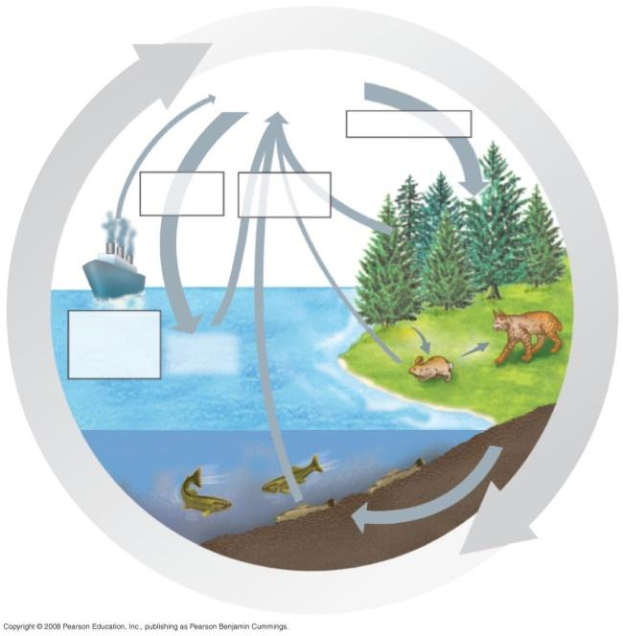
a.

b.

26. Use the following figure to describe the carbon cycle. In doing so, explain how carbon enters the living system and how it leaves, indicate the role of microorganisms in the cycle.

27. Indicate the role of microorganisms in nitrogen fixation, nitrification, and denitrification.

42.5 Restoration ecologists help return degraded ecosystems to a more natural state
28. Explain the roles of bioremediation and bioaugmentation.

