Name ____________________________________________________ Fred and Theresa Holtzclaw
AP Biology

Chapter 41-Species Interactions
41.1 Community interactions are classified by whether hey help, harm, or have no effect on the species involved
1) Define a community. Explain how a community is different from a population.

2) This section will look at interspecific interactions. Be clear on the meaning of the prefix! To begin, distinguish between intraspecific competition and interspecific competition. Give an example of each.

3) What is G. F. Gause’s competitive exclusion principle? Explain how his experiment with the paramecium shows this principle.

4) Define ecological niche. What is the difference between the fundamental niche and the realized niche?

6) What is herbivory? Describe several defense mechanisms to predation that have evolved in plants.

9) Define and give an example of the following animal defenses:
a. Cryptic coloration:

ex.

b. Aposematic :

ex.

c. Batesian mimicry:

ex.

d. Mullerian:

ex.
10) Fill out the chart below:
Type of interaction | Description | Example | +/+, +/–, –/–, +/0
Parasitism

commensalism

mutualism

41.2 Diversity and trophic structure characterize biological communities
11) What is species diversity? What are its two components? Why is it important?

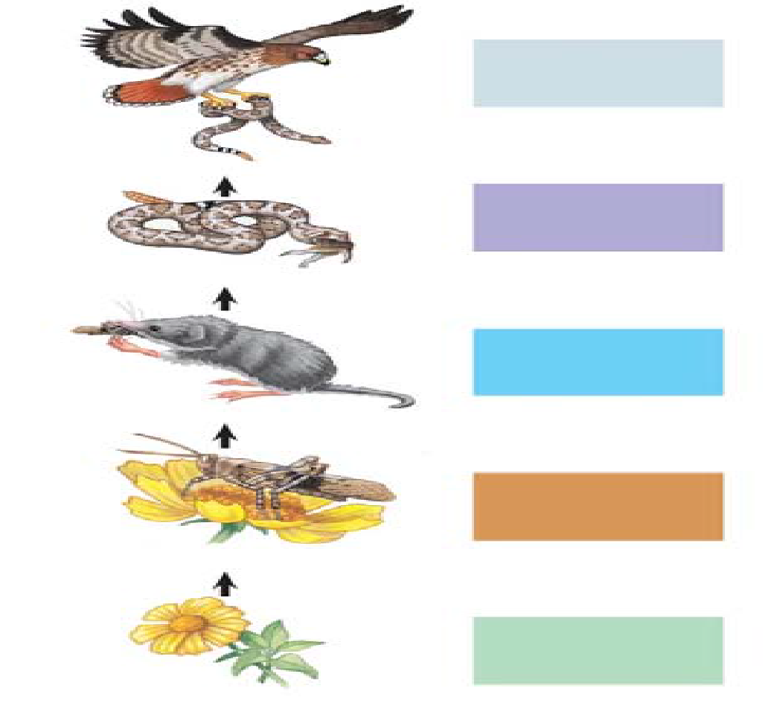
12) For the organisms in the pictured food chain, and label with the following terms:. (some may be used more than once or not at all) producer, consumer, decomposer, autotroph, heterotroph, carnivore, herbivore, omnivore etc.

13) According to the energetic hypothesis, why are food chains limited in length? How much energy is typically transferred to each higher level?

14) How is a keystone species different from a dominant species?

41.3 Disturbance influences species diversity and composition
17) Ecological succession is the changes in species that occupy an area after a disturbance. What is the difference between primary succession and secondary succession?

41.4 Biogeographic factors affect community diversity
18) Explain latitudinal gradients in terms of species richness. Where is species richness greatest?

19) Renowned American ecologists Robert MacArthur and E. O. Wilson developed a model of island biogeography. While the model can be demonstrated with islands, any isolated habitat represents an island. What are the two factors that determine the number of species on the island?

