Name _____________________________________________ Fred and Theresa Holtzclaw
AP Biology
Chapter 40-Population Ecology and the Distribution of Organisms

40.1 Earth’s climate influences the distribution of terrestrial biomes
1) Define the terms:
a. ecology

b. microclimate

8. What is climate? What abiotic factors are its components?

9) What is a biome?

14) Figure 10.1 on page 278 in the Review Book shows a climograph for some major biomes in North America. What two abiotic factors shown here are most important in determining the distribution of the biome?

40.2 Aquatic biomes are diverse and dynamic systems that cover most of Earth
11) Identify factors that are significant to organism distribution and abundance in a lake.

13) What is the difference between a lake that is oligotrophic and one that is eutrophic? (see p. 850 in your text)

40.3 Interactions between organisms and the environment limit the distribution of species
4) Define the following terms and give 3 examples for each.
a. abiotic:

examples:

b. Biotic:

examples:

40.4 Biotic and Abiotic factors affect population density, dispersion, and demographics
1) What two pieces of data are needed to mathematically determine density?

2) What is the difference between density and dispersion?
3) Try the following problem.
A population ecologist wished to determine the size of a population of white-footed deer mice, Peromyscus leucopus, in a 1-hectare field. Her first trapping yielded 80 mice, all of which were marked with a dab of purple hair dye on the back of the neck. Two weeks later, the trapping was repeated. This time 75 mice were trapped, out of which 48 of the mice were marked. Using the formula below, what is the population of mice in the field? Show all Work!!!
# marked originally
Total population
# recaptured
# of recaptured marked
=
Proportion: ratio of what was caught to total population is the same as the ratio of the recaptured that were marked, with the recaptured total

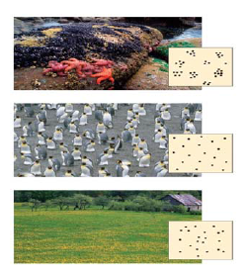
4) Label the dispersion pattern shown by each population in the figure below. Second, and most important, what do the dispersion patterns tell us about the population and its interactions?

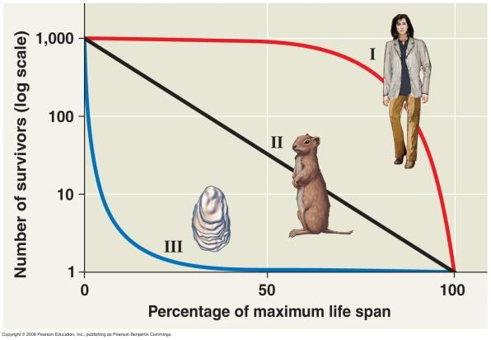
7) Compare the survival strategies of species and give an example of each type.
Type I

Type II

Type III

40.5 The exponential model describes population growth in an idealized, unlimited environment
14) What are two examples of conditions that might lead to exponential population growth in natural populations?

15) What is carrying capacity?

17) In the logistic population growth model, the per capita rate of increase approaches zero as the __________________________ is reached.

19) Explain why the exponential growth curve produces a “J-shaped” curve instead of a straight line.
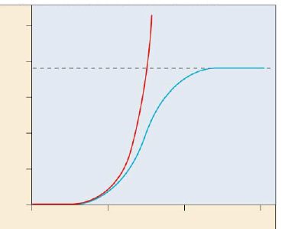
21) Label the graph illustrating the two models of population growth.

22) What happens to a population when the number of individuals approaches carrying capacity?

40.6 Population dynamics are influenced strongly by life history traits and population density
24) Compare K-selected to r-selected species. Give examples of each.
K-selected:

r-Selected:

25) Compare and contrast these two terms and list some examples:
density-independent regulation

density-dependent regulation

