Name: ___________________ AP Biology Reading Guide
Fred and Theresa Holtzclaw

Chapter 3B: Macromolecules

Concept 3.2 Macromolecules are polymers, built from monomers.
3. What is a polymer?

a monomer?

4. Monomers are connected in what type of reaction? What occurs in this reaction?

5. Large molecules (polymers) are converted (broken down) to monomers in what type of reaction?

6. The root words of hydrolysis will be used many times to form other words you will learn this year. What does each root word mean?

hydro–

lysis—

Concept 3.3 Carbohydrates serve as fuel and building material
8. Let’s look at carbohydrates, which include sugars and starches. First, what are the monomers of all carbohydrates? What is the name of the link that binds the monomers together?

9. Most monosaccharides are some multiple of (CH2O). For example, ribose is a 5-carbon sugar with the formula C5H10O5. It is a pentose sugar. (From the root penta–, meaning 5.) What is the formula of a hexose sugar?

18. There are two main functions of polysaccharides. Identify them and give examples.
Function of Polysaccharide | Examples

19. Why can you not digest cellulose? What organisms can?

Concept 3.4 Lipids are a diverse group of hydrophobic molecules
21. Lipids include fats, waxes, oils, phospholipids, and steroids. What characteristic do all lipids share?

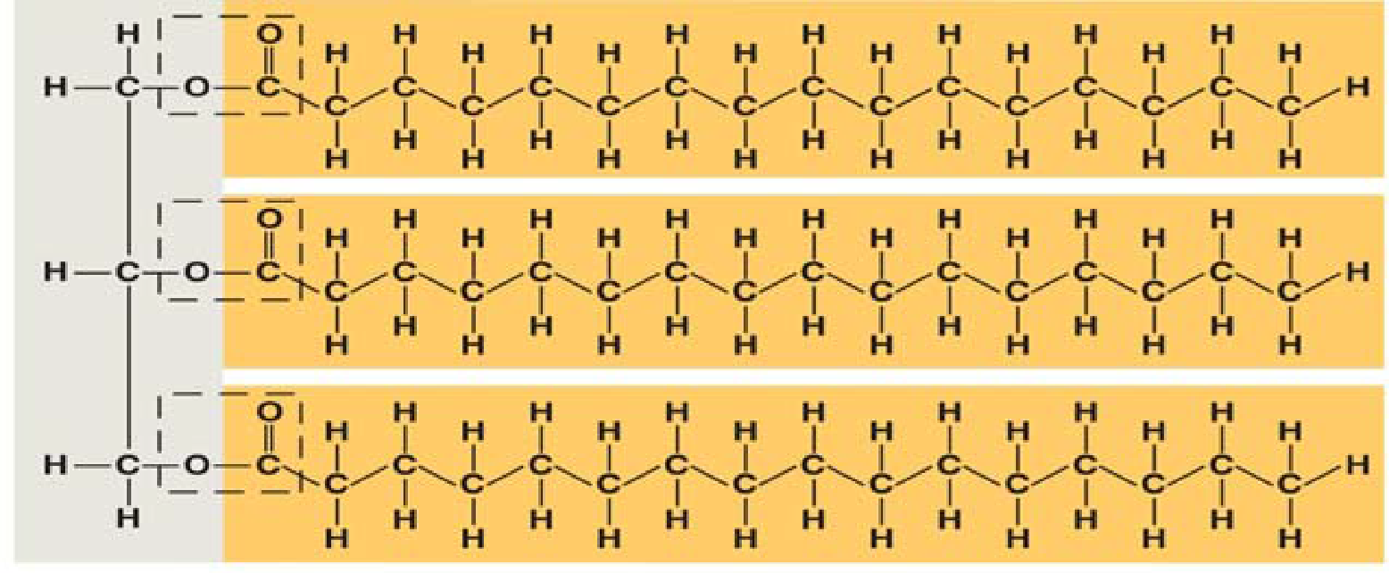
22. What are the building blocks of fats? Label them on this figure.

23. If a fat is composed of 3 fatty acids and 1 glycerol molecule, how many water molecules will be removed to form it? Again, what is this process called?

24. On the figure with question 22, label the ester linkages.

26. Define and name two saturated fats.

27. Define and name two unsaturated fats.

28. Why are many unsaturated fats liquid at room temperature?

30. List two important functions of lipids.
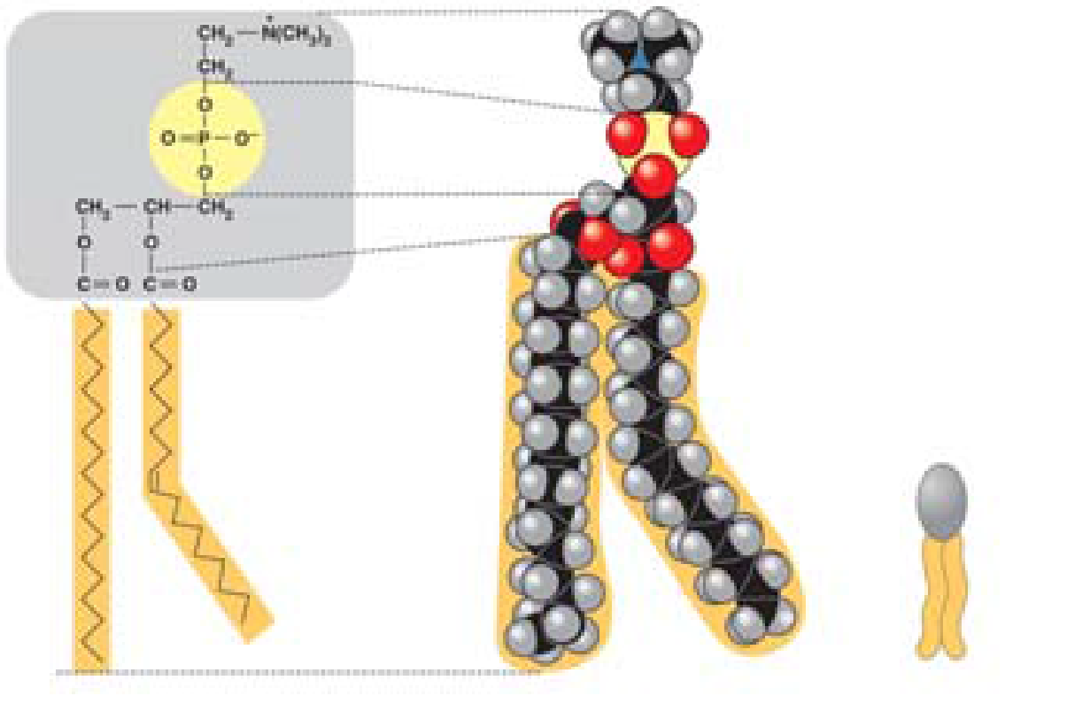

31. Here is a figure that shows the structure of a phospholipid. Label the sketch to show the phosphate group, the glycerol, and the fatty acid chains. Also indicate the region that is hydrophobic and the region that is hydrophilic.

32. Why is the “tail” hydrophobic?

33. Which of the two fatty acid chains in the figure with question 31 is unsaturated? Label it. How do you know it is unsaturated?

34. What do all steroids have in common and what are three examples of steroids?

Concept 3.5 Proteins have many structures, resulting in a wide range of functions

41. The monomers of proteins are amino acids. Sketch an amino acid in the box (like the sketch on the bottom of p. 56 in your text.Label the alpha or central carbon, amino group, carboxyl group, and R group.

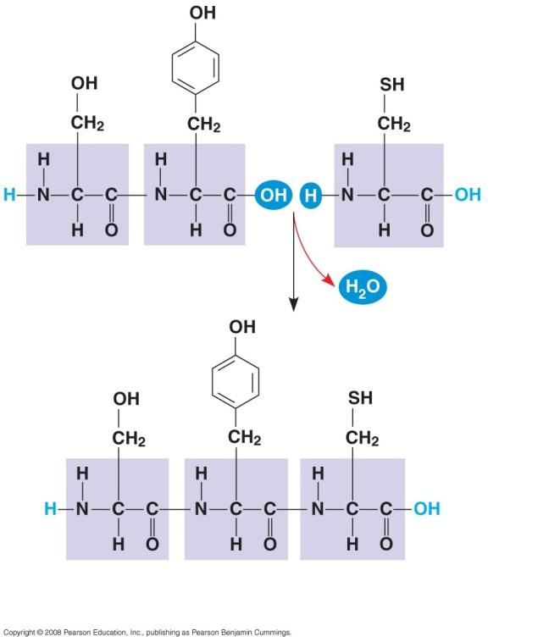
44. Define these terms:
dipeptide

polypeptide

peptide bond

Label each of these terms on the
diagrams.

45. There are four levels of protein structure. Refer to Figure 3.22, and summarize each level in the following table.
Level of Protein Structure | Explanation
Primary
Secondary
(Alpha helix or Beta pleated sheet)
Tertiary
Quaternary

46. Label each of the levels of protein structure on this figure.
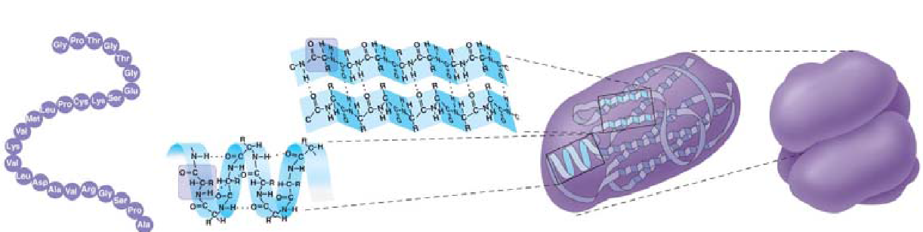
49. Besides mutation, which changes the primary structure of a protein, protein structure can be changed by denaturation. Define denaturation, and give at least three ways a protein may become denatured.

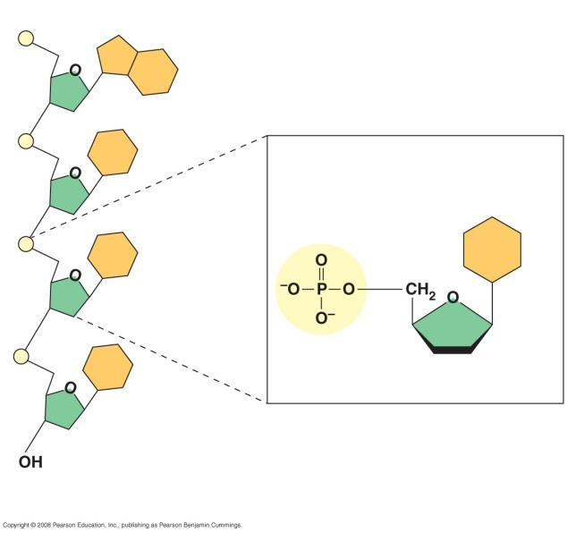
Concept 3.6 Nucleic acids store and transmit hereditary information

52. What are the three components of a nucleotide?. Label each on the figure to the right.

54. Notice that there are five nitrogen bases. Which four are found in DNA?

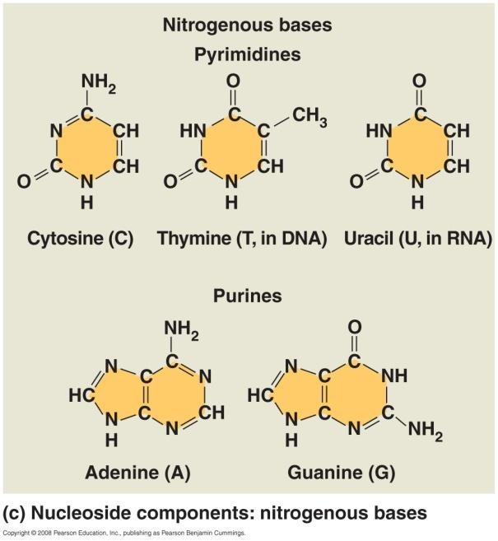
55. Which four are found in RNA?

56. What is the function of DNA? Of RNA?

57. What type of bond holds the nitrogenous bases together in the double helix of DNA?

