Name: ___________________ AP Biology Reading Guide
Fred and Theresa Holtzclaw

Chapter 3A: Carbon and the Molecular Diversity of Life

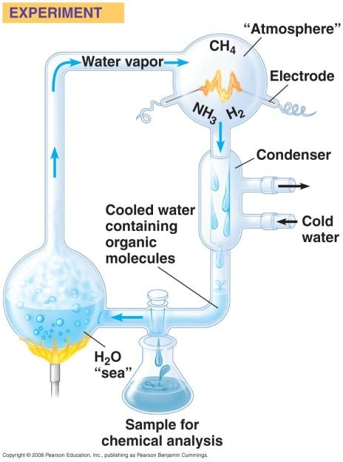
Concept 4.1 Organic chemistry is the study of carbon compounds (from Miller-Urey Experiment: Campbell Biology chapter 4)

1. Study this figure of Stanley Miller’s experiment to simulate conditions thought to have existed on the early Earth. Explain the elements of this experiment, using arrows to indicate what occurs in various parts of the apparatus.

2. What was collected in the sample for chemical analysis? What was concluded from the results of this experiment?

Concept 3.1 Carbon atoms can form diverse molecules by bonding to four other atoms

3. Make an electron distribution diagram of carbon. It is essential that you know the answers to these questions:

a. How many valence electrons does carbon have?

b. How many bonds can carbon form?

c. What type of bonds does it form with other elements?

4. What is an isomer and what is an example of isomers?

11. There are seven functional groups. Complete the following chart which includes 6 of them.

Functional Group | Structure | Properties: hydrophobic or hydrophillic? form Hydrogen bonds? uses? What macromolecules are they found on? (This last question will be easier to answer after you do the 3B notes.)
Hydroxyl
Carboxyl
Amino
Phosphate
Sulfhydryl
Methyl

