Name:__________________________________ Fred and Theresa Holzclaw
AP Biology
Chapter 39-Motor Mechanisms and Animal Behavior

39.3 Discrete sensory inputs can stimulate both simple and complex behaviors
- How is behavior defined?

6. What is a fixed action pattern (FAP)? Give an example.

7. What is a sign stimulus?

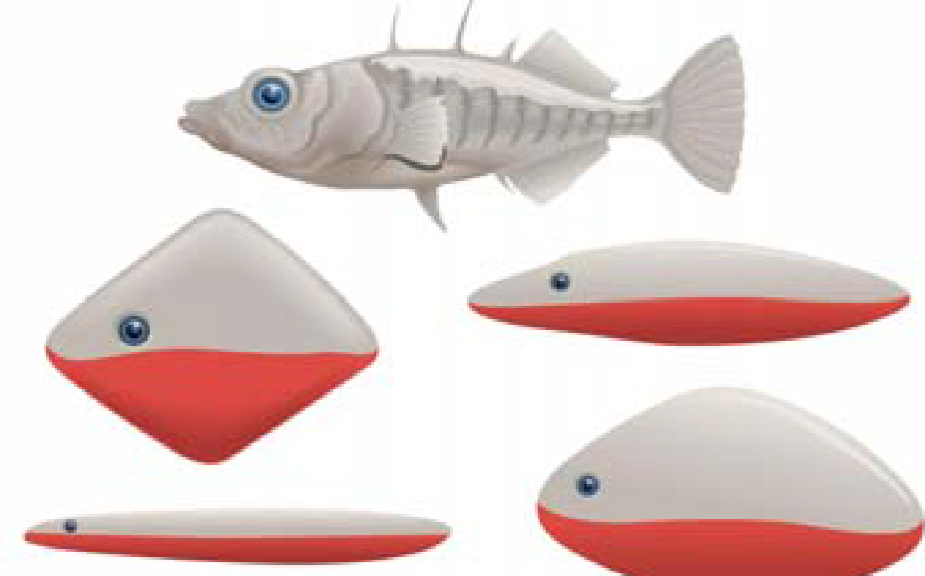

8. Nicholas Tinbergen’s work with the stickleback fish is a classic study. Explain what he found. Use the terms fixed action pattern and sign stimulus in your response.

10. Explain what is meant by circadian rhythms. Identify two behaviors, either plant or animal, that demonstrate a circadian rhythm. (You may need to refer to previous chapters for examples.)

11. Discuss two navigational strategies used by birds to migrate.

12. Animals communicate with various signals that lead to a response. (The signal-response is an important concept to remember.) Discuss two specific examples using different organisms.

39.4 Learning establishes specific links between experience and behavior
16. What is the difference between innate and learned behavior? Give an example of each.

18. Describe the process of imprinting, and explain what is meant by sensitive or critical period.

39.5 Selection for individual survival and reproductive success can explain diverse behaviors
29. What is proposed by the optimal foraging theory? Explain it in terms of cost and benefit, and cite two examples from your text.

31. Explain each of these mating systems:
promiscuity
monogamy

polygamy

39.6 Genetic analysis and the concept of inclusive fitness provide a basis for studying the evolution of behavior
37. Explain the evolutionary advantage to a population of having members who exhibit altruistic behavior.

38. Altruism may reduce the fitness of an individual—for example, by making that individual more obvious to a predator. Explain this behavior using the concept of inclusive fitness.

39. Explain the logic behind geneticist J.B.S. Haldane’s comment that he would lay down his life for two brothers or eight cousins.

2010 Pearson Education, Inc.

