Name: ____________________________________ Fred and Theresa Holtzclaw
AP Biology
Chapter 38: Nervous and Sensory Systems
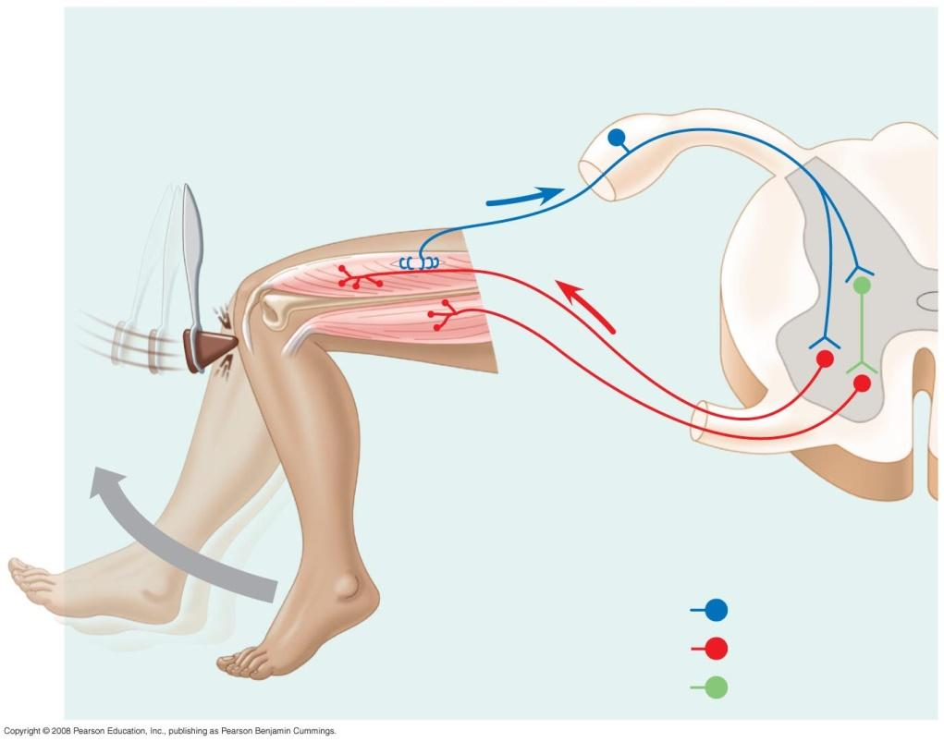
6. A reflex arc is illustrated and explained in this figure. It is important for you to understand this pathway, so take some time with the figure below. Label the following: stimulus, receptors (sensors), sensory neuron, interneuron, spinal cord, gray matter, white matter, motor neuron, effector (muscle).
*Describe the benefit of reflex arcs. (Use your review book page 260 to answer.)

7. What is the function of cerebrospinal fluid in mammals? Where is it found?

10. What makes up the peripheral nervous system (PNS)? What is the function of the PNS?

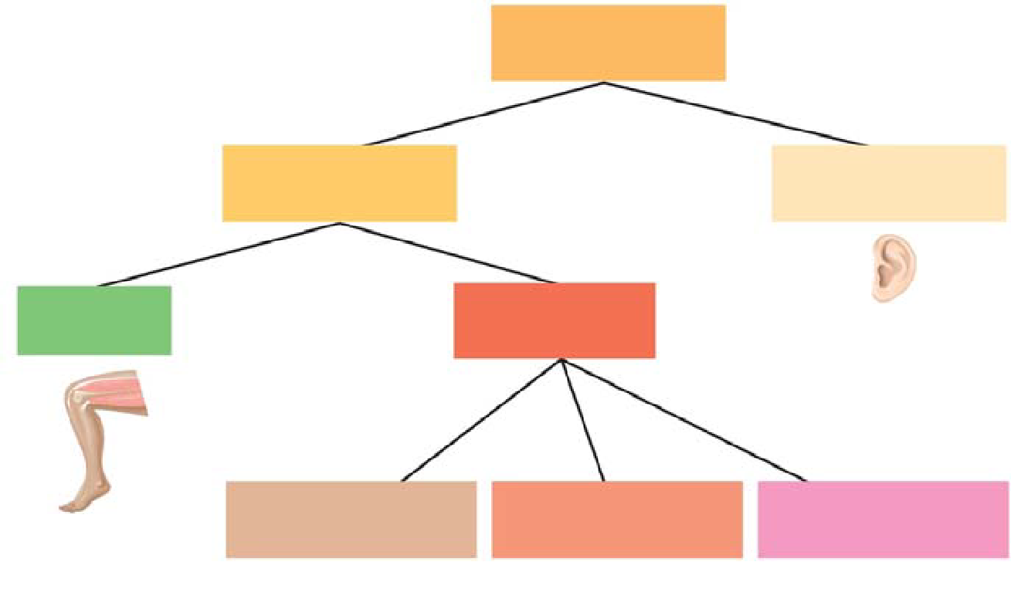
12. The figure shows the branches of the peripheral nervous system. Label these branches. Which branch is sometimes called the “voluntary nervous system”? Which one is often termed “involuntary?” Include these terms on the diagram.

13. What would be the effect of stimulation by the sympathetic nervous system on heart rate?

What would be the effect of stimulation by the parasympathetic nervous system on peristalsis?

38.2 The vertebrate brain is regionally specialized

