Name: ____________________________________ Fred and Theresa Holtzclaw
AP Biology
Chapter 35: The Immune System
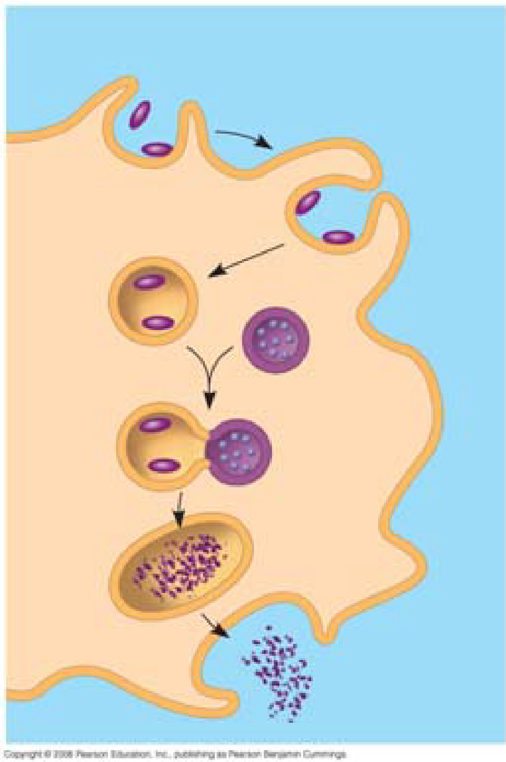
35.1 In innate immunity, recognition and response rely on traits common to groups of pathogens
1. We first encountered phagocytosis in the 1st semester, but it plays an important role in the immune systems of both invertebrates and vertebrates. Review the process by briefly explaining the six steps to ingestion and destruction of a microbe by a phagocytic cell.

8. Explain the role of the following two antimicrobial compounds.
Interferon

Complement

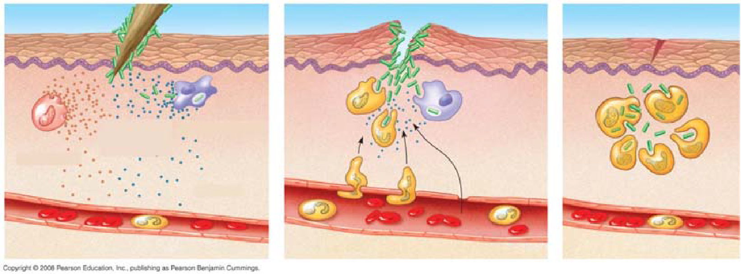
9. Use the following figure to explain the three steps of an inflammatory response.

35.2 In adaptive immunity, receptors provide pathogen-specific recognition
12. From the first four paragraphs of this concept, summarize where T cells and B cells develop, and give an overview of their functions. (Note that they are a type of white blood cell known as a lymphocyte.)

14. Explain how cytokines help coordinate the innate and acquired immune responses.

15. The following brief questions will serve as a primer for immune system recognition.
a. What is an antigen?

19. T cells also display only one type of antigen receptor on the surface of the cell. Compare and contrast a T cell with a B cell.

20. B-cell receptors recognize and bind to antigens whether they are free antigens (like a secreted toxin) or on the surface of a pathogen. Explain the role of the major histocompatibility complex (MHC) to T-cell receptor binding.

27. Define the following terms.
Effector cells (AKA Plasma Cells)

Memory cells

Clonal selection

21. Explain how an infected host cell uses the MHC molecule to display an antigen.

29. Graphs similar to the following have been seen on several AP Biology exams. It depicts the primary and secondary immune response. The first arrow shows exposure to antigen A. The second arrow shows exposure to antigen A again, and also antigen B. Label this graph and then use it to explain the difference between a primary and secondary immune response.

35.3 Adaptive immunity defends against infection of body fluids and body cells
30. Explain fully the function of the two divisions of acquired immunity.
Humoral immune response

Cell-mediated immune response

c. How is an epitope related to an antigen?

31. Helper T cells play a critical role in activation of both T cells and B cells. In full detail, label and explain the three steps involved using Figure 35.13. This is an important step!
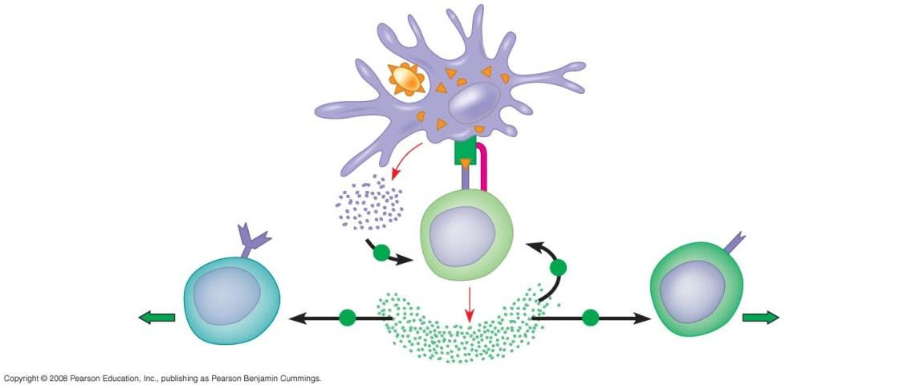

42. Using examples, explain the difference between active and passive immunity.

43. Describe how immunizations can serve as an example of active immunity.

45. Briefly describe the following features of immune rejection.
a. Explain how antibodies against blood types are present.

b. What is the role of MHC in tissue and organ transplants?

46. What are allergies?

49. Autoimmune diseases occur when the immune system turns against particular molecules of the body. Describe the cause and symptoms of the following autoimmune diseases.
Lupus

Type 1 diabetes mellitus

Multiple sclerosis

51. Just as our immune system has evolved to thwart pathogens, pathogens have evolved to thwart our immune system. Describe the following pathogen strategies.
Attack on the immune system: HIV

52. Explain how the high mutation rate in surface antigen genes in HIV has hampered development of a vaccine for AIDS. (You might take note that HIV—human immunodeficiency virus—is the virus that causes the disease AIDS—acquired immunodeficiency syndrome. These acronyms are often used incorrectly.)

