Name: ________________________________ Fred and Theresa Holtzclaw
AP Biology
Chapter 32: The Internal Environment of Animals: Organization and Regulation

32.1 Animal form and function are correlated at all levels of organization
3. What is a tissue?

32.2 The endocrine and nervous systems act individually and together in regulating animal physiology
1. What is a hormone?

2. Why does a hormone elicit a response only with target cells?

8. Recall that target cells have receptors for specific hormones. Where are the receptors for lipid-soluble hormones found?

9. Where are the receptors for the water-soluble proteins found? Explain this difference for the two types of hormones.

18. Throughout this course, we have emphasized feedback loops. What occurs in a negative feedback loop?

19. Complete the following chart for this pair of antagonistic hormones.
Hormone | Secreted by | Action
Insulin
glucagon
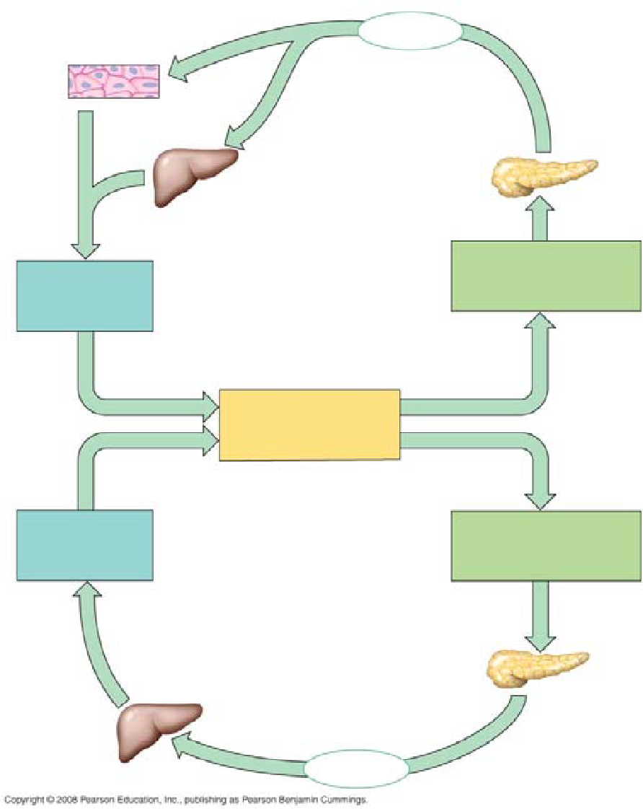
20. On the AP Biology exam, you will be expected to explain a feedback loop. Use this figure to explain the control of blood glucose by insulin and glucagon. This is a commonly used example, and one you should know.

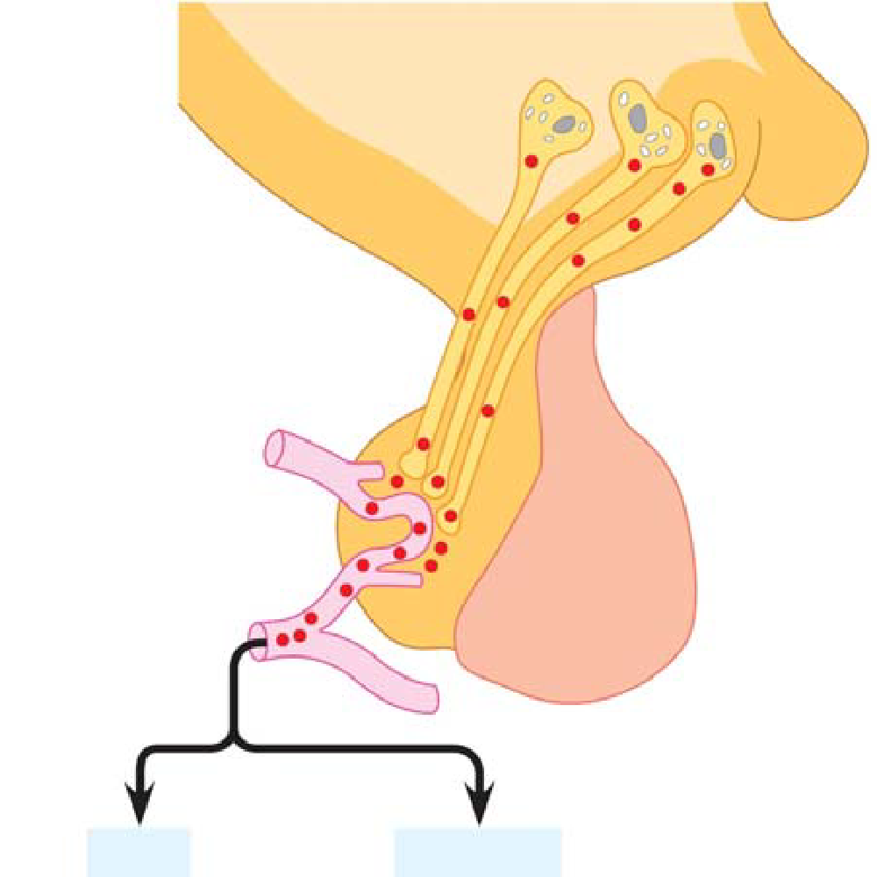
24. The hypothalamus directly secretes hormones that travel to the posterior pituitary and regulating hormones that affect secretions of hormones by the anterior pituitary. On this sketch, label hypothalamus, anterior pituitary, and posterior pituitary and the two hormones secreted from the posterior pituitary and list the hormones secreted by the anterior pituitary.

Anterior pituitary hormones

27. Let’s pull out a few more details from this section. How is oxytocin an example of a hormone that is under positive regulation?

29. What two hormones are antagonistic controllers of blood calcium levels?

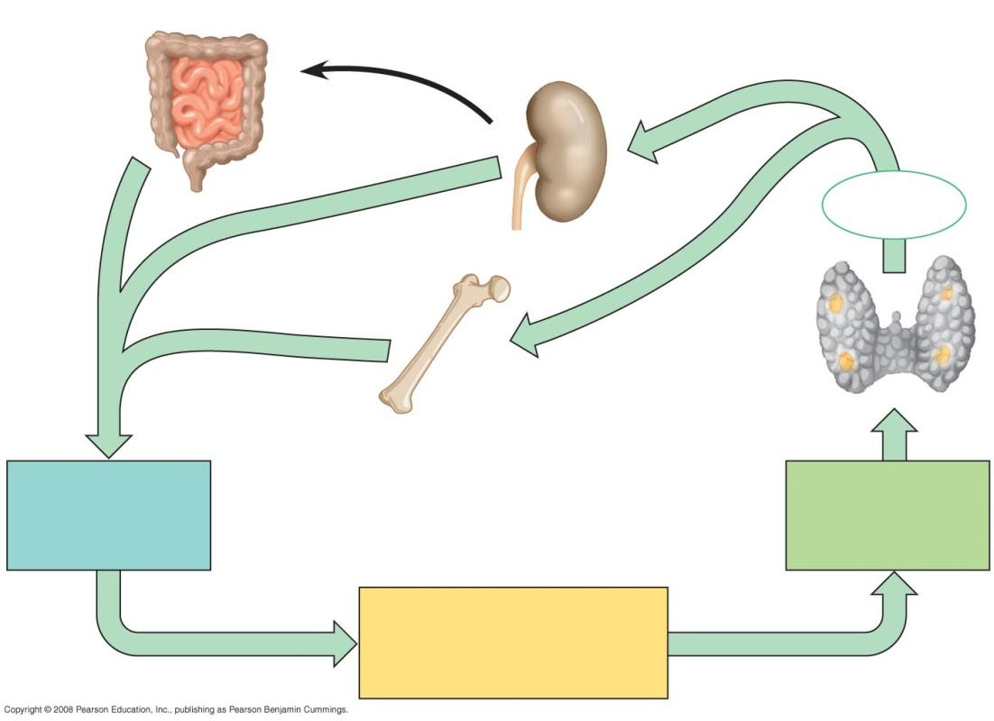

30. How does parathyroid hormone (PTH) raise blood calcium? (three ways)

31. Fill in the following chart to explain the regulation of blood calcium levels.

32.3 Feedback control maintains the internal environment in many animals
7. Throughout the text, a common theme has been regulation of homeostasis by feedback loops. We discuss feedback loops again as we look at hormone levels. What is meant by a set point?

8. Describe an example of a negative feedback loop. Clearly identify the set point, the stimulus, and the response.

9. We sometimes say that in negative feedback “more gets you less,” and in positive feedback “more gets you more.” Describe an example of a positive feedback loop.

10. What is thermoregulation?

11. Describe the difference between endothermy and ectothermy, and give an animal that exhibits each.
Property | Description | Example
Endothermy
Exothermy
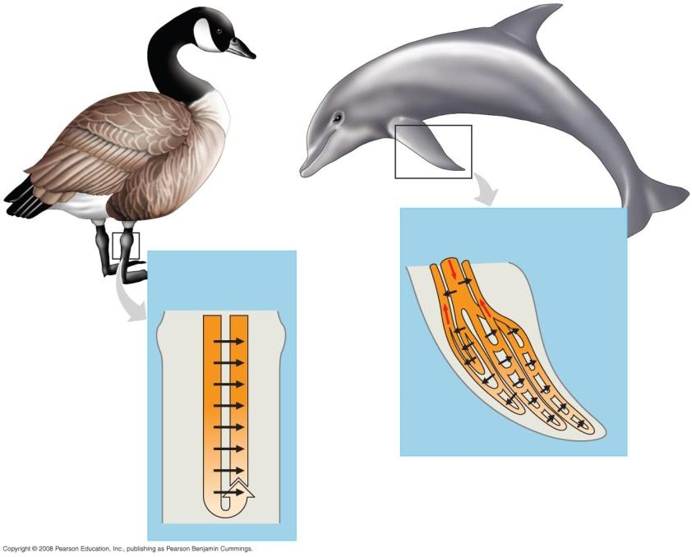

14. Heat loss in extremities is reduced by countercurrent exchange. Use this figure (32.15) to explain how countercurrent exchange works.

15. Use the terms set point, stimulus, and response when describing how a home thermostat works.

32.4 A shared system mediates osmoregulation and excretion in many animals
1. Define these two terms.
Osmoregulation

Excretion

2. Why are nitrogenous wastes associated with nucleic acids and proteins, but not with lipids or
carbohydrates?

32.5 The mammalian kidney’s ability to conserve water is a key terrestrial adaptation
3. What is a nephron?

11. The basic process of excretion usually requires four steps. Label and explain the four processes in
Figure 9.4 (page 246 in your review book).
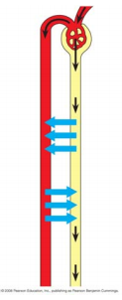
24. Explain the role of antidiuretic hormone (ADH) in maintaining blood osmolarity.

