Name: ____________________________ AP Biology Reading Guide
Fred and Theresa Holtzclaw

Chapter 2A: The Chemical Context of Life

Concept 2.1 Matter consists of chemical elements in pure form and in combinations called compounds

1. Define and give an example of the following terms:
matter

element

compound

2. What four elements make up 96% of all living matter?

3. What is the difference between an essential element and a trace element?
essential element

trace element

Concept 2.2 An element’s properties depend on the structure of its atoms
4. Sketch a model of an atom of helium, showing the electrons, protons, neutrons, and atomic nucleus.

5. What is the atomic number of helium? _________ Its atomic mass? ________

6. Here are some more terms that you should firmly grasp. Define each term.
neutron

proton

electron

atomic number

atomic mass

isotope

8. Which is the only subatomic particle that is directly involved in the chemical reactions between atoms?

15. What type of bond is seen in O2? (covalent or ionic) Explain what this means.

16. What is meant by electronegativity?

17. Explain the difference between a nonpolar covalent bond and a polar covalent bond.

19. Another bond type is the ionic bond. Explain what is happening in the figure below (2.14):

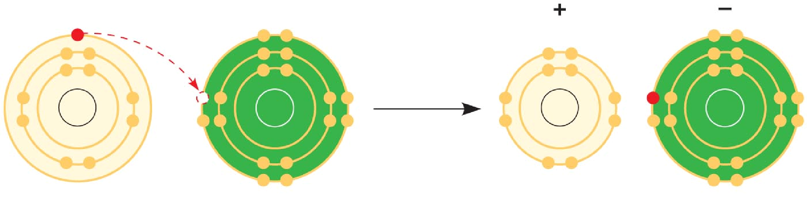

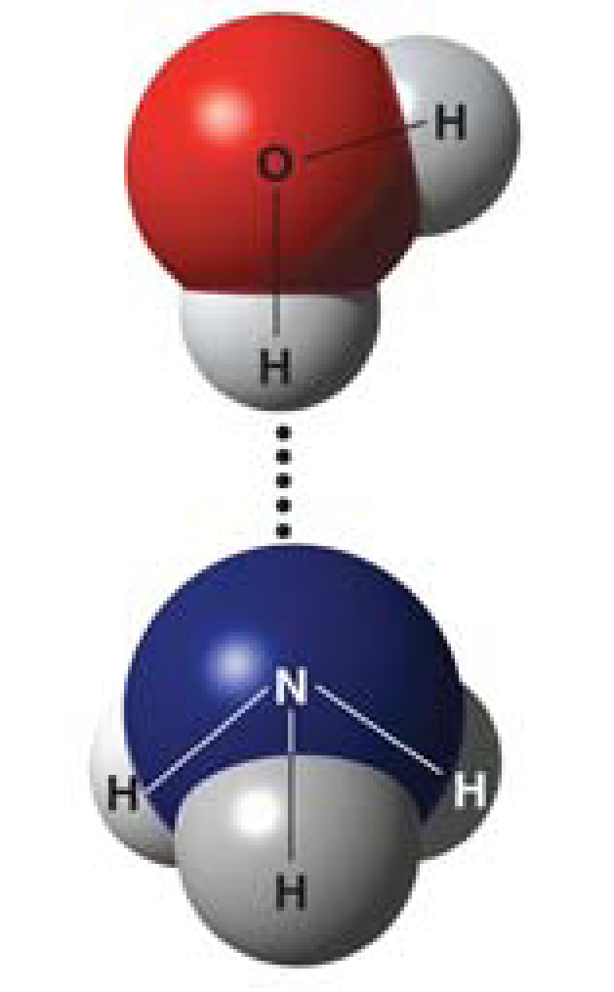
22. What is a hydrogen bond? Indicate where the hydrogen bond occurs in this figure.

23. Explain van der Waals interactions. Though they represent very weak attractions, when these interactions are numerous they can stick a gecko to the ceiling!

24. Here is a list of the types of bonds and interactions discussed in this section. Place them in order from the strongest to the weakest: hydrogen bonds, van der Waals interactions, covalent bonds, ionic bonds.

STRONG WEAK

26. Write the chemical shorthand equation for photosynthesis. Label the reactants and the products.

27. Describe chemical equilibrium.

