Name ____________________________________________ Fred and Theresa Holtzclaw
AP Biology
Unit 8-Plant Form and Function (Chapters 28-31)

29.2 Different mechanisms transport substances over short or long distances
22. Define these terms:
flaccid

turgid

plasmolysis

26. What is bulk flow?

Concept 29.5 Transpiration drives the transport of water and minerals from roots to shoots via the xylem
Explain the cohesion-tension hypothesis.

Concept 29.6 The rate of transpiration is regulated by stomata
20) Leaves generally have large surface areas and high surface-to-volume ratios. Give an advantage and disadvantage of these traits.
advantage

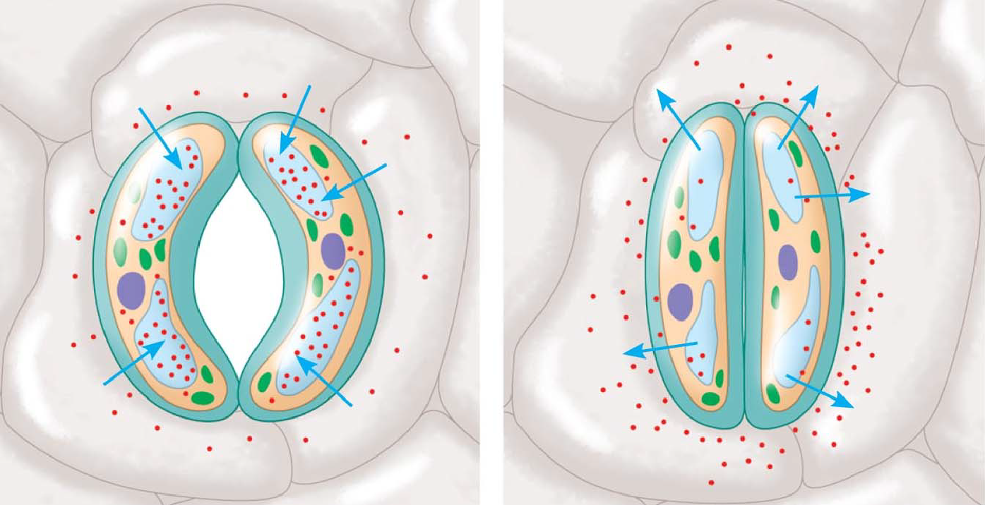
disadvantage

35. On the sketches, label the guard cell, stomata, K+, and H2O. Explain why the stoma opens when K+ accumulates in the guard cells.

36. Three types of stimuli can cause guard cells to open. Name and explain how each one works.
Stimulus for Stomatal Opening and Closing | Explanation
Concept 31.1 Plant hormones help coordinate growth, development, and responses to stimuli
21) Both plants and animals have hormones. The definition of a hormone has three parts. What are they, and how do they fit into the signal transduction pathway model?

22) What is a tropism?

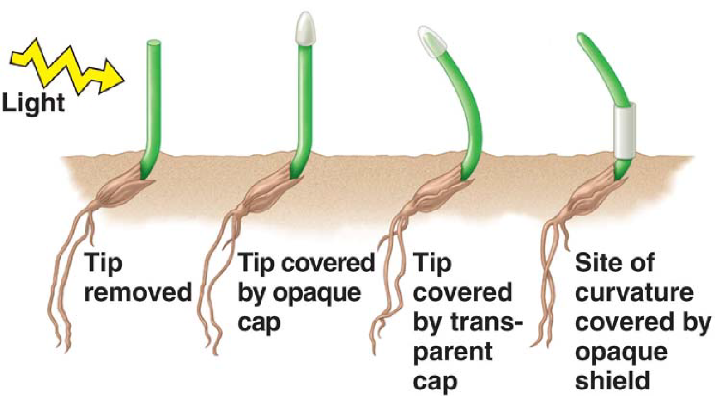
23) The sketch below describes early experiments on phototropism conducted by Charles and Francis Darwin. What can be concluded from these experiments?

26) In jest, we tell our students that when in doubt about which plant hormone causes which plant response, just answer auxin. Auxin has so many functions, this answer often works. List and describe three functions of auxin.
Auxin Functions | Description
31.2 Responses to light are critical for plant success
24. What color light is absorbed by phytochromes?

25. What are two different responses initiated by blue light?

31) What is a circadian rhythm? Give one plant example and one human example.

33. Plants detect photoperiod, and in many species it affects their time of flowering. Explain each of the following, and give an example of a plant that is in the group.
short-day plant

long-day plant

day-neutral plant

31.3 Plants respond to a wide variety of stimuli other than light
32) What is gravitropism? How may a plant detect gravity?

37. What is thigmotropism? How is it adaptive?

