Name ____________________________________________ Fred and Theresa Holtzclaw
AP Biology

Chapter 27--The Rise of Animal Diversity (Invertebrates and Vertebrates)

27.1 Animals are multicellular, heterotrophic eukaryotes with tissues that develop from embryonic layers
2. What two types of specialized cells do only animals have?

3. Most animals reproduce __________________, and the ____________________stage dominates
the life cycle.

7. All eukaryotes have sets of regulatory genes containing common sets of DNA sequences called
homeoboxes. What are the unique homeobox genes of animals called?

27.3 Animals can be characterized by “body plans”
8. Which animal group lacks symmetry?___________________________________

9. Two types of symmetry are seen in all other animal groups. Name and describe them in words or
with a sketch.

11. Animals that have bilateral symmetry have a front and rear. Draw a sketch of a cat, and label these
regions: anterior, posterior, dorsal, and ventral.

18. Now we are going to move into a discussion that many students find confusing. Pay close
attention! What is a coelom?

Invertebrates
4. Most sponges are hermaphrodites. What does this mean?

7. Cnidarians are diploblastic and have radial symmetry. Explain what this means, you may use a sketch to help.

8. Platyhelminthes means “flatworm,” which describes the shape of these worms. This is the first phylum we are studying that is triploblastic. What does this mean?

30. The only way an arthropod can grow is to shed its chitinous exoskeleton. What is this shedding process called?

43. As adults, many echinoderms appear to have radial symmetry, but their larval stage is bilateral. This is an important feature to note. As you read this section, what other interesting facts do you find about members of this group?

3. Here is a figure showing the four key chordate characteristics. Label and explain each one.
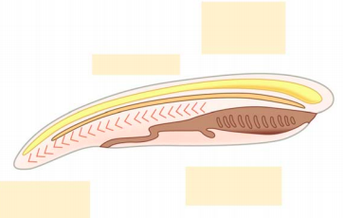

Vertebrates
13. What does the name Chondrichthyes mean? What material makes up their skeleton?

15. The “fishes” with a bone skeleton are aquatic Osteichthyes. How do they breathe?

18. What animals are in the class Amphibia?

23. What factors tie amphibians to a life near water?

29. What is the body covering of a reptile? How does this enable it to live a more terrestrial life?

36. There are three groups of mammals. Contrast the groups based on how they bear young, and give
an example.
Mammalian Group | Reproduction | Example
Monotremes

Marsupials

Eutherians

