Name ____________________________________________ Fred and Theresa Holtzclaw
AP Biology
Chapter 24—Early Life and the Diversification of Prokaryotes

24.1 Conditions on early Earth made the origin of life possible
1) How old is the planet? __________ How old is the earliest evidence of life on Earth? ____________

2) The current theory of the origin of life suggests a sequence of four main stages. Summarize them here.

3) What was the early atmosphere like?

4) A. I. Oparin and J. B. S. Haldane hypothesized that the early atmosphere was a reducing environment. What did they suggest was the source of energy for the early organic synthesis?

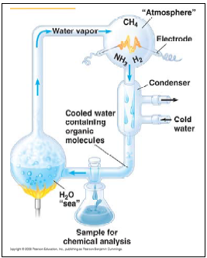

5) Using the picture on the right, explain the significance of the Miller-Urey experiment in testing the abiotic synthesis hypothesis. What was concluded from the results of this experiment?

7) What was proposed as the first genetic material, DNA or RNA? ____________ Explain the evidence for an early “RNA world.”

24.2 Structural and functional adaptations contribute to prokaryotic success
3. Let’s focus on some general details about prokaryotes.
a. Are they multicellular or unicellular?
b. Compare their size relative to eukaryotic cells.
d. What is the composition of the typical bacterial cell wall?
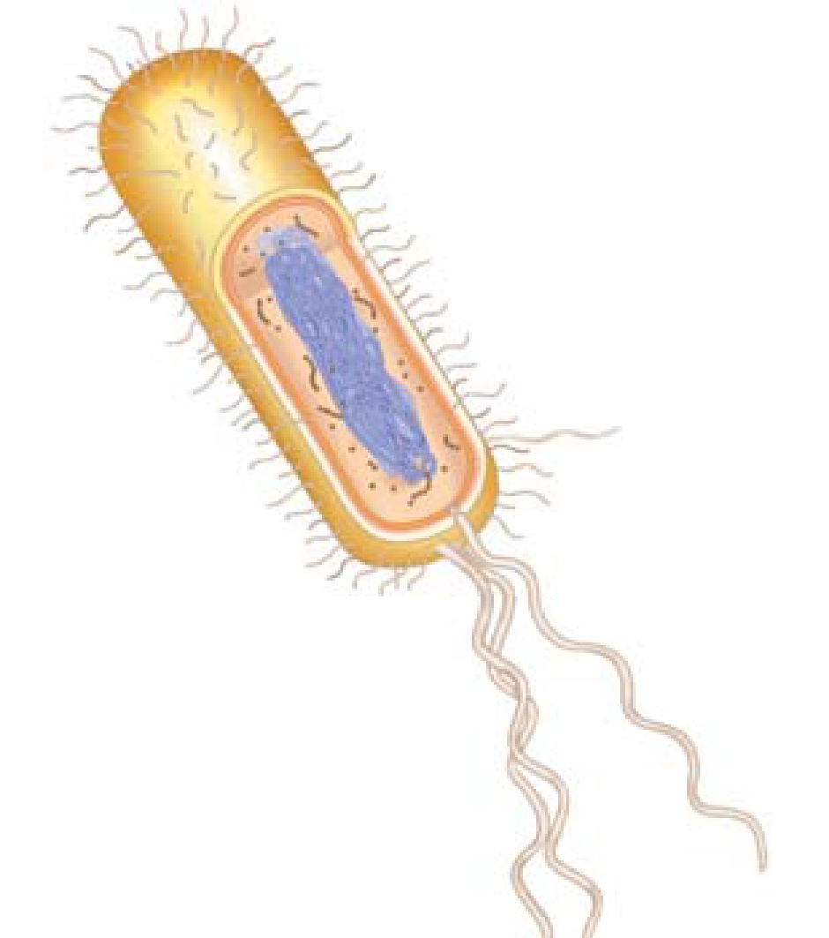
5. Quick review! What material comprises the cell wall of plants? of fungi?

15. Label the following structures of a typical prokaryote seen here: cell wall, sex pilus, circular chromosome, nucleoid region, ribosomes, flagella, capsule, and fimbriae. Sketch in a plasmid or two, and label them. For each structure, know the function. (Go to the end of the chapter, p. 495, for help with this figure or p. 191 of your review book.)

30. Compare the metabolic requirements of each group with respect to oxygen:
obligate aerobes

obligate anaerobes

facultative anaerobes

24.3 Rapid reproduction, mutation, and genetic recombination promote genetic diversity in prokaryotes
17. You should now have some idea why there is so much potential for genetic diversity with bacterial populations. Although mutation is the major source of genetic variation in prokaryotes, listed below are the other three ways variation is introduced. Explain each one.
Source of Variation | Summary of Explanation
Transformation
Transduction
Conjugation

24.4 Prokaryotes have radiated into a diverse set of lineages
34. As you read in the Overview to this chapter, many archaea live on the edge and so are termed extremophiles. Where would you find these types of archaea?
extreme halophiles

extreme thermophiles

The thermophiles are interesting because their DNA and enzymes are stable at high temperatures. DNA polymerases from thermophiles are important in polymerase chain reaction (Chapter 13).

35. Pee-yoo! Methanogens are found in many habitats. What are some of these habitats? What do they all have in common?

24.5 Prokaryotes play crucial roles in the biosphere
37. Define each of these terms,
Decomposers

symbiosis

host

mutualism

commensalism

parasitism

18) What are antibiotics?

19) Not all bacterial activity is negative. Humans employ bacteria for many diverse activities. Cite three human applications of prokaryotes here.

