Name __________________________________________________ Fred and Theresa Holtzclaw
AP Biology
Chapter 22—The Origin of Species
1) Define speciation.

2) Distinguish between microevolution and macroevolution.

22.1 The biological species concept emphasizes reproductive isolation
3) Use the biological species concept to define species.

5) What are hybrids?

6) Explain the two types of barriers that maintain reproductive isolation.

7) The following charts summarize the various ways that reproductive isolation is maintained. Explain and give an example of each type of isolating mechanism.
Prezygotic Reproductive Barriers | Explanation | Example
Habitat Isolation
Temporal Isolation
Behavioral Isolation
Mechanical Isolation
Gametic Isolation
Postzygotic Reproductive Barriers | Explanation | Example
Reduced Hybrid Viability
Reduced Hybrid Fertility
Hybrid breakdown

22.2 Speciation can take place with or without geographic separation
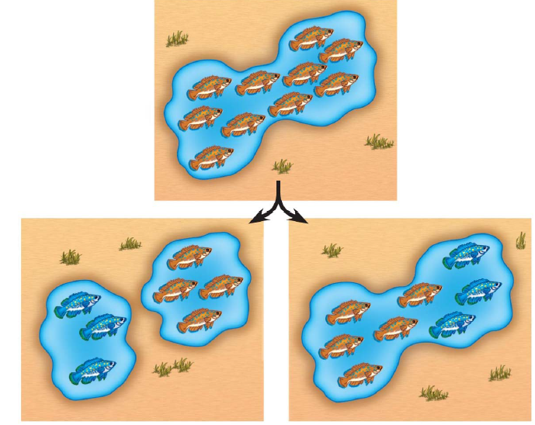
9) Gene flow can be interrupted in two main ways. Explain and give an example of each by labeling and annotating this figure, which shows an ancestral species of fish and then the two modes of speciation

11) What type of speciation is caused by a barrier such as the Grand Canyon? ____________________________.

12) Sympatric speciation occurs in populations that live in the same geographic area. How is this possible?

13) How do island chains encourage adaptive radiation?

14) How can polyploidy lead to speciation?

22.4 Speciation can occur rapidly or slowly and can result from changes in a few or many genes
17) Stephen Jay Gould and Niles Eldredge coined the term punctuated equilibria. What is meant by a punctuated pattern?

18) This figure shows 2 different views of speciation. Label this figure, and explain how each of the pictures explains speciation.
