Name __________________________________________________ Fred and Theresa Holtzclaw
AP Biology
Chapter 21-The Evolution of Populations

This chapter begins with the idea that we focused on as we closed chapter 19: Individuals do not evolve! Populations evolve. The Overview looks at the work of Peter and Rosemary Grant with Galápagos finches to illustrate this point, and the rest of the chapter examines the change in populations over time.

1) What is microevolution?

21.1 Genetic variation makes evolution possible
2) What are the three main mechanisms that can cause shuffling of alleles?

5) Mutations are any change in the nucleotide sequence of an organism’s DNA. These mutations provide the raw material from which new traits may arise and be selected.
a) What occurs in a point mutation?

b) What are chromosomal mutations? How could they be beneficial?

c) How does gene duplication occur? How might it play a role in evolution?

21.2 The Hardy-Weinberg equation can be used to test whether a population is evolving
6) Population genetics puts a mathematical approach to the study of microevolution. Define each of the terms commonly used in population genetics.
a. population:

b. gene pool:

c. gene frequency:

7) The greater the number of fixed alleles, the lower the species’ diversity. What does it mean to say that an allele is fixed?

8) If the frequency of alleles in a population remains constant, the population is at Hardy- Weinberg equilibrium (No Evolution). There are five conditions for Hardy-Weinberg equilibrium. It is very important for you to know these conditions, so write the five conditions below:
a.

b.

c.

d.

e.
It is not very likely that all five of these conditions will occur, is it? Allelic frequencies change. Populations evolve. This data can be tested by applying the Hardy Weinberg equation. Let’s look at how to do this.

Equation for Hardy-Weinberg Equilibrium
p2 + 2pq + q2 = 1
9) Define the following:
a. p² = ___________________________________________________________________
b. 2pq = __________________________________________________________________
c. q² = ___________________________________________________________________

If we know the frequency of one of the alleles, we can calculate the frequency of the other allele:
p + q = 1
10) Work out these practice problems. Assuming H-W equilibrium, find both the allele and genotype frequencies.
a. In Drosophilia, the allele for normal length wings is dominant over the allele for vestigial wings. In a population of 1,000 individuals, 160 show the recessive phenotype. SHOW ALL WORK!!!

a. allele frequencies: dominant allele (W) = _______; recessive allele (w) = _______

b. genotype frequencies: WW = ________; Ww = ________; ww = ________

21.3 Natural selection genetic drifts, and gene flow can alter allele frequencies
12) First, let’s try to summarize the big idea from this section. Scan through the entire concept to pull out this information. Three major factors alter allelic frequency and bring about evolutionary change. List each factor, and give an explanation.

13) Which of the factors above results in a random, non adaptive change in allelic frequencies?

a. Which of the factors above tends to reduce the genetic differences between populations and make populations more similar?

b. Of the three factors you listed above, only one results in individuals that are better suited to their environment. Which is it?

14) Explain what happens in each of these examples of genetic drift:

founder effect:

bottleneck effect:

21.4 Natural selection is the only mechanism that consistently causes adaptive evolution
15) In evolutionary terms, fitness refers only to the ability to leave offspring and contribute to the gene pool of the next generation. It may have nothing to do with being big, or strong, or aggressive. Define relative fitness.

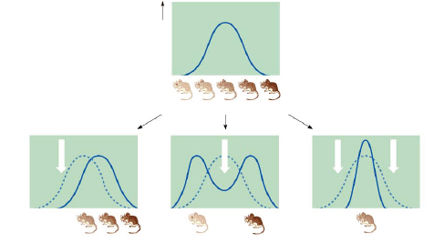

16) Label the following graphs of variation with the type of selection.

17)

18) What is often the result of sexual selection?

19) Explain two ways in which genetic variation is preserved in a population.

20) Discuss what is meant by heterozygote advantage, and use sickle-cell anemia as an example.

21) Finally, give four reasons why natural selection cannot produce perfect organisms

