Name ____________________________________________ Fred and Theresa Holtzclaw
AP Biology
Chapter 20—Phylogeny and the Tree of Life

20.1 Phylogenies show evolutionary relationships
1) What is systematics? How is it used to develop phylogenetic trees?

2) What is taxonomy?

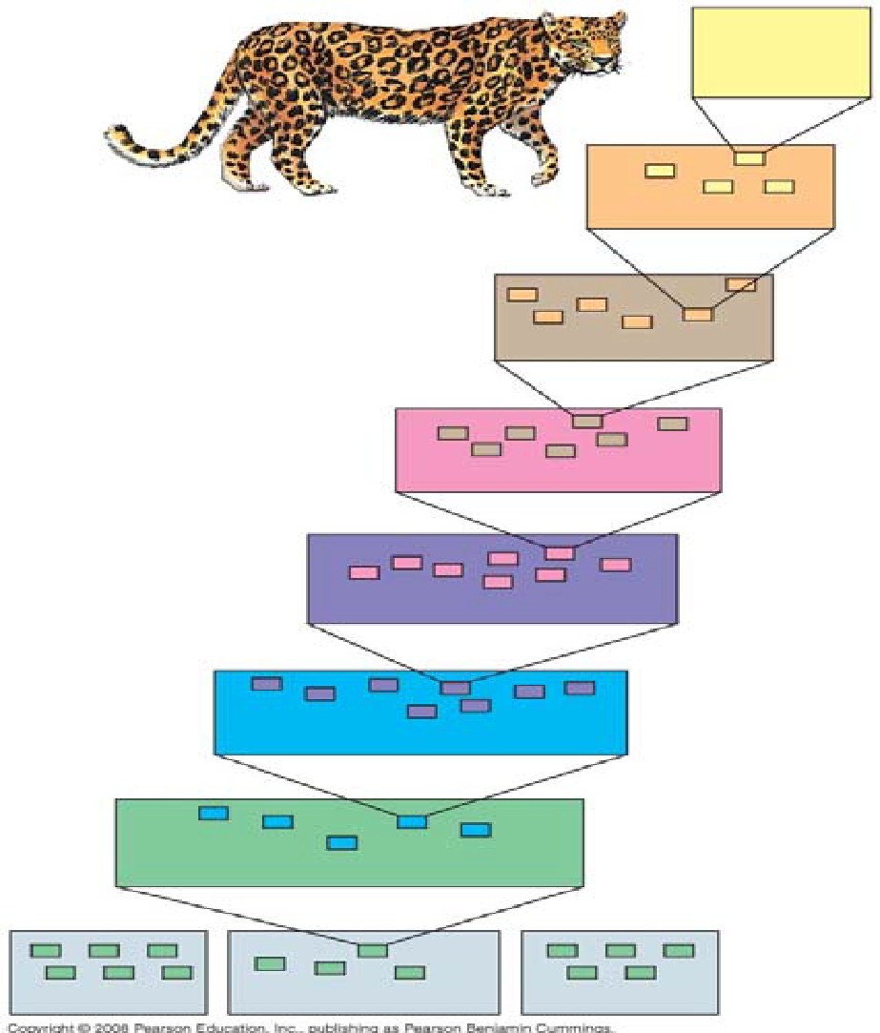
3) What are the two components of every binomial name?

4) Taxonomy uses hierarchical categories that nest within each other, like Russian dolls. The figure (20.3) below shows the categories, each called a taxon. Label each taxonomic category, in the boxes, and then give the one that applies exclusively to this panther to the side of each box.

5) So, which are more closely related, organisms in the same phylum, or those in the same order? _________

6) Here is a phylogenetic tree. Recall that branch points represent common ancestors of the two lineages beyond the branch or node. Circle the common ancestor of badgers and otters, and label it as A. Circle the common ancestor of cats and dogs, and label it as B.
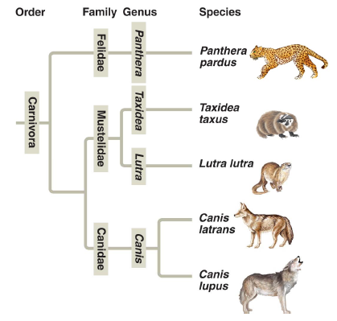

20.2 Phylogenies are inferred from morphological and molecular data
7) Molecular systematics is a valuable tool used today to sort homology from analogy. What is it?

20.3 Shared characters are used to construct phylogenetic trees
8) Below are three cladograms. What is a clade? Circle a clade that is not highlighted below.

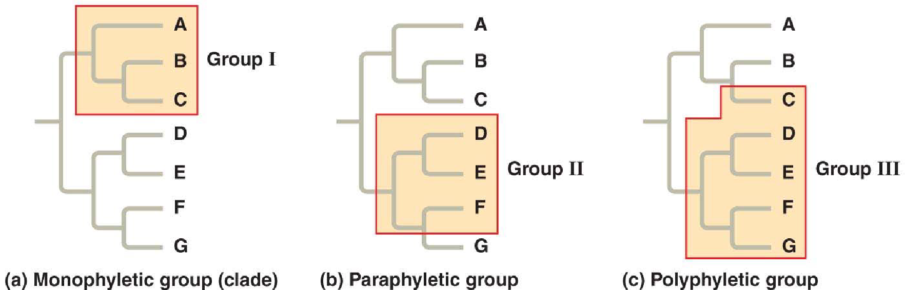

12) Clades are derived by using shared derived characters. What are these?

20.4 Molecular clocks help track evolutionary time
Let’s summarize some important information from this section. The rate of evolution of DNA sequences varies from one part of the genome to another; therefore, comparing different sequences helps us to investigate relationships between groups of organisms that diverged a long time ago. For example, DNA that codes for ribosomal RNA (rRNA) changes relatively slowly and is useful for investigating relationships between taxa that diverged hundreds of millions of years ago. DNA that codes for mitochondrial DNA (mtDNA) evolves rapidly and can be used to explore recent evolutionary events.
13) Which method reveals that fungi are more closely related to animals than to green plants?

14) What are molecular clocks?

20.5 Our understanding of the tree of life continues to change based on new data
Biologists have adopted a three-domain system, which consists of the domains Bacteria, Archaea, and Eukarya. This system arose from the finding that there are two distinct lineages of prokaryotes.

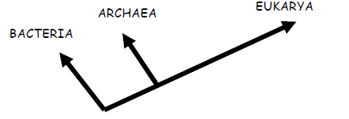
14) On the figure above, place an arrow at the point showing the common ancestor of all three domains.

15) What two domains include all prokaryotes? Which two domains are most closely related?

16) Which kingdom is made obsolete by the three-domain system? Why?

