Name ________________________________________________ Fred and Theresa Holtzclaw
AP Biology
Chapter 19-Descent with Modification

As you study this chapter, read several paragraphs at a time to catch the flow of ideas and understand the reasoning that is being described. In some places, the text describes a narrative or story of events that led to Darwin’s theory of evolution. Therefore, first read the narrative to absorb the big picture and then return to answer the few questions that accompany this material.

19.1 The Darwinian revolution challenged traditional views of a young Earth inhabited by unchanging species
3) How did each of the following sources view the origin of species?

The Old Testament

Carolus Linnaeus

Georges Cuvier

4) How did Charles Lyell and geological gradualism and uniformitarianism influence Darwin? Make sure you explain both of these ideas.

5) Jean-Baptiste de Lamarck proposed a mechanism for how life changes over time. Explain the two principles of his mechanism.

use and disuse

inheritance of acquired characteristics

19.2 Descent with modification by natural selection explains the adaptations of organisms and the unity and diversity of life
6) Charles Darwin proposed that the mechanism of evolution is natural selection and that it explains how adaptations arise. What are adaptations? Give two examples of adaptations.

8) Let’s try to summarize Darwin’s observations that drive changes in species over time:
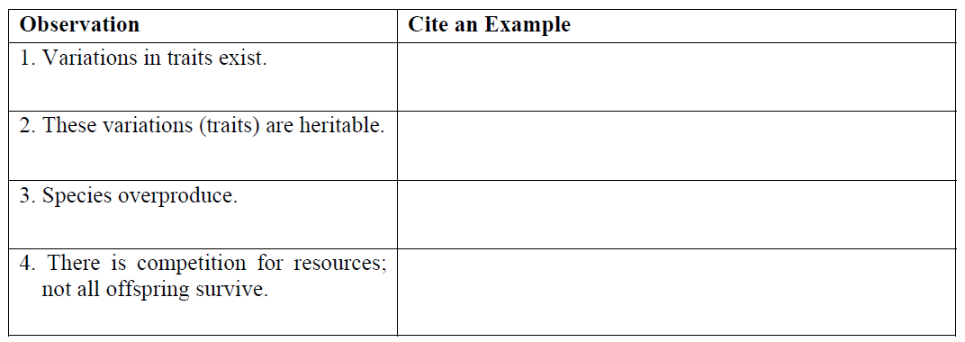
9) From these four observations, which two inferences did Darwin make?

Finally, if you are ever asked to explain Darwin’s theory of evolution by natural selection (a common AP essay question), do not pull out the phrase “survival of the fittest.” Instead, cite the points made in question 8 and explain the inferences that are drawn from them.

19.3 Evolution is supported by an overwhelming amount of scientific evidence
11) Do antibiotics cause bacteria to become resistant? Explain your response.

12) How does the fossil record give evidence for evolution?

13) What is meant by each of the following terms? Give an example of each.

Term | Example
Homologous structures
Vestigial structures
Analogous structures

14) How do homologous structures give evidence for evolution?

16) Organisms that are only distantly related can resemble each other. Explain convergent evolution, and describe how analogous structures can arise.

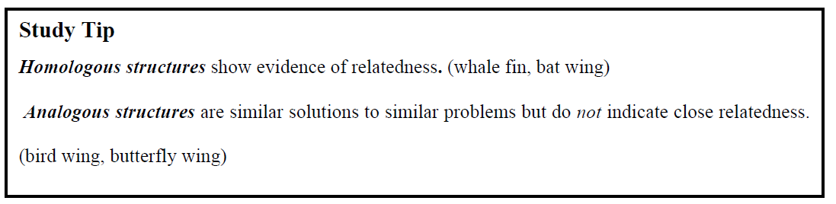
17) What is biogeography? How is it affected by continental drift and the presence of endemic species?

